

**SWE30010 - Managing IT Projects**

**PORTFOLIO**

*Individual proposal and Research Essay*

Nguyen Dinh Nhat Minh

*Human Resource Management With Attendance System*

Group 2

**GROUP 2 INFORMATION**

| **Name** | **ID** | **Tutor** | **Class** |
| --- | --- | --- | --- |
| Le Hoang Hai | 103542974 | Thomas Hang  Nsam@swin.edu.au | Saturday  7:00 AM |
| Nguyen Dinh Nhat Minh | 103802490 |
| Nguyen Nhat Huy | 103802911 |
| Nguyen Ngoc Minh Thy | 103802791 |

Table of Content

**Individual Tasks: 2**

TASK 01P: Scope and Product Backlog 2

TASK 03P: Solution Direction and Design 2

TASK 05P: Software Quality and Definition of Done 2

TASK 061C: Estimation Method 2

TASK 062C: Estimation Accuracy 2

TASK 071D: Quality Definition 2

TASK 072D: Quality Planning 2

TASK 073D: Quality Review 2

TASK 081HD: Software Project Planning, Design and Quality Management 2

TASK 082D: Software Development Methodology Comparison 2

TASK 15P: Peer Review 2

**Group Tasks: 3**

TASK 02P: Scope and Product Backlog 3

TASK 04P: Solution Direction and Design 6

TASK 06P: Software Quality and Definition of Done 16

TASK 07P: Project Proposal 25

TASK 08P: Sprint Planning Meeting 38

TASK 09P: Project Set Up 44

TASK 10P: Sprint 1 Mid-Point Progress Reporting 48

TASK 11P: Sprint 1 End-of-Sprint Progress Reporting 70

TASK 12P: Sprint Review 92

TASK 13P: Sprint Retrospective 95

TASK 14P: Software Design 97

# 

# Individual Tasks:

## TASK 01P: Scope and Product Backlog

**Project Proposal:** *Human Resource Management system for Gemadept*

**Synopsis**

Gemadept Corporation is a leading logistics and shipping company headquartered in Ho Chi Minh City, Vietnam. With a strong commitment to excellence, we are seeking a comprehensive Human Resource Management Software System to enhance our HR operations.

We would like to have a complete HR Management Software System that meets our specific requirements and integrates seamlessly with our existing systems. This system will be expected to streamline HR processes, increase efficiency, and improve employee management.

**1.** **Background**

Gemadept, a leading logistics and shipping company headquartered in Ho Chi Minh City, Vietnam, is requesting a HRM software to streamline HR processes, enhance employee management, and improve overall organizational efficiency. The primary objective of this proposal is to introduce a robust Human Resource Management (HRM) system tailored specifically for Gemadept. This proposal aims to establish the creation of a comprehensive HRM infrastructure, spanning the stages of design, development, and maintenance.

**2. Scope**

**2.1 Objectives:**

This system will be expected to streamline HR processes (recruitment, onboarding, payroll, and performance management), increase efficiency, and improve employee management by allowing employers to track and manage employee’s data.

**2.2 Solutions:**

To achieve the objectives listed, this software will include but not limited to these key features:

* **Employee Information Management**: Centralized database for storing and managing employee data, such as personal details, employment history, and contact information.
* **Recruitment and Applicant Tracking**: Tracking of applied applications and managing the recruitment pipeline.
* **Onboarding and Offboarding**: Structured procedures for integrating new hires into the organization and managing the exit process for departing employees.
* **Payroll Management**: Adjustable automated calculation of employee salaries, deductions, and taxes.
* **Time and Attendance Tracking**: Tools for monitoring employee attendance, tracking work hours, and managing leave requests.
* **Reporting and Analytics**: Generation of customizable reports and dashboards to provide insights into employee’s information and status.
* **Performance Management**: System for setting performance goals, conducting evaluations, and providing feedback to employees.
* **Learning and Development**: Scheduling training sessions and tracking employee progress in skill development.
* **Integration with Existing Systems**: Integration with other business systems such as ERP and accounting software.

**3. Deliverables and schedule**

**3.1 Documentation:**

For the main product, instruction on how to operate and use the software will be provide via the following documentations:

* User Manuals
* System Architecture Documentation
* Training Materials

**3.2 Training Plan:**

A comprehensive training plan will be developed to ensure that all relevant users become proficient in utilizing the new HRM system. Our team will leverage this plan to facilitate and conduct training sessions, either through online platforms or in-person sessions, guiding users through the functionalities of the software.

**3.3. Schedule:**

This project is expected to take around 20 weeks to completed, while the maintenance support will be an on-going process. The timeline for each stage (from designing to implementation) of the project is outlined as follow:

* System Design and Prototyping: 4 weeks.
* Development and Testing: 12 weeks.
* Implementation and Training: 4 weeks.
* Post-implementation support and maintenance: On-going from go live date.

**Initial Release Schedule of the Product backlog items**

| **No.** | **Item** | **Dependencies** | **Business Value  (1 least – 10 most)** | **Release Schedule**  **(Sprint 1 | 2 | 3 | …)** |
| --- | --- | --- | --- | --- |
| F1 | Product UI/UX Design | None | 7 | Sprint 1 |
| F2 | HR database schema design | None | 9 | Sprint 2 |
| F3 | Employee information form implementation | F2 | 8 | Sprint 3 |
| F4 | Recruitment module development | F2 | 7 | Sprint 4 |
| F5 | Payroll calculation module development | F2 | 7 | Sprint 5 |
| F6 | On, Offboarding checklist template implementation | F2, F4 | 6 | Sprint 6 |
| F7 | Leave request feature implementation | F2, F3 | 6 | Sprint 7 |
| F8 | Performance evaluation module development | F2, F3 | 6 | Sprint 8 |
| F9 | Integrate with Gemadept’s ERP system | After all modules are tested | 9 | Sprint 9 |
| F10 | Implement reporting dashboard | F9 | 8 | Sprint 9 |
| F11 | Gemadept’s HR staff training | After successful UAT | 7 | Sprint 10 |
| F12 | Post-implementation maintenance | Once product goes live | 5 | Sprint 10 |

## TASK 03P: Solution Direction and Design

## 1. SOLUTION DIRECTION

## 1.1. PROBLEM DOMAIN

## The problem domain of this project is Human Resource and Online Management.

## It involves developing a comprehensive and user-friendly HRM application that enables effective HR management for Gemadept. Key features of theproject include:

## Employee Information Management: Centralized database for storing and managing employee data, such as personal details, employment history, and contact information.

## Recruitment and Applicant Tracking: Tracking of applied applications and managing the recruitment pipeline.

## Onboarding and Offboarding: Structured procedures for integrating new hires into the organization and managing the exit process for departing employees.

## Payroll Management: Adjustable automated calculation of employee salaries, deductions, and taxes.

## Time and Attendance Tracking: Tools for monitoring employee attendance, tracking work hours, and managing leave requests.

## Reporting and Analytics: Generation of customizable reports and dashboards to provide insights into employee’s information and status.

## Performance Management: System for setting performance goals, conducting evaluations, and providing feedback to employees.

## Learning and Development: Scheduling training sessions and tracking employee progress in skill development.

## Integration with Existing Systems: Integration with other business systems such as ERP and accounting software.

## In addition to the core functionalities, this development also focuses on:

## User-friendly interface for easy navigation.

## Customizable user roles and permissions.

## Automated workflows for HR processes.

## Mobile accessibility for remote workforce management.

## 1.2. SOLUTION DOMAIN

## 1.2.1. The Discussion of Alternative Solutions

## The HRM solution entails expertise in HR management, employee information systems, recruitment, applicant tracking, onboarding, offboarding processes, payroll management, reporting, analytics, integration with existing systems, etc. It also encompasses application programming, user interface design, and hosting servers.

## The medium in which this solution can be implemented are plenty, from website, OS app, to mobile. However, we have chosen to develop a web-based application due to its adaptability and accessibility. Other options were ruled out due to their limitations in meeting the comprehensive requirements of Gemadept's HRM needs, the reason for why the alternatives were discarded is as follow:

## 

| Alternative | Discard reasons |
| --- | --- |
| Desktop-based application | It can take up unnecessary storage space on the user’s device.Limiting accessibility for users who require remote access or use multiple devices.Maintenance of different version base on their OS can be tedious.User needs to manually install updates. |
| Mobile application | Elevated time and resources required to develop compatible versions for each mobile platform.Restricted availability on mobile platforms such as iOS and Android.Incompatibility or insufficient hardware capabilities of mobile devices may hinder the execution of the application's various tasks.Elaborate approval procedures for mobile applications on App Store and Google Play, potentially causing project delays incapable of handling the app’s various processes. |

## 

## Web-based applications provide greater accessibility, cross-platform compatibility, and ease of updates, which makes it the best solution out of all the option*s*, for example, the user can access this app anywhere and does not need specific devices to be able to use this app.

## 

## The main platform where this application will be hosted is a hybrid of dedicated servers on AWS instances. This solution will guarantee the ease of customization and reliability of dedicated servers, while also incorporating the flexibility and scalability of the AWS cloud.

## 

| Criteria | AWS and Dedicated hybrid | Dedicated server | On-premises |
| --- | --- | --- | --- |
| Scalability | Auto-scaling services facilitate handling increased traffic efficiently. | Limited scalability; manual action and downtime involved in scaling. | Limited scalability; additional hardware and resources required for scaling. |
| Reliability | Multiple availability zones and redundancy features minimize downtime. | Reliability dependent on hardware and network maintenance. | Reliability dependent on infrastructure maintenance. |
| Infrastructure | Reduced latency with data centers in various regions, enhancing proximity to customers. | Limited by physical server location; latency reduction requires servers in different regions. | Restricted by physical infrastructure location; latency reduction requires additional premises environments. |
| Security | The web will be protected by Laravel’s various security modules, and AWS can provide the added security of ACLs and security group. | Security dependent on settings implemented on the dedicated server, which may require significant time and effort for maintenance and modifications. | Security dependent on infrastructure, necessitating more resources for comprehensive protection. |
| Cost | Pay-as-you-go model enables scaling resources as needed, cost-efficient for varying business sizes. | Costly hardware maintenance, less cost-effective for small businesses. | Costly setup, maintenance, and resources required. |
| Integration with other tools | Seamless integration with all Amazon services, and other framework that can help to integrate with Gemadept current technologies. | Limited integration, manual setup required. | Limited integration, manual setup required. |

## 1.2.2. The KoST Analysis of My Knowledge

## Knowledge *(what you know)*

## Required knowledge:

## Web-based application: Knowledge of HTML/CSS, PHP, Javascript and frameworks like Laravel and React.

## Cloud services: Knowledge of AWS platform.

## Hosting server: Expertise in server management, networking, databases, and understanding of hosting services.

## Human Resource Management: Knowledge of cooperate human resource management, and management processes.

## My knowledge:

## Web Development Courses: Enrolled in two web development courses and acquired foundational knowledge of HTML, CSS, PHP, and JavaScript.

## Database Management System Course: Enrolled in a Database Management System course and gained a basic understanding.

## AWS Cloud Architecture Course: Completed an AWS cloud architecture course and acquired a foundational understanding of its services.

## HR Management Basics: Possess basic knowledge of HR management through engagement in volunteer operations involving personnel allocation and administration.

## Skills *(your experience)*

## Required skills

## Technical Skills:

## Framework/Tools Proficiency: Practically experienced in utilizing chosen frameworks/tools to facilitate smooth platform development.

## Application Development and UI Design: Proficient in application development projects and user interface design.

## Server Management and Deployment: Skilled in inspecting hosting servers and deploying platforms into Production environments.

## Infrastructure Acquisition: Knowledgeable in hiring or acquiring necessary infrastructure/resources.

## 

## Domain knowledge:

## HRM Applications: Experienced with HRM applications and their connections.

## Human Resource Operations: Understanding the core operations of human resources.

## Third-Party Integration: Proficient in third-party integration to ensure compliance with security regulations.

## My skills

## Technical Skills:

## Web Development: Built three small web projects using HTML/CSS, Javascript, and PHP.

## Database Management: Proficient in creating and managing databases using SQL Developer by Oracle.

## UI/UX Design: Skilled in web user interface design utilizing Figma and Adobe XD.

## Cloud Hosting: Experienced in hosting websites on the AWS cloud.

## Domain knowledge

## Employee Data Auditing: Experienced in auditing employee data and observing recruitment pipelines.

## HRM System Feature: Familiar with using features within a larger Human Resource Management (HRM) system.

## Technology *(existing solution)*

## Web-based HRM systems can be built using a variety of current technologies and solutions. Among the essential tools and technologies are:

## 

## Proprietary HRM Software: Companies like SAP (SuccessFactors), Oracle (Oracle HCM Cloud), and Workday offer comprehensive HRM suites that cover a wide range of HR functions. These solutions often provide modules for core HR, talent management, workforce planning, payroll, benefits administration, and analytics.

## Cloud-based HRM Platforms: Cloud-based HRM platforms like BambooHR, Namely, Zenefits, and Gusto offer scalable and customizable solutions for managing HR processes. These platforms typically provide features such as employee self-service portals, onboarding/offboarding tools, performance management, time and attendance tracking, and compliance management.

## Open-source HRM Solutions: Open-source HRM solutions provide flexibility and customization options for building web-based HRM applications. Popular open-source HRM frameworks and platforms include OrangeHRM, Sentrifugo, IceHrm, and Odoo HR. These solutions offer modules for managing employee information, leave management, attendance tracking, and more.

## 

## Rationale

## Following a comparative examination of several options and a gap analysis utilizing the KsoT framework, the following factors indicate that developing a web application and hosting it on AWS cloud services is the best course of action for this project:

## Web-based applications offer a user-friendly interface and are easily accessible from various devices, allowing them to seamlessly integrate and blend in with the current system.

## Scalability capabilities provided by AWS enable the platform to accommodate growing traffic and customer needs. By growing resources as needed, the pay-as-you-go model also guarantees cost-effectiveness.

## AWS provides features like Application Load Balancing, EC2 hosting, and comprehensive security options that are essential for running an e-commerce platform.

## I have the necessary abilities to construct a modest project like this one.

## 1.2.3. Final Solution

## The HRM Application will be built as a web-based application using React for front-end, and Laravel for the back-end.

## The HRM Application will be built on Nginx Web Servers accompanied by Cloudflare and hosted on an EC2 instance, this combination offers a powerful solution for web application development, providing benefits in terms of performance, security, scalability, and reliability.

## Oracle Database will be used to store user data because it can handle a large volume of data efficiently, moreover, Oracle security and compliance are top-notch which can help with protecting user’s sensitive data.

# 1. ARCHITECTURE DESIGN

## 1.1. 3-TIER ARCHITECTURE DESIGN

**TIER 1: PRESENTATION**

The front end interface of the application will be in charge for housing the UI of the application, it is composed of the following component:

* Cloudflare: For optimizing and securing the delivery of web applications.
* React: A JavaScript library for building user interfaces.
* Bootstrap: A front-end framework for developing responsive websites.

**TIER 2: APPLICATION**

This layer handles the business logic and core functionalities of the platform, such as displaying reports, processing calculations, and analyze the data it collects. Tier 2 connects the user interface (tier 1) and the database (tier 3).

The framework used for this layer is Laravel, and it has the following component:

* Laravel: A PHP web application framework for building web applications following the model-view-controller (MVC) architectural pattern.
* Oracle DB connection: Allows Laravel to connect and interact with an Oracle database.
* Business Logic Modules: Custom modules developed within the Laravel framework to handle specific business logic and functionalities of the application.
* API Integration: Components responsible for integrating with external APIs to fetch or send data as required by the application.
* Authentication and Authorization: Components responsible for managing user authentication and authorization within the application, ensuring secure access to resources based on user roles and permissions, this part will be the backbone for the authentication feature in the front end.

**TIER 3: DATABASE**

Data administration, data query, and storage are handled by this layer. Databases and a database management system are part of Tier 3. It is in charge of guaranteeing the availability, security, and confidentiality of data. It enables the execution of insert, update, and delete queries. In order to deliver the data that the user or application layer request, this layer communicates with Tier 2.

Oracle Database is used for this layer, its components are:

* Data Models: Structures and relationships defined within the Oracle database to organize and store data efficiently.
* Data Access Layer: Components responsible for accessing and manipulating data stored in the Oracle database, including querying, inserting, updating, and deleting records.
* Database Security: Measures implemented within the Oracle database to ensure data confidentiality, integrity, and availability, including user access controls, encryption, and auditing.
* Database Administration Tools: Tools used for monitoring, managing, and optimizing the performance of the Oracle database, such as Oracle Enterprise Manager and SQL Develop.

## 1.2. UML CLASS DIAGRAM

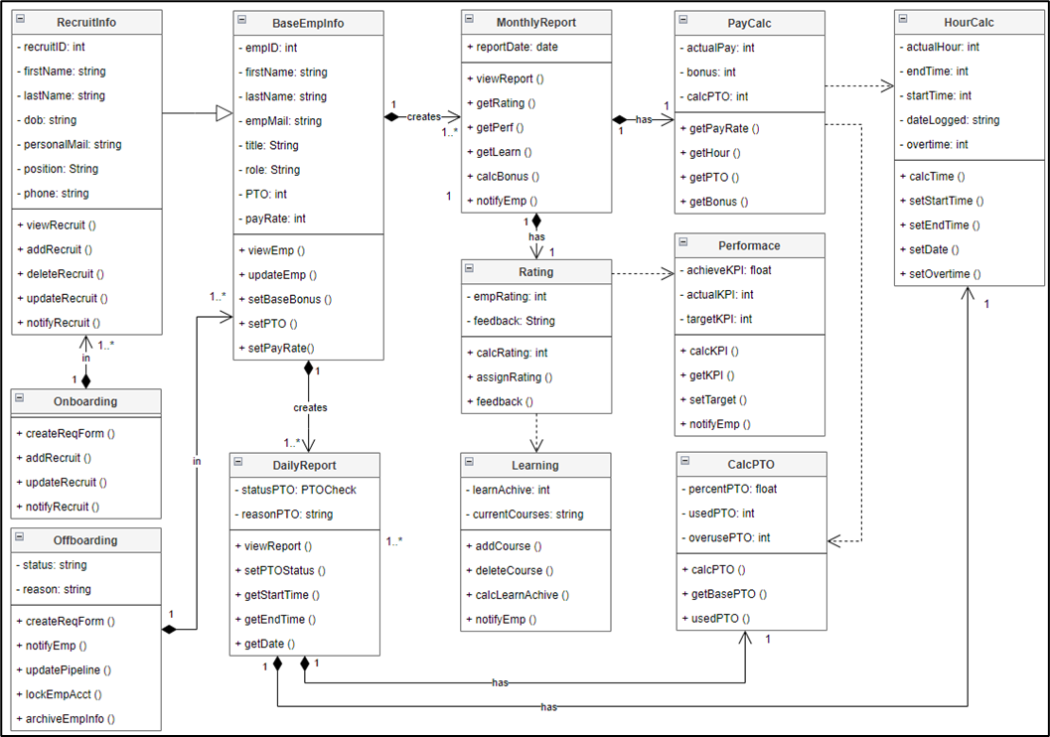

*Figure 2: App Class UML*

## TASK 05P: Software Quality and Definition of Done

**What is Quality?**

With ISO’s definition of quality, we can rule out that quality the existence of characteristics of a product, which can be assigned to requirements, and we can also determine the quality of a system by measuring the degree to which it satisfies the stated and implied requirements of its various stakeholders, ultimately providing value.

To determine the requirement needed for this HRM application, we can follow the simple framework outlined here:

**Technical requirements**

* Appropriate framework and the hosting server.
* Responsive user interface.
* User accessibility.
* Data security.

**Functional Requirements**

* User registration and account management.
* Employee management and tracking.
* Time, pay, performance calculations.
* Review/Rating system.
* Feedback mechanism.
* Notification and Alert settings.

**Non-functional Requirements**

* Have user-friendly UX/UI
* Integrate appropriate security techniques and comply with data protection regulations.
* Integrate with existing system, i.e., ERP, database, timesheet, etc.
* High scalability

**Software Requirements**

Using the S.M.A.R.T guidelines that indicate that goals and achievement should be Specific, Measurable, Achievable, Realistic, and Time-bound. It is logical to pursue and align the HRM’s application’s quality definition on the ISO 25010 standard, which indicates the following objective to ensure the quality of a given software:

* **Functional Suitability:** Ensuring that the HRM software provides all necessary functions to support HR processes such as recruitment, employee onboarding, performance management, and training.
* **Performance Efficiency:** Ensuring that the HRM software performs tasks such as data processing and report generation within acceptable time frames and with minimal resource consumption.
* **Compatibility:** Ensuring that the HRM software can integrate with existing systems such as payroll software, time-tracking systems, and enterprise resource planning (ERP) systems.
* **Usability:** Ensuring that the HRM software is user-friendly and intuitive, allowing HR professionals and employees to easily navigate and perform tasks within the system.
* **Reliability:** Ensuring that the HRM software operates reliably without frequent crashes or errors, especially during critical HR processes.
* **Security:** Ensuring that the HRM software protects sensitive HR data such as employee personal information, payroll details, and performance evaluations from unauthorized access or modification.
* **Maintainability:** Ensuring that the HRM software can be updated and modified efficiently to accommodate changes in HR policies, regulations, and business requirements without introducing bugs or issues.
* **Portability:** Ensuring that the HRM software can be deployed across different hardware and software environments, such as on-premises servers or cloud platforms, with minimal effort and modifications

With ISO 25010 as the reference, we create the detail requirement as the definition of done for our project as follow:

* **Core functionalities development:** The platform must be constructed with all of the essential features listed in the project proposal. Both automated test cases and manual tests can be used throughout the testing process.
* **Usability and Scalability:** Consider factors like reaction time and resource usage while assessing the software's performance under workloads. Verify that the system is capable of handling an unexpected increase in workload.
* **Code Quality and Conventions:** Verify that the code complies with the requirements for readability, maintainability, naming conventions, and code structure.
* **Security:** Verify if the platform followed the necessary data protection and authentication guidelines. Performing security testing, reviewing protocols, and reviewing IT policies and documentation are all part of this process.
* **Testing and Documentation:** Conduct unit testing to verify individual components, integration testing to validate interactions between modules, and user acceptance testing (UAT) involving end-users.
* **UX/UI Testing:** Make that the UI is responsive, easy to use, and visually consistent. It ought to satisfy every design criterion listed in the proposal.

**DEFINITION OF DONE CHECKLIST**

The following checklist is prepared based on the ISO25010 Model with 8 main characteristics to measure the ‘Quality’ of the HRM application.

| **No** | **(Sub) Characteristics** | **Description** | **Y/N** |
| --- | --- | --- | --- |
| **1. Functionality Suitability** | | | |
| 1.1 | Functional Appropriateness | Deploy the platform on the cloud-based hosting server | ☐ |
| 1.2 | Functional Appropriateness | The platform allows user creation for 2 account types: business account and user account | ☐ |
| 1.3 | Functional Appropriateness | The platform allows users to switch between different languages. All content, messages, and alternative text are translated correctly | ☐ |
| 1.4 | Functional Appropriateness | The employee report module can generate reports with meaningful insights from the data. | ☐ |
| 1.5 | Functional Appropriateness | The platform's core functionalities can integrate with external systems, such as ERP, database, timesheet. | ☐ |
| 1.6 | Functional Correctness | The number of errors of each core functionality of the e-commerce platform should be less than 5% of total automated test cases | ☐ |
| 1.7 | Functional Correctness | During the account registration process, important fields such as name, password, and email are required | ☐ |
| 1.8 | Functional Correctness | Employee information (base and daily/monthly report) correctly appear on the screen | ☐ |
| 1.9 | Functional Correctness | The searching and filtering options return the correct result | ☐ |
| 1.10 | Functional Correctness | 99% of the daily/monthly process are completed and recorded in the databases at the end of day or at the time of generating report. | ☐ |
| 1.11 | Functional Completeness | The app can display well-organized daily employee report with time, leave check, name, title/dept. | ☐ |
| 1.12 | Functional Completeness | The platform can send notifications via email to remind users to check the timesheet of their work time daily at 3 o’ clock. | ☐ |
| **2. Performance Efficiency** | | | |
| 2.1 | Time Behaviour | The following actions have a response time of less than 2 seconds:  § Return searching results after users search the employee’s name or functions of the app.  § Display a list of employees.  § Display the base employee’s information when clicking on employee.  § Record employees check in to time calculation module.  § Login/Logout | ☐ |
| 2.2 | Time Behaviour | The loading time of pages is less than 5 seconds | ☐ |
| 2.3 | Resource Utilization | The CPU utilization when running the platform is below 80% and memory consumption is below 70% | ☐ |
| 2.4 | Capacity | A simulated workload of 1,000 employees is used for testing. Could the platform handle this simulated workload without reducing the performance by at least 30% | ☐ |
| **3. Compatibility** | | | |
| 3.1 | Co-existence | The platform can operate simultaneously with at least 2 other software in an operating system without conflicting | ☐ |
| 3.2 | Interoperability | 95% of record (reports, module’s calculation) shows up correctly on third-party system | ☐ |
| 3.3 | Interoperability | The operational data of the platform can be displayed on the data analytics tool in real-time with a maximum delay of 1 minute. | ☐ |
| **4. Usability** | | | |
| 4.1 | Appropriate recognizability | Users complete the following tasks in less than 3 minutes:  § Register a new account.  § Complete their timesheet.  § Managers can search for employees. | ☐ |
| 4.2 | Learnability | 90% of users (employees and manager) can complete basic tasks to serve their needs on the first day of the testing period | ☐ |
| 4.3 | Operability | The average number of errors that test users encountered during a 15- minute testing session is less than 2 errors | ☐ |
| 4.4 | User interface aesthetics | The platform is responsive on desktop | ☐ |
| 4.5 | User interface aesthetics | This condition is evaluated based on feedback survey  The minimum average satisfaction score of 20 users about the UX/UI of the platform, including webpage structure, text font, color palette, languages, navigation, information display, buttons, etc. is 8 out of 10 | ☐ |
| 4.6 | User error protection | 90% of test users can understand the content of the confirmation dialog box displayed when they:  Submit timesheet.  Update their information.  Change the HRM settings.  Generate report generation | ☐ |
| 4.7 | Accessibility | 80% of non-text content (video, images) have alternative text descriptions | ☐ |
| **5. Reliability** | | | |
| 5.1 | Maturity | Mean Time Between Failures (MTBF) metrics of the platform is at least 30 days | ☐ |
| 5.2 | Fault Tolerance | Mean Time to Recover (MTTR) takes less than 2 hours to recover platform data from errors or failures | ☐ |
| 5.3 | Recoverability | All functionalities of the platform can be fully restored from the backup within 5 hours after the failure | ☐ |
| 5.4 | Availability | The platform is accessible for 99.9% of operating hours | ☐ |
| **6. Security** | | | |
| 6.1 | Confidentiality | Block at least 95% of unauthorized access attempts and send alerts to users | ☐ |
| 6.2 | Confidentiality | Data encryption and secure authentication protocols are integrated | ☐ |
| 6.3 | Integrity | 100% of data is stored and transmitted correctly. Data in the databases is reflected correctly on the user interface and data analytics tools | ☐ |
| 6.4 | Integrity | The platform follows data protection regulations | ☐ |
| 6.5 | Non-repudiation | Implement non-repudiation measures for at least 95% of user actions | ☐ |
| 6.6 | Accountability | 100% of user interactions on the platform and the platform events are recorded in the logbook | ☐ |
| 6.7 | Authenticity | 95% of user authentication processes are successful | ☐ |
| **7. Maintainability** | | | |
| 7.1 | Analyzability | Reduce time taken to diagnose and resolve reported issues to less than 1 hour 30 minutes | ☐ |
| 7.2 | Modifiability | New change/enhancement is integrated into the platform 1 week after the change request is made | ☐ |
| 7.3 | Testability | Maintain a code coverage of at least 80% through automated test cases | ☐ |
| 7.4 | Modularity | The platform architecture is designed with at least 5 modules | ☐ |
| 7.5 | Reusability | All codes have naming conventions, and comments to modify when needed without affecting other parts (Low coupling – High cohesion) | ☐ |
| 7.6 | Reusability | A minimum of 80% code is reusable | ☐ |
| **8. Portability** | | | |
| 8.1 | Adaptability | The time to deploy the platform on a new hosting server (on-premises or cloud server) is less than 7 days | ☐ |
| 8.2 | Installability | The time to complete the installation and configuration of all platform components in an environment is less than 8 hours | ☐ |
| 8.3 | Replaceability | Could we replace a component of the platform with a migration time of less than 1 week without impact on other components? | ☐ |

## TASK 061C: Estimation Method

**BACKLOG**

This table below shows a portion of our product backlog, specifically just that of sprint one.

| **No.** | **Item** | **Dependencies** | **Business Value (1 least – 10 most)** | **Release Schedule** |
| --- | --- | --- | --- | --- |
| **F1** | **Product UI/UX Design** | **None** | **7** | **Sprint 1** |
| **F2** | **Website for HRM** | **None** | **9** | **Sprint 1** |
| **F3** | **HR database schema design** | **F2** | **8** | **Sprint 1** |
| **F4** | **Manager Portal** | **F1, F3** | **7** | **Sprint 1** |

**1. Sprint Backlog Item to develop**

Following discussions with my team members, we have decided to prioritize the development of the ***Website for the HRM Application***. Our decision is based on utilizing the SMART framework, which revealed that our team possesses the most relevant skill sets for this task, including UI/UX design and web coding. Moreover, this will serve as the backbone of our project, enabling us to house further features and functionalities.

The decision not to prioritize Product UX/UI Design was driven by its cosmetic nature, which we determined would not significantly impact the website's functionality. Therefore, it can be deferred to a later stage.

Similarly, the schema design and manager portal will be contingent upon the completion of the website's backbone. As such, they will not be prioritized and will be developed once the website's core functionality is established.

**2. Work Breakdown Structure**

As a team, we leveraged our collective experiences and expertise to thoroughly discuss and outline the tasks required to complete the sprint backlog items. For the website, we identified five primary tasks that need to be accomplished. These tasks will be further delineated using the Work Breakdown Structure (WBS) model to ensure a detailed and comprehensive approach to completing this sprint item.

We utilize the Software Development Lifecycle’s stages to determine how to break the task down into various sections:

| **Software Development Lifecycle** | **Work Breakdown Structure** |
| --- | --- |
| Planning & Analysis | Requirement Collection |
| Design | Architecture Design |
| Implementation | Development |
| Testing & Integration | Testing & Deployment |
| Maintenance | No maintenance at this stage as the whole product has not been finalized. |

*Figure 2.1: SDLC table to determine WBS.*

We adopt a hybrid approach, combining both activity-based and product-based methods, to construct our Work Breakdown Structure (WBS). We first concentrate on identifying the main requirements associated with each product, which serves as the foundation for outlining the general framework of our website. Subsequently, we delineate the first task within each product, breaking them down into sub-tasks.

This approach enables us to efficiently address tasks required for specific components within our build, facilitating prompt completion as they arise and ensuring comprehensive control over our product development process.

Through this method, we have devised the design of the WBS diagram as follows:

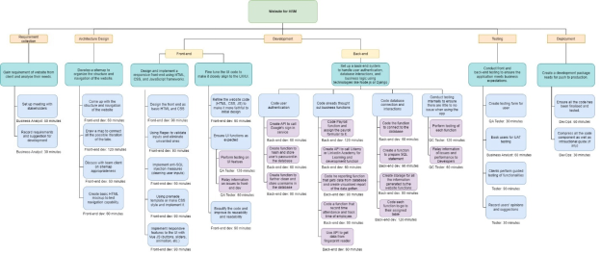

*Figure 2.1: WBS Chart with Time Estimation for each task*

The WBS structure aids in clarifying tasks by breaking them down into smaller, more manageable components. As a result, each main task that lacks clarity regarding its purpose will be complemented by two to three sub-tasks to provide greater clarity and detail.

**3.** **Rationale and Analysis**

The first step is gathering the client's requirements, after which business analysts will schedule a meeting to record the client's website specs. This step requires the least amount of time because it mostly focuses on the client's additional expectations for the website, as the core criteria were specified in the project proposal.

The front-end designer or developer is responsible for drafting the website's layout during the process of building the sitemap. Based on my prior sitemap design experience from my web development degree, this work can be very time-consuming and tedious. It entails laying up every tab and feature that the website might have. Furthermore, extensive team discussions are required to guarantee fluid programming and seamless function linkage; as a result, this task may take longer than expected.

With regard to the principal duty of creating and executing the front-end framework, the design stage may proceed in a gradual manner. That could speed up the process, though, if a UI draft has been created using a platform like Adobe XD or Figma. On the other hand, due to the thorough nature of code development, writing the front-end with the selected framework will require significant resources and effort. Additionally, potential DDOS and SQL injection attacks must be dealt with on the front end, adding another level of complexity and requiring more work.

As a checkpoint to guarantee the promised usability and user-friendliness, the front-end must be modified to match the design precisely once it has been developed with responsive functionality and features. Additionally, testing the website to find and fix any security flaws is part of this step. It goes without saying that in order to fully guarantee security and efficient operation, this stage will also require a substantial time commitment.

As the back-end handles the majority of the website's functions, development inevitably takes a long time. Even though authentication code is time-consuming since it must follow security guidelines, it could nevertheless be completed faster than the website's many features. Creating a database connection is time-consuming because SQL queries must be prepared in order to query the data, and the connection must be kept open at all times so that clients can get the information they need without having to repeatedly shut down. Additionally, because of the nature of the coding needed, coding and building data tables might take a lot of time.

It will take a lot of time and work to carefully review the functions throughout the back-end development stage because QC testing is also necessary to guarantee functionality and fix vulnerabilities.

User testing and feedback gathering comprise the penultimate step, which can be finished really rapidly. The main task of this step is to arrange user testing sessions and gather input to improve the website. Other than scheduling users' spare time, it doesn't require any labor.

DevOps must be included in the deployment stage of the process in order to examine all pertinent product details prior to packaging the product for production. DevOps shouldn't have too much trouble determining the product's readiness if all testing proceeds as planned, making this task reasonably rapid and not unduly time-consuming.

## TASK 062C: Estimation Accuracy

**Evidence**

# 1. Work Burndown Chart

A burndown chart to keep track of the days it should take in order for the sprint to be completed. It is important to note that this chart represent the total effort for all the sprint product in sprint one and not particularly any sprint product.

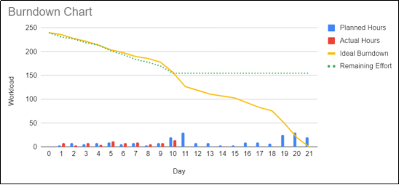

*Figure 1.1: Sprint 1 burndown chart*

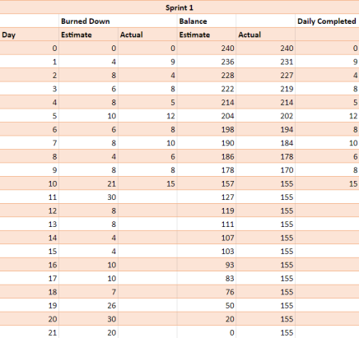

*Figure 1.2: Sprint 1 burndown table*

# 2. Work Breakdown Structure

We created a WBS chart to estimate the effort it would take to develop the base website for our project. Other sprint products are merely features or design for our website, hence we put our focus on analyzing this particular product.

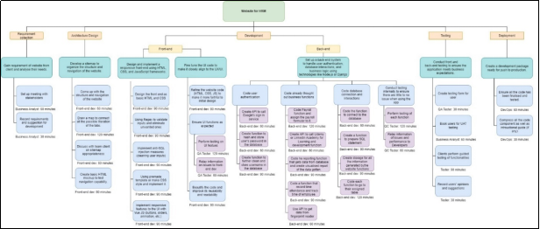

*Figure 2.1: WBS Chart with Time Estimation for each task*

**3.** **Website building – Front end and Back end**

Per inquiry with our developer, he spent 40 hours (which amount to 4 hours per day) on the website’s backend and front end, he also recorded all of his work on Github for ease of review.

**Front end Github:**

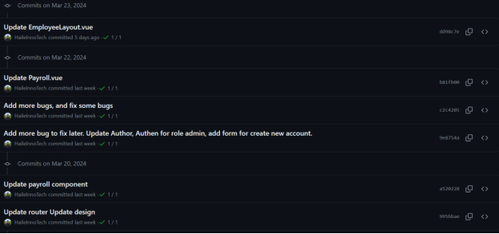

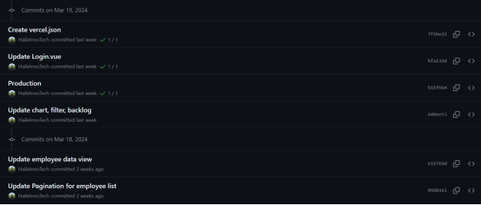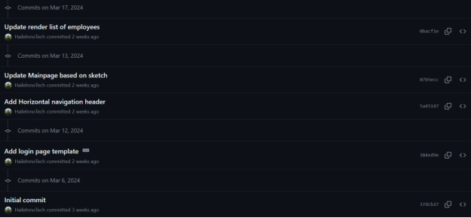

*Figure 3.1, 3.2, 3.3: Front-end Github commits*

**Back end Github:**

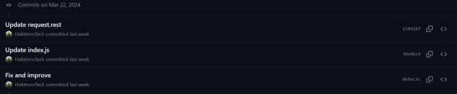

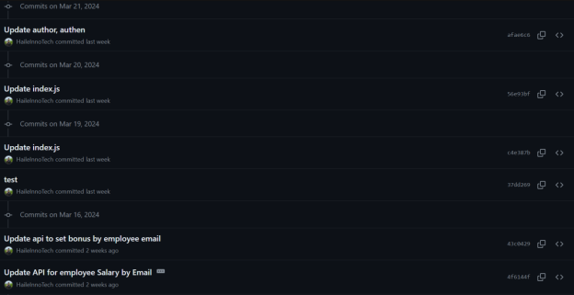

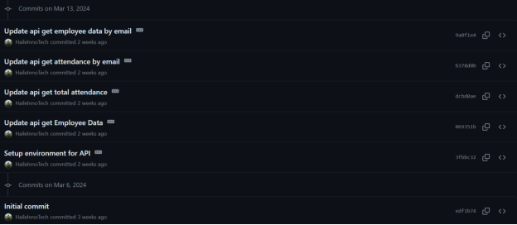

*Figure 3.4, 3.5, 3.6: Back-end Github commits*

As can be seen, he was able to push a number of commits on the dates that is parallel to the 9 dates he was able to work on the project. There is a lack of 1 commit on both he front and the back end which equals to 1 date, but it is due to the fact that some of the packages that should have been a separate commit, were collectively pushed into 1 commit.  
**4.** **Rationale and Analysis**

We devise a product backlog that defined 4 sprints for our project, each sprint would be as long as 21 days, and the total work hour it would take for each of the them is 240 hours (about 3 hours per day for 4 person). In our first project sprint, we have got four tasks to tackle, building the website is the main focus and will likely be the most lengthy.

As of the moment, our team had finished the first 10 days of the sprint, so we reached the halfway milestone of our project. According to our burn down table and chart, we should have worked on the entire project at least 83 hour at this point and looking at the work breakdown structure, building the website will take around 44.5 hours in total, and since we had defined the website as the utmost important product in our plan, we put a lot more effort in to finishing that product first.

Given the predicted 44.5 hours needed for it in total, we were able to work on this website for 40 hours, give or take. This is within the 10% error margin of our project, as we have not yet completed the additional testing duty. Thus, of the 85 hours that we really worked on the sprint, the website consumes almost half of our time, leaving us with 45 hours to concentrate on the other three products.

Completing the website we had envisioned seemed like a great accomplishment, especially considering the amount of time and work that goes into establishing a website or software. It resembles demolishing a massive wall. The foundation for future feature additions is established by the essential functionality of this website.

In order to get ready for the upcoming sprint, we took some time to evaluate our performance from the previous one and determine how we were able to achieve a narrow margin of error. We found a few key components that truly helped us accomplish our goal of finishing the website in the allocated amount of time:

* **Consulting with Professionals:** Although the term "professionals" can be a bit wide, we tried to interact with people who might offer insightful information on the intricacies of creating a website (such as YouTube teachers, peers who have done a lot of web development, etc.). We felt that by getting outside advice, we were able to increase the precision of our estimates and gain a deeper understanding of the work needed for each component.
* **Leveraging past experiences:** Since every member of our team had studied web development and was aware of its complexity, we were able to analyze past data to find trends and patterns in the amount of time it took to complete tasks. It proved to be quite beneficial for us in terms of project planning.
* **Prioritize Important Tasks:** We eat the frog and complete the most important functions of our website first (e.g., database, payroll, handling user’s data, etc.), this allow us to do the smaller tasks later and not be too overwhelmed with the amount of work ahead, effectively make our processes more efficient.
* **Regular Meeting:** We held frequent refinement sessions prior to sprint planning because we believed in checking in with one another. This allowed us to review and reevaluate our initial estimations and gain insight into the work progress of other team members. By means of cooperative deliberations and input from fellow team members, we can enhance our approximations, accommodate new insights or modifications in specifications, and ensure compliance with team capabilities..

We believed that accuracy achieved in our project's progress stems from a combination of planning, prioritization of critical tasks, and adaptability to changing circumstances. By leveraging these strengths and remaining agile in our approach, we are well-positioned for continued success in future sprints and beyond.

## TASK 071D: Quality Definition

**SPRINT BACKLOG**

This table below shows a portion of our sprint backlog, specifically that of sprint one.

| No. | Item | Business Value (1 least – 10 most) |
| --- | --- | --- |
| F1 | Product UI/UX Design | 7 |
| F2 | Website for HRM | 9 |
| F3 | HR database schema design | 8 |
| F4 | Manager Portal | 7 |

**1. Sprint Backlog Item to develop**

The *Website for HRM* item will be the product with the highest prioritization and will be the first thing to be produce in the meantime. Its steadfast development is due to its business value and importance I.e., being the backbone for other functions to be developed upon.

In SDLC, quality separate the different between a still-developing product and a fully functional one. Hence, it is important to define a quality checklist to ensure the sprint product can perform well in the real world.

**2. Software Quality**

**Definition of Done**

For a product to be shippable or done, it must satisfy the stated and implied needs of its various stakeholders, and thus provides value. In this sprint, for the website to be considered done, its functional requirement should be fulfilled. All core functionalities of the website can work efficiently and do not have any severe errors that corrupt the system. Core functionalities include:

* Biometric Attendance Tracking
* Employee information Management
* Payroll Integration
* Reporting and Analytics
* Time checks and attendance
* Performance and Development tracking
* Integration with third party services
* Basic website capability
* These definitions should be the base to build the quality checklist on.

ISO25010 Software Quality Model

Using the ISO25010 model, and the desired core functionalities of the website listed above, we can select the characteristics which can be the most significant to our product, and in this case, we will implement the Functional Suitability characteristic and its Functional Correctness sub-characteristic to build our quality checklist on.

To create a checklist that can present how well the functional correctness of the actual build can be, we will be applying the SMART framework again to help us measure our own capabilities and devise specifics metrics and thresholds to assist in designing the quality checklist.

Applying the elements, we can finalize a quality checklist for our website as follow:

| Functional Suitability – Functional Correctness | | |
| --- | --- | --- |
| No. | Metrics | Thresholds |
| 1 | Individually, each calculation module (e.g., payroll, time worked, rating) should have little to no calculation errors. | < 5% calculation error |
| 2 | When a calculation is made in any one of the modules, the related attribute in other modules must update correctly. | < 5% calculation error |
| 3 | Employee’s information updates should correctly appear on the screen. | 100% accuracy |
| 4 | Employee's information should be recorded correctly within the database | 100% accuracy |
| 5 | The dashboard chart should be used properly to show clear details of employee’s information. | Clear visualization with < 5% deviation |
| 6 | The database searching and filtering options should return the correct result. | 95% accuracy |
| 7 | Biometrics token must be correctly verified and apply for the correct personnel | 95% accuracy |
| 8 | Data conversion of the fingerprint to be stored in the database must be accurate for each of the employees. | < 5% fingerprint data conversion error |
| 9 | During the account registration process, important fields such as name, password, and email are required. | 100% of the information is fulfilled |
| 10 | Most authentication attempts must be successful | 90% success rate |
| 11 | The website must pass many test cases that prevent XSS and exploiting URLs. | 98% test case passed |
| 12 | Proper input sanitization should be checked to prevent code injection or unintended characters. Additionally, handling of special characters, whitespace, and input encoding should be validated. | 100% input fields are protected |
| 13 | Form submission and data transmission should be tested to ensure that data is correctly processed and sent. | 95% test case passed |
| 14 | Error messages should be displayed when invalid data is entered, providing clear instructions on how to correct them. | 100% accuracy |
| 15 | Links to different functionalities should be correct. | 100% accuracy |
| 16 | API connection to other services (i.e., existing ERP, Google sign in, Google sheet, etc.) should have little error | < 5% API errors |
| 17 | The website should display and run as expected on various browsers. | 98% of browser tested must passed |

Figure 2.1: Functionality correctness checklist

**3. Metric and Threshold values rationale**

We based our checklist around the functional correctness; hence, it will be heavily focused on the accuracy and correctness of each of the HRM website’s core capabilities in addition to every website’s basic functionality.

Justification for each of the items mentioned in the checklist are as follow:

| Functional Suitability – Functional Correctness | |
| --- | --- |
| No. | Rationale |
| 1 | As a reporting platform, calculation must be as precise as possible, hence calculation errors or formula errors must be minimal. |
| 2 | Like the previous metric, this one is concerned with calculation taken from various models. And the result of this calculation must not have calculation error larger than 5% |
| 3 | Functions that record data from the main website must update the database correctly 100% of the time to aid in various other functions. |
| 4 | On the webpage, information of the employees must be displayed in full and without errors. This will not only help with visualization but also aid in modular calculations. |
| 5 | Functions that visualize or report data of employee |
| 6 | The function that queries the data from database to the website should be able to accurately get the correct result not only for displaying but for other modules calculation as well. |
| 7 | The fingerprint token of each employee should record correctly as set up in the database. |
| 8 | To track the employees' time and attendance, it is important that their fingerprint data is collected correctly with little to no errors. |
| 9 | For employee's data to not be missed or not recorded, all the important field are required. |
| 10 | The authentication functions must work 90% of the time in order for people to access their information. |
| 11 | XSS and URL exploitation are serious and pose significant threat to the data and privacy of the website, hence, this feature must be thoroughly tested. |
| 12 | All the input fields of the website must be able to deal with wrongful data to prevent SQL injections and other breaches. |
| 13 | Data transmission from one layer (front, back, database) must be checked and ensure the accuracy of data. |
| 14 | Should error arise when using the website, error handling prompt must pop up for users or developer to fix the issue. |
| 15 | Ensure all the link to different function points exactly to the specified function. |
| 16 | Integration of other services should be available most of the time and should only be down (intentionally or unintentionally) when traffic is low. |
| 17 | To ensure smooth operation on different choice of browsers, this website and its functionalities should be tested on various browsers. |

Figure 3.1: Functionality correctness checklist

By checking the quality checklist after the sprint or product is done, we can have a total view of the progress of our project, enabling us to make more informed decisions and improving the product as needed.

## TASK 072D: Quality Planning

## HRM WEBSITE QUALITY CHECKLIST

| Functional Suitability – Functional Correctness | | |
| --- | --- | --- |
| No. | Metrics | Thresholds |
| 1 | Individually, each calculation module (e.g., payroll, time worked, rating) should have little to no calculation errors. | < 5% calculation error |
| 2 | When a calculation is made in any one of the modules, the related attribute in other modules must update correctly. | < 5% calculation error |
| 3 | Employee’s information updates should correctly appear on the screen. | 100% accuracy |
| 4 | Employee's information should be recorded correctly within the database | 100% accuracy |
| 5 | The dashboard chart should be used properly to show clear details of employee’s information. | Clear visualization with < 5% deviation |
| 6 | The database searching and filtering options should return the correct result. | 95% accuracy |
| 7 | Biometrics token must be correctly verified and apply for the correct personnel | 95% accuracy |
| 8 | Data conversion of the fingerprint to be stored in the database must be accurate for each of the employees. | < 5% fingerprint data conversion error |
| 9 | During the account registration process, important fields such as name, password, and email are required. | 100% of the information is fulfilled |
| 10 | Most authentication attempts must be successful | 90% success rate |
| 11 | The website must pass many test cases that prevent XSS and exploiting URLs. | 98% test case passed |
| 12 | Proper input sanitization should be checked to prevent code injection or unintended characters. Additionally, handling of special characters, whitespace, and input encoding should be validated. | 100% input fields are protected |
| 13 | Form submission and data transmission should be tested to ensure that data is correctly processed and sent. | 95% test case passed |
| 14 | Error messages should be displayed when invalid data is entered, providing clear instructions on how to correct them. | 100% accuracy |
| 15 | Links to different functionalities should be correct. | 100% accuracy |
| 16 | API connection to other services (i.e., existing ERP, Google sign in, Google sheet, etc.) should have little error | < 5% API errors |
| 17 | The website should display and run as expected on various browsers. | 98% of browser tested must passed |

## Quality Control Planning

## To ensure that our product meets the expected quality, there needs to be a plan of action for each of the quality. Hence, we will be using two methods namely Risk Assessment and Eisenhower Matrix to justify and devise an in-depth plan.

## 1. Ensuring Product meets the Quality defined

## To ensure that each quality stay within the predetermined quality aspect and don't exceed the threshold, they are paired with a matching task

| Functional Suitability – Functional Correctness | |
| --- | --- |
| No. | Plan |
| 1 | Insert 50 rows of employees with varying degrees of different parameters to observe whether the calculation function is correctly configured. |
| 2 | Use a wide range of values for the employee parameters on individual modules and observe whether the final calculation is correct. |
| 3 | Verify the displayed information on the website against the database |
| 4 | Make 20 employees updates on the website and observe their data in the database |
| 5 | Use a wide range of value on the employees’ parameters and observe whether the chart function is correctly configured |
| 6 | Use the search function with a variety of keywords and random words to note the displayed information. |
| 7 | Create 20 samples of fingerprint and create 20 employee accounts according to the prints, then observe it in the database |
| 8 | Create 25 fingerprints on the reader and observe whether the website made a mistake when transferring fingerprint data to the database |
| 9 | Check whether all input field are programmed with the "required" tag in the HTML code |
| 10 | Create 20 employees accounts with different emails to log into the system |
| 11 | Create 20 test cases that simulate XSS, or URLs exploiting and test the website against them |
| 12 | Test all input field on the website against 20 different test cases of varying error |
| 13 | Test form submission input on the website against 20 different test cases and note any difference between the website and the database |
| 14 | Wrongly execute any input and observe whether error messages appear |
| 15 | Click on all the tabs presented on each page of the website and verify them against the sitemap |
| 16 | Intentionally disrupt network connectivity during an ongoing API request and verify that the system handles the timeout or connection failure gracefully |
| 17 | Run the HRM website on Opera, Chrome, Coc Coc, Firefox, Brave, and Edge, and note any differences or issues. |

## *Figure 1.1: Plan for each quality*

**2. Risk Assessment**

We can rank the most significant attributes while considering the associated risks by using the quality checklist to ascertain whether each quality meets any risk criteria. These risks will be ranked from least to highest influence on business functions, with a distinction made between risks with less impact, like browser compatibility, and those with greater impact, like SQL injection.

As part of this categorization process, assigning each attribute to the relevant risk category lays the groundwork for action planning. There are three different priority levels: Normal, Important, and Urgent. Urgent tasks are prioritized, followed by Important tasks, and finally Normal ones.

We can make the following risk assessment chart by following the item numbers on the checklist as a reference:

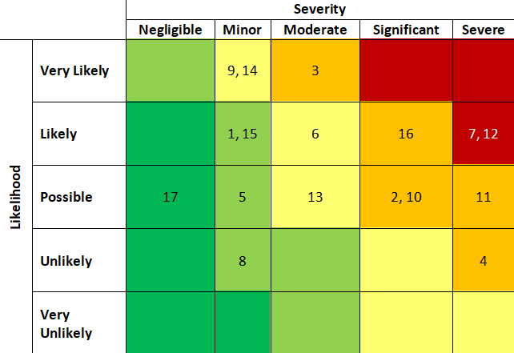

Figure 2.1: Risk assessment chart

## 3. Planning Quality Review

## We can efficiently design and plan tasks to maintain the quality of the HRM website thanks to the risk assessment chart. Then we can use Trello dashboard to help with the management and organizing of all required actions. With the aid of this dashboard, we will be able to organize and classify jobs in a methodical manner according to the Risk Assessment Chart, guaranteeing thorough monitoring and efficient implementation of quality assurance procedures for the HRM website.

## 

## *Figure 3.1: Quality Review Plan Trello board*

## To improve clarity, we will group tasks and qualities according to the color of the risk assessment into three separate groups, as mentioned in the section above. Green-colored tasks and attributes will be categorized as Normal. Yellow and Orange range represent tasks that are more than minor but still lesser than severe; these tasks are labeled Important. Severe tasks and qualities will be categorized as Urgent and will don the color red.

## TASK 073D: Quality Review

## Conducting Quality Control Measure

## Implemented Measures

## After defining the quality that our product must have for the first sprint, we performed those tasks and observe their progress via Trello, some of the evidence is also collected to determine our quality performance and progress.

## We separated the testing into different groups that have similar component for ease of backtracking and review and during this period, we have tested 3 groups of tests that has been done.

## 

## *Figure 1.1: Plan for each quality*

## 2. Evidence & Report

## Evidence

## Group 1: Display and record

## Quality 1: Individually, each calculation module (e.g., payroll, time worked, rating) should have little calculation errors.

## Testing measure: Insert 50 rows of employees with varying degrees of different parameters to observe whether the calculation function is correctly configured.

## 

## Original Data

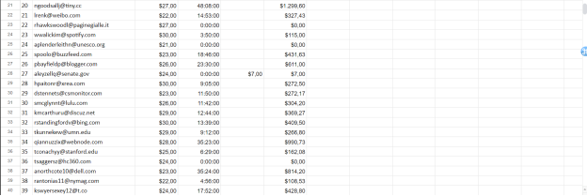

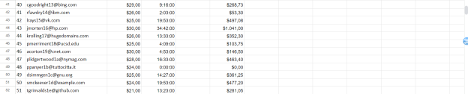*Figure 2.1, 2.2, 2.3: 50 Original Rows*

## 

## After testing

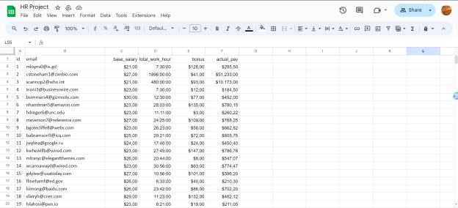

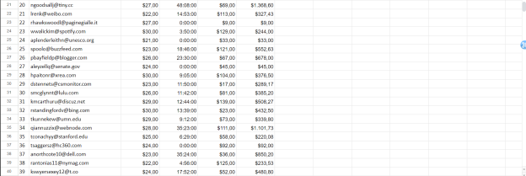

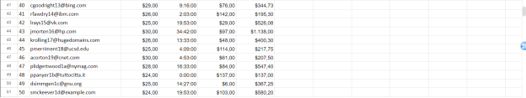*Figure 2.1, 2.2, 2.3: 50 Post-tested Rows*

We employed our database as our calculation module as well, we used the following formula to calculate our employee’s pay:

=(((LEFT(D2 ; FIND(":"; D2) - 1))+(MINUTE(D2)/60))*C2)+E2

After testing, all the rows have been calculated correctly and this quality passed our defined threshold.

## Quality 3: Employee’s information updates should correctly appear on the screen.

## Testing measure: Verify the displayed information on the website against the database.

## 

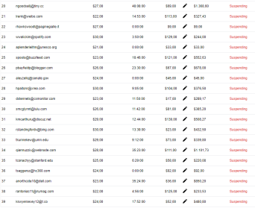

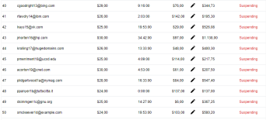

*Figure 2.4, 2.5, 2.6: Displaying of payroll on website*

## With the database’s pay calculated, we can take a look at the website to see how it displayed the data, and as can be seen, all the 50 rows have been updated correctly.

## Employees’ information has also been correctly displayed in the employee’s management tab:

## 

## *Figure 2.7: Employee’s information in Database*

## 

## *Figure 2.8: Employee’s information on Website*

## 

## With the website displaying the correct information within the database, this quality passed our benchmark.

## 

## Quality 4: Employee's information should be recorded correctly within the database.

## Testing measure: Make 20 employees updates on the website and observe their data in the database.

## 

## *Figure 2.9: First 20 employees*

## 

## 

## *Figure 2.10, 2.11: Update, Confirmation Prompt and Amount*

## 

## *Figure 2.12: After update on Website*

## 

## *Figure 2.13: Information in Database*

## The information written on the website matches that of the database, hence, the accuracy is correct, and this quality passed our benchmark.

## 

## Quality 17: The website should display and run as expected on various browsers.

## Testing measure: Run the HRM website on Opera, Chrome, Coc Coc, Firefox, Brave, and Edge, and note any differences or issues.

## Opera:

## 

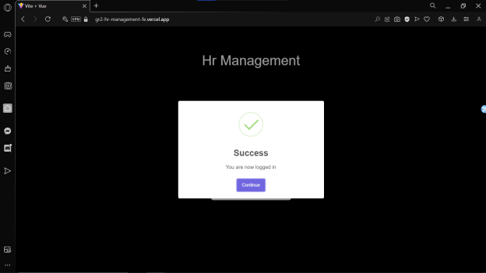

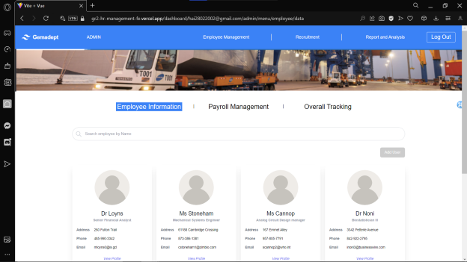

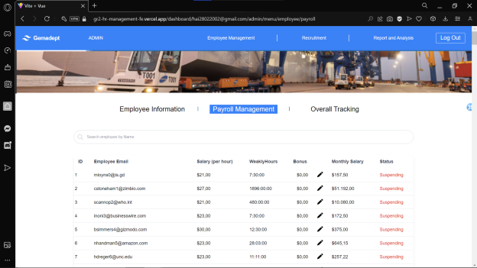*Figure 2.14 – 2.17: Website on Opera Browser*

## Google Chrome

## 

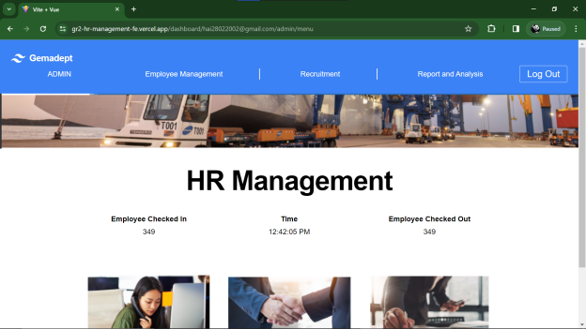

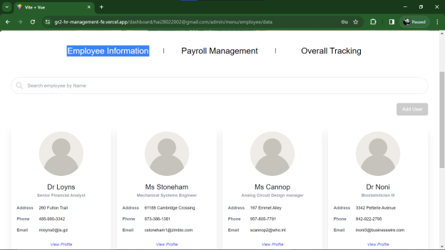

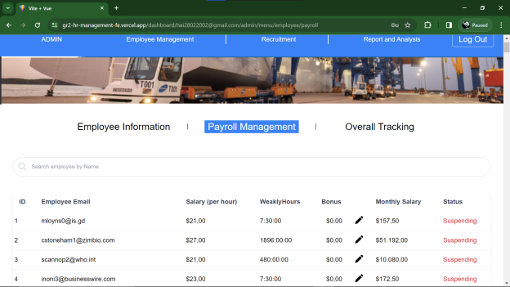*Figure 2.18 – 2.21: Website on Google Chrome*

## 

## Coc Coc:

## 

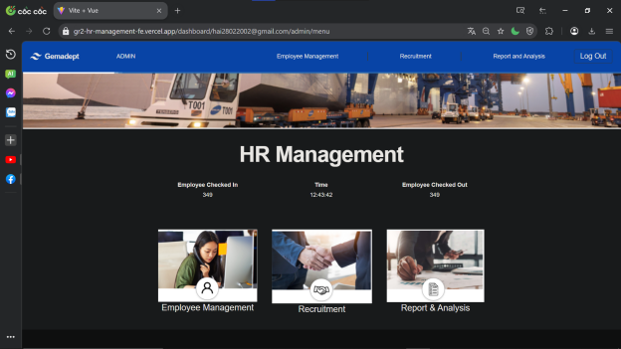

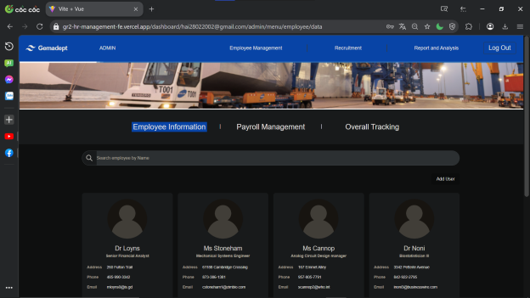

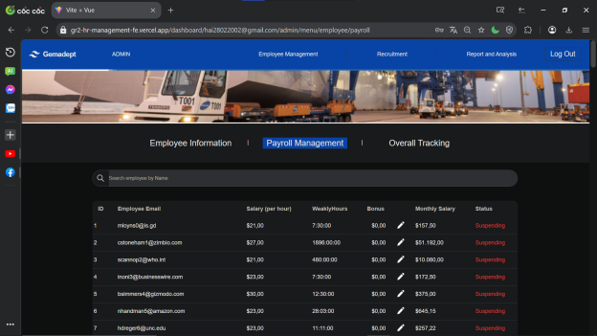*Figure 2.22 – 2.25: Website on Google Chrome*

## Firefox:

## 

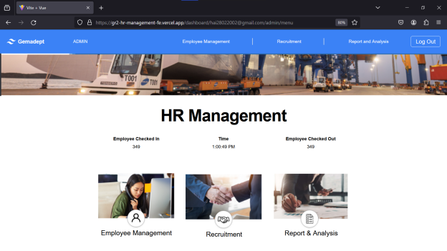

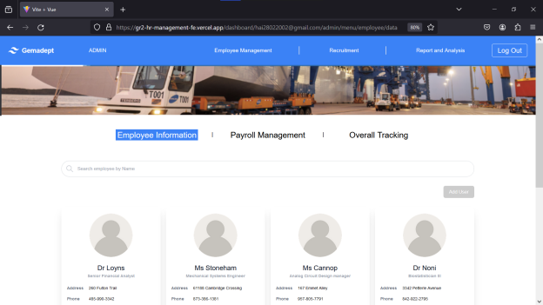*Figure 2.26 – 2.29: Website on Firefox*

Brave:

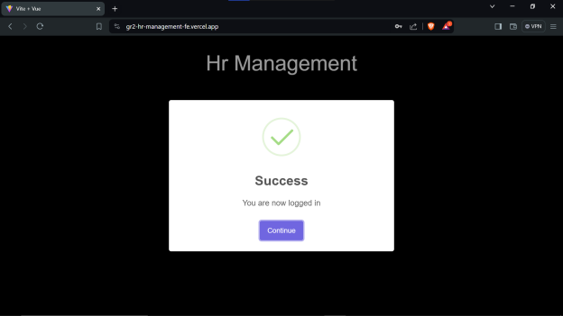

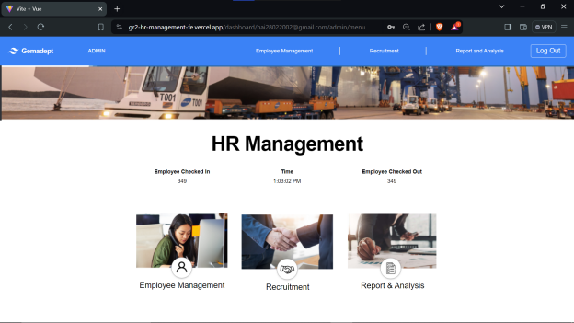

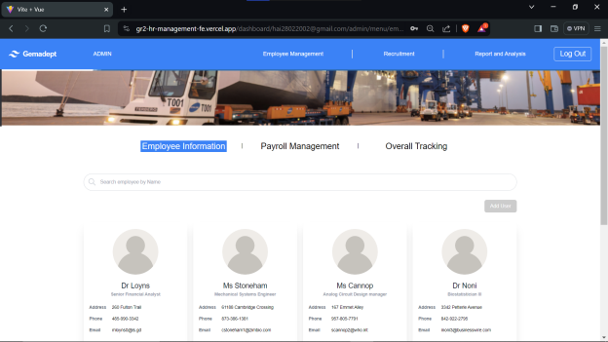

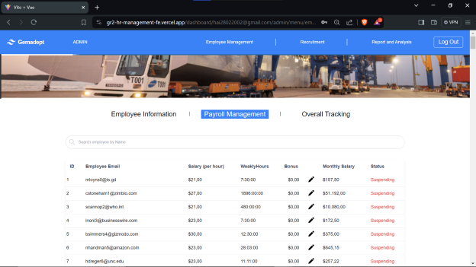*Figure 2.30 – 2.33: Website on Brave*

Edge:

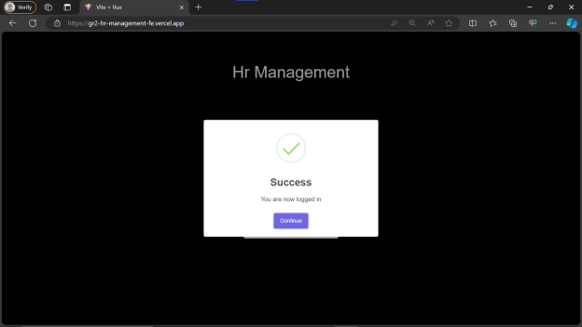

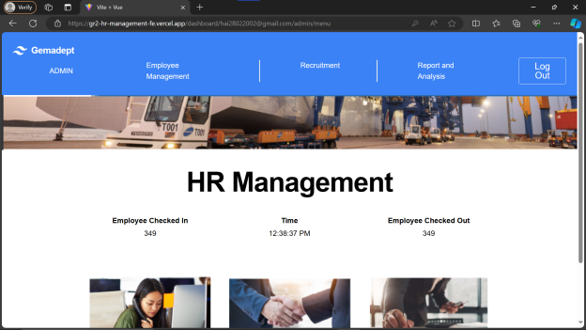

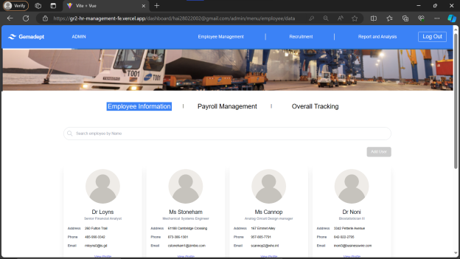

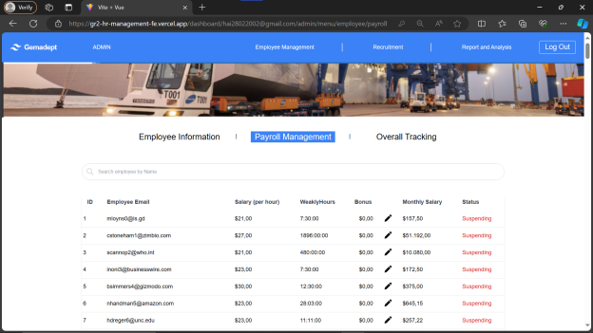 *Figure 2.34 – 2.37: Website on Edge*

We tested login in and other tests on various browser and our website held itself well. Hence, this quality passed our benchmark.

**Group 2: Search and Input**

**Quality 6**: The database searching and filtering options should return the correct result.

**Testing measure**: Use the search function with a variety of keywords and random words to note the displayed information.

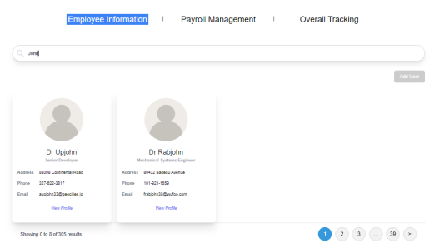

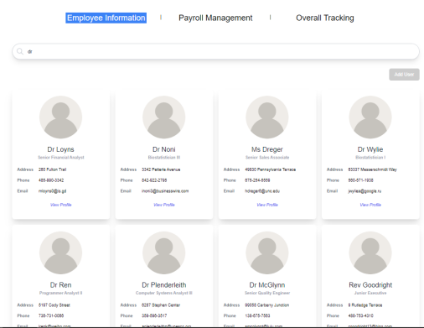

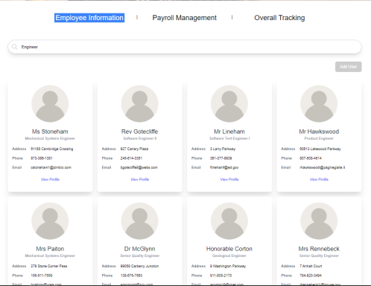

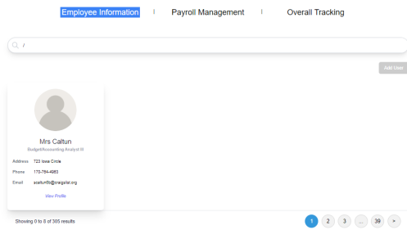

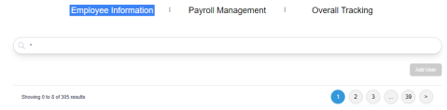

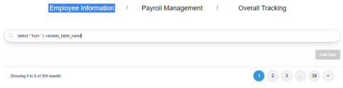

*Figure 2.38 – 2.43: Testing search query*

We tested the website’s query with a variety of input from words, names, to special characters, and as can be seen, the search returns accurate results and does not allow special characters, hence this quality passed our benchmark.

**Quality 12**: Proper input sanitization should be checked to prevent code injection or unintended characters. Additionally, handling of special characters, whitespace, and input encoding should be validated.

**Testing measure**: Test all input fields on the website against 20 different test cases of varying error.

## 

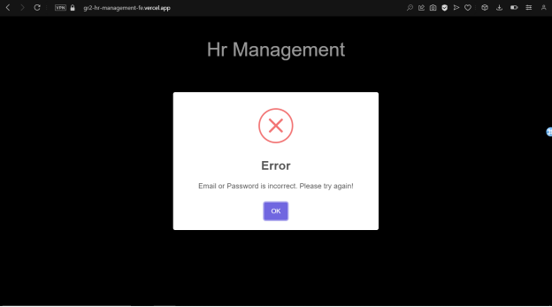

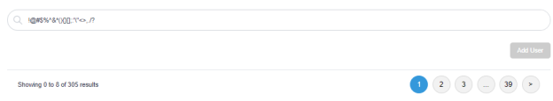

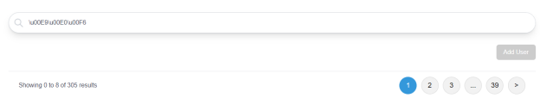

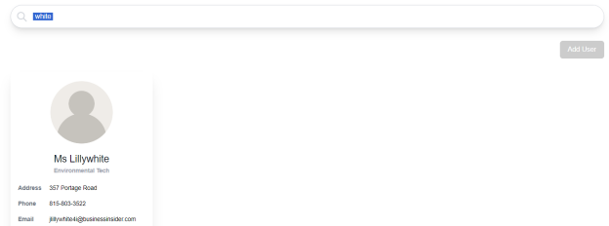

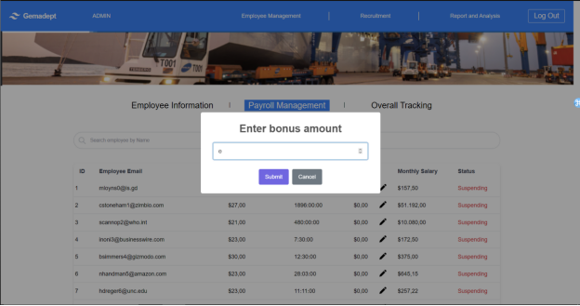

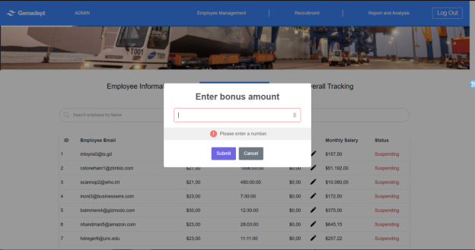

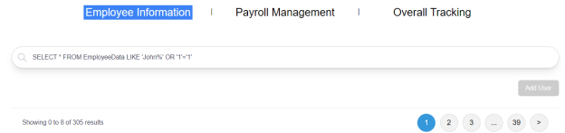*Figure 2.44 – 2.51: Input Testing*

After testing, we can see that our input has passed a good number of test cases, and those with severe priority are addresses. Hence, this quality passes our benchmark.

**Group 3: Other Tests**

**Quality 14**: Error messages should be displayed when invalid data is entered, providing clear instructions on how to correct them.

**Testing measure**: Wrongly execute any input and observe whether error messages appear.

## 

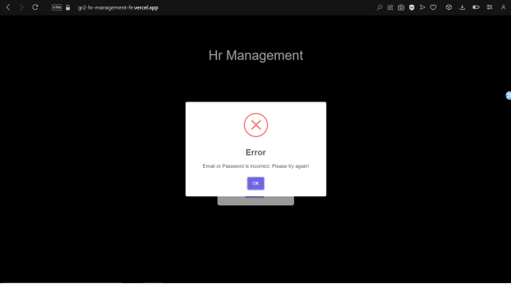



*Figure 2.52 – 2.55: Instruction Testing*

The invalid text prompt is correctly showing on our website. Hence this quality passed out benchmark.

**Quality 16**: API connection to other services (i.e., existing ERP, Google sign in, etc.) should have little error.

**Testing measure**: Intentionally disrupt network connectivity during an ongoing API request and verify that the system handles the timeout or connection failure gracefully.

## 

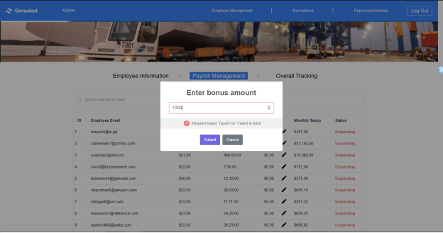

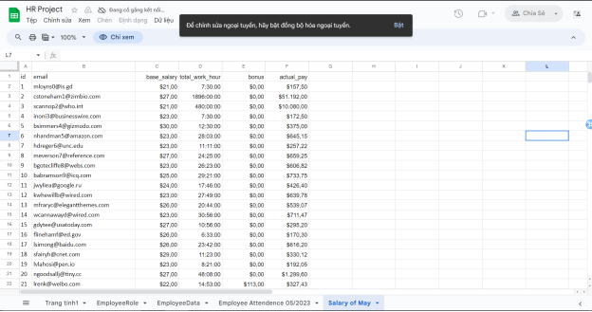*Figure 2.56 – 58: API connectivity check*

We tested the API connectivity by disconnecting the device from the internet and attempted to add information on the website. As can be seen, the API failed to fetch, and data was not added to the database. This quality hence passed our benchmark.

**Report**

So, we were able to conduct quality testing for 6 out of 17 of our quality tests that were defined in the previous document. This means that we have yet to achieve the substantial amount of quality that was defined, and our product is lacking a significant amount. Moreover, some important and urgent quality has not been done.

The reason that we have not completed all the quality defined is due to the fact that our sprint was originally planned to be as long as 21 days, but we have only done 10 days of work as of this period of time. Hence, we can state that our backlog item (HRM website) does not satisfy the quality requirements defined.

**3. Rationale and Analysis**

**What Worked:**

* **Clear Task Definition**: The sprint backlog items, in my opinion, had well-defined goals and acceptance criteria. This helps teamwork become better while also making tasks in the sprint easier to follow through.
* **Achievable Thresholds**: We created achievable thresholds for our sprint goals and adhered to the SMART framework, so we had reasonable goals to strive for. Which adds to our ability to achieve a lot of quality in a limited amount of time.
* **Efficient Communication**: We had multiple channels of communication, which became very useful for exchanging ideas, solutions and urge one another to do tasks.

**What Did Not Work:**

* **Rushed Development**: As we had to do our sprint in a timeframe lower than what was planned, development activities were rushed, which leads to some compromission in code quality and could potentially introduce defects.
* **Inefficient Time Allocation**: With a limited timeframe, time was not always allocated efficiently, which results in delays or unfinished tasks towards the end of the sprint.
* **Too Many Qualities**: We tried to achieve too many quality metrics at the same time and may have stretched the team’s focus too thin.

**Future Recommendations:**

* **Improved Time Management**: We believe that we should put time tracking and task prioritizing strategies into practice. Which will hopefully help avoid last-minute rushes, and divide work into smaller, more manageable chunks and allot time wisely.
* **Quality Over Quantity**: We need to focus on tasks that have a higher priority first (e.g., urgent, and important task). We believe that would help us to concentrate efforts on key quality aspects, and the team can deliver more impactful results within the sprint timeframe, while putting the less important task for later.
* **Continuous Improvement**: As a team, we should strive for greater growth by valuing input, introspection, and using lessons from the past. To assess sprint performance, pinpoint areas for improvement, and execute iterative modifications to improve procedures and practices, more meetings are held.

## TASK 081HD: Software Project Planning, Design and Quality Management

**Project Proposal: *Cloud-based work planner and organizer system***

**1. Background / Problem Description**

Task management is critical in today’s world, from studying to working it is crucial that we keep track of our tasks, progress and development in order to manage our time and resources in the most efficient way possible. However, traditional methods of task tracking like paper based or standalone software introduces drawbacks that limits scalability and collaboration with other people; which is why our project proposed a cloud-based task planner and tracking system that would allow stream-lined management processes and enhanced collaboration within teams and organizations.

**2. Scope**

**2.1 Objectives:**

The cloud-based planner app will assist in the steam-lining management process as it allows users to organize tasks, track progress, and manage deadlines effectively. This can be achieved as users can create, group and categorize projects based on their relativity or priority. The app will allow for collaboration between users which would facilitate increased collaboration and we aimed to have it working on both mobile and desktop which will aid in the overall productivity. Another notable objective we aimed for is deadline notification, which will notify users about tasks that are about to be due shortly.

2.2 Solutions:

To achieve the objectives listed, this software will include but not limited to these key features:

● Task Organization: Allow users to categorize and prioritize tasks via task groups, priority, or category, etc.

● Collaboration: Enable users to share tasks and projects with one another, assign tasks to team members, and track collaborative progress.

● Progress Tracking: Provide tools (checklists, progress bar, etc.) for users to track the progress of their tasks and projects, completion percentages, and milestone tracking.

● Integration: Integrate with other tools, plug-ins and platforms commonly used for productivity, like email, calendar apps, or communication tools like Slack.

● Customization: Offer customization options for users, which could include customizable task fields, color-coding options, or the ability to create custom task templates.

● Mobile Accessibility: The planner should be accessible on mobile devices via website or mobile app.

● Notifications: Provide customizable notification via email or in-app notifications settings to remind users of upcoming deadlines, task assignments, or changes to tasks.

3. Stakeholders

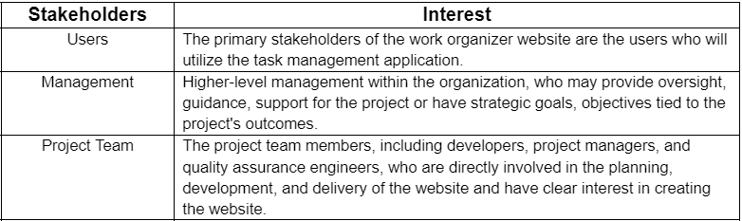

4. Deliverable and schedule

Schedule:

This project is expected to take around 2 weeks (10 working days) to complete, while the maintenance support will be an on-going process. The timeline for each stage (from designing to implementation) of the project is outlined as follow:

System Design and Prototyping: 1 day.

Development and Testing: 7 days.

Fine tuning and Implementation: 3 days.

Post-implementation support and maintenance: On-going from go live date

Initial Release Schedule of the Product backlog items

| No. | Item | Dependencies | Business Value  (1 least – 10 most) | Release Schedule  (Sprint 1 | 2 | 3 | …) |
| --- | --- | --- | --- | --- |
| F1 | Website design and wireframe. | None | 9 | Sprint 1 |
| F2 | Basic website with task card creation function. | None | 8 | Sprint 1 |
| F3 | Feature to hold tasks card defined. | F2 | 7 | Sprint 1 |
| F4 | Urgency assigned for tasks. | F3 | 7 | Sprint 1 |
| F5 | Signup and Login feature | F2 | 8 | Sprint 1 |
| F6 | Feature to set deadlines to tasks. | F2, F3 | 7 | Sprint 2 |
| F7 | Email users on impending deadline feature. | F3, F4 | 9 | Sprint 2 |
| F8 | Further customization options (background, color, ec.) | None | 5 | Sprint 2 |
| F9 | Feature to assign users to different tasks. | F2, F3, F5 | 8 | Sprint 2 |
| F10 | Integration with Google calendar. | F5, F9 | 7 | Sprint 3 |
| F11 | UAT Testing and suggestion collection. | After all prior product | 7 | Sprint 3 |
| F12 | Back and front-end thorough testing. | F11 | 8 | Sprint 3 |
| F13 | Final bug fix and documentation. | F12 | 9 | Sprint 4 |
| F14 | Go live and ongoing maintenance | F13 | 10 | Sprint 4 |

Business value rationale:

| Sprint | Item | Business Value | Reasons |
| --- | --- | --- | --- |
| Sprint 1 | Website design and wireframe. | 9 | Essential for setting the overall tone and impression of the website. |
| Sprint 1 | Basic website with task card creation function. | 8 | Forms the backbone of the website's core functionality. |
| Sprint 1 | Feature to hold tasks card defined. | 7 | Fundamental to the website's purpose and usability. But is less significant as it is a feature, not backbone. |
| Sprint 1 | Urgency assigned for tasks. | 7 | Enhances efficiency in task management and prioritization. But is less significant compared to other items in the sprint. |
| Sprint 1 | Signup and Login feature | 8 | Essential for user authentication and engagement. |
| Sprint 2 | Feature to set deadlines to tasks. | 7 | Promotes time management and productivity. But is less significant as it is a feature, not backbone. |
| Sprint 2 | Email users on impending deadline feature. | 9 | Significantly enhances user engagement and task completion. |
| Sprint 2 | Further customization options (background, color, ec.) | 5 | While adds value in user satisfaction, not critical to core functionality. |
| Sprint 2 | Feature to assign users to different tasks. | 8 | Facilitates collaboration and delegation, essential for team-based projects. Foster collaboration, one of the key (but not the most important) feature |
| Sprint 3 | Integration with Google calendar. | 7 | Synchronizes tasks and deadlines with a widely used calendar platform. But is less significant compared to other items in the sprint |
| Sprint 3 | UAT Testing and suggestion collection. | 7 | Ensures functionality and usability meet user expectations. Significant, but need completion from other features in the sprint. |
| Sprint 3 | Back and front-end thorough testing. | 8 | Crucial for reliability, performance, and user experience. |
| Sprint 4 | Final bug fix and documentation | 9 | Ensures stability, maintainability, and smooth transition to a live environment. |
| Sprint 4 | Go live and ongoing maintenance | 10 | Critical for launching a website and ensuring continued operation and improvement. |

Work Breakdown Structure:

We will use the Work Breakdown structure to estimate the effort it will take to develop our first sprint of the project. As we have 2 weeks to complete the project, and each person will work at most 8 hours per week which leaves us with 64 hours to plan our project.

As the first sprint has the most number of products with a great degree of complexity, half of the effort will be put into developing this sprint. This is because the subsequent sprint relies on this sprint as the backbone, hence, its completeness is the utmost priority. So 34 hours will be put into the first sprint, while the remaining 30 hours will be spread between the other 3.

## TASK 082D: Software Development Methodology Comparison

**Title of the article**

**Scrum is better than CPM – a case study of a software project “HRM system with Biometric Attendance”.**

**Nguyen Dinh Nhat Minh**

**Student id 103802490**

**103802490@student.swin.edu.au**

# Abstract

This essay attempts to compare the effectiveness of Scrum, an agile software development approach versus a traditional approach to software project management, the Critical Path Method. The comparison will be achieved by applying scum or CPM to address challenges or enhance development management within a case study of a project named HRM system with biometric attendance. The effectiveness of the scrum methodology when it comes to the modern software development process outweighs that of the traditional Critical Path Method because the scrum agile methodology shines in terms of increasing adaptability, changes responsiveness, and collaboration between different parties.

# 1. Introduction

Building a software involves a lot of elements, from planning the scope to developing a product, these elements can contribute to making the cycle of software development complex as the duration of the project goes on and tasks start increasing. Hence, it is of the utmost importance that the project management bodies select and use the right Software Development Life Cycle models to devise a plan that would accommodate their project effectively [1, 2].

Within this essay, we will attempt to discuss how the scrum and CPM approach aid in addressing the challenge brought about by a software project, which is the case study that will be used as our analysis medium title: “Human Resource Management system with Biometric Attendance” or HRMwBA in lieu of a better acronym.

# 2. Background

## 2.1 Software Project "HRMwBA":

The project HRMwBA is a web-based application development project created to address the need for stream-lining human resources management within the Gemadept corporation. The application will consist of all the human resource management needs from payroll, employees information tracking, to timely visualised report on the employee’s progress.

This application will be further improved by adding a fingerprint scanner-based biometric attendance system. With the use of this technology, the HR department can precisely track when employees clock in, which makes it possible to calculate their actual work hours for a variety of purposes, including payroll and performance reviews. As a result, this is an improvement over conventional HRM systems, where regulation is lax, and attendance is frequently not formally documented.

The objectives set the stage for the team coming up with the features that would satisfy the requirement for this project:

● Employee Information Management.

● Recruitment and Applicant Tracking.

● Onboarding and Offboarding.

● Payroll Management.

● Time and Attendance Tracking.

● Reporting and Analytics.

● Performance Management.

● Learning and Development.

● Integration with Existing Systems.

These features are expected to be achieved in a period of 4 sprints each lasting around 4 weeks (21 days) and have around 5 to 6 products to be done. As of the time of this research, our team had successfully developed our first sprint and created a usable first version of the product.

## 2.2 Overview of Scrum:

A method that is based on the agile framework, scrum according to Schwaber and Beedle [3] is an empirical approach that reintroduces flexibility, adaptability and increased productivity into system development. The Scrum process cuts through complexity and focuses exclusively on building software that meets business needs.

Scrum breaks a project down into iterations of fixed duration (one to four weeks) called Sprints. And personnel can assume one of the three main roles.

* Product Owner: responsible for the product vision represented by a Product Backlog.
* The Scrum / Delivery team: a group of people that is in charge of developing the software.
* The Scrum Master: guides the team through the process and helps the team to resolve issues that may occur.

Scrum gained its effectiveness [4] since it promotes regular inspection and adaptation through a variety of activities like frequent meetings and check ups to make sure everyone stays on progress, and work from everyone can be synchronized better. Moreover at the end of each sprint, retrospective review or sprint demo that would be used as reports on progress of the project.

These elements combined well with one another and create a very realistic, effective and efficient model that is loved by every project manager in the world.

## 2.3 Overview of Critical Path Method (CPM):

The Critical Path Method, a traditional software development methodology used to determine the critical path in a project’s network, project duration, and efficient use of resources. CPM is used to plan and manage complex projects with interdependent activities as it follows a sequential approach, meaning that in order to achieve one product, the prior product must be done first.

In CPM, the project is represented as a network of activities [5], each with its duration and dependencies on other activities. The critical path in a CPM is meant to figure out the longest sequence of activities that determines the minimum duration of the project, which means that the duration of the project is fixed and changes within any activities will directly translate to the project’s overall duration. Management bodies can leverage CPM’s critical path analysis to identify critical activities and allocate resources accordingly to ensure the smooth delivery of the project.

Just like any traditional project management framework, CPM would perform especially well in projects that have well defined scope and detailed plan from the get-go, or within an environment of robust communication and strong commitment [6]. Which is one of the reasons why software developed with this method does not have any extra features but does carry a higher chance of delivering software to clients.

# 3. Discussion

**3.1 Main Challenges of the Software Project:**

Throughout the development of the HRMwBA project, several challenges emerged like (1) *Tight deadlines* as we originally devised each sprint in our project to be 4 weeks long, however, due to time constraint, we must shorten the time to 2 weeks, which made our time get more tight. (2) *Expanded scope* because we are determined to incorporate one of our later sprint’s into the first sprint midway through the project, which made our scope for sprint 1 expanded a little. (3) *Rushed development* due to time constraints, hence, we must rush our website’s development. (4) *Knowledge deficit* among team members**,** as our team members studied IT, hence, we have little knowledge when it comes to human resource management, which is why it took us quite some time to research and develop a plan that would suit HRM business needs.

**3.2 Scrum's Approach to Addressing Challenges:**

It is not surprising to learn that scrum helped us address almost all of our problems with our HRMwBA project. Because we designed our product based on scrum's product backlog, we can adjust the priority of the products at any time during the project. Which allows us to develop the product sooner than planned.

*Figure 3.2.1: Original Product Backlog*

Figure 3.2.2: Adapted Product Backlog

We also apply scrum’s frequent meeting practice and conduct meetings twice to thrice a week to discuss what each member of the team is doing, and what news there to be had. This led to the team being able to adjust the time for each product as well as speed up the human resource research for all of us as we can exchange our findings to one another within those meetings.

*Figure 3.2.3: Meeting minute summary example*

**3.3 CPM's Approach to Addressing Challenges:**

The CPM analysis did help us combat the rushed development drawback of our project. By creating a work breakdown structure (WBS) we were able to determine the most critical product that needed to be done, and it helped us know what task we need to be doing, how long it should take, these elements and make our development move more smoothly.

*Figure 3.3.1: WBS for one of the product*

Even though this style of project management can pull through when detailed objectives are made, should we pursue this approach from the get-go, we would not be able to develop our website how we envisioned it and will slow down development as we need to progress each product step-by-step. Despite this benefit, it can be easy to overestimate or underestimate the time it could take to carry out any product, which makes time planning of this approach unrealistic at times [7].

**3.4 Comparison and Conclusion:**

Within the HRMwBA project, Scrum's characteristics like adaptability, flexibility, and its practice of regular discussion did create more work for us to do and expanded our original scope a little. However, it made up for this by addressing most of our main challenges with those same characteristics. In addition, this method allows us to develop our sprint’s product however we like and does not need to rely on complex dependencies of other products.

Even though CPM’s approach was not useless as it helped us pull through our rushed schedule with its scheduling, it does not prove as significant as Scrum. It was only taken into account when doing initial planning for each product (which changes as the project goes on) and diving head first into creating an intricate network of tasks and dependencies will be too complex and cost too much precious time and resources for our team.

# 4. Conclusion

Through the case study of the Human Resource Management system with Biometric Attendance, it's evident that the Scrum methodology outperforms the CPM approach due to its ease of use and other characteristics. Scrum's adaptability and simplicity make it well-suited for the rapid development of software [8], especially in our project's context. In contrast, CPM's reliance on extensive planning and complex task networks does not align well with the dynamic nature of today's software development landscape and our project's specific needs.

# References

[1] R. S. Pressman, *Software Engineering: A Practitioner’s Approach*. McGraw-Hill Science, Engineering & Mathematics, 2010.

[2] R. K. Wysocki, *Effective Project Management : Traditional, Agile, Extreme.* Somerset: Wiley, 2011.

[3] K. Schwaber and M. Beedle, *Agile Software Development with Scrum*. Pearson, 2002.

[4] C. Scharff and R. Verma, “Scrum to support mobile application development projects in a just-in-time learning context,” *Proceedings of the 2010 ICSE Workshop on Cooperative and Human Aspects of Software Engineering - CHASE ’10*, 2010, doi:<https://doi.org/10.1145/1833310.1833315>.

[5] J. E. Kelley and M. R. Walker, “Critical-path planning and scheduling,” *Papers presented at the December 1-3, 1959, eastern joint IRE-AIEE-ACM computer conference on - IRE-AIEE-ACM ’59 (Eastern)*, 1959, doi:<https://doi.org/10.1145/1460299.1460318>.

[6] P. A. Hofmann, “Critical Path Method: An Important Tool for Coordinating Clinical Care,” *The Joint Commission Journal on Quality Improvement*, vol. 19, no. 7, pp. 235–246, Jul. 1993, doi:<https://doi.org/10.1016/s1070-3241(16)30004-9>.

[7] M. Lu and H. Li, “Resource-Activity Critical-Path Method for Construction Planning,” *Journal of Construction Engineering and Management*, vol. 129, no. 4, pp. 412–420, Aug. 2003, doi:<https://doi.org/10.1061/(asce)0733-9364(2003)129:4(412)>.

[8] P. Adi, “Scrum Method Implementation in a Software Development Project Management,” *International Journal of Advanced Computer Science and Applications*, vol. 6, no. 9, 2015.

## TASK 15P: Peer Review

**SWE30010 Managing IT Projects**

**Self and Peer Review Assessment Form [Sprint #1]**

Date: 26/3/2024

Your Team: Group 2 Your Name: Nguyen Dinh Nhat Minh

Use the instructions (see below) to fill in scores for each category A to J.

| Team Members (Name) | A | B | C | D | E | F | G | H | I | J | Total |
| --- | --- | --- | --- | --- | --- | --- | --- | --- | --- | --- | --- |
| Self | 3 | 3 | 2 | 2 | 2 | 3 | 4 | 3 | 3 | 2 | 2.7 |
| Nguyen Nhat Huy | 4 | 4 | 3 | 4 | 4 | 5 | 5 | 4 | 4 | 4 | 4.1 |
| Le Hoang Hai | 5 | 3 | 4 | 5 | 4 | 4 | 5 | 4 | 5 | 4 | 4.3 |
| Nguyen Ngoc Minh Thy | 3 | 3 | 3 | 3 | 5 | 4 | 4 | 4 | 3 | 4 | 3.6 |

**Your Reasoning / Justification** (You must write a paragraph about each team member below. Incomplete reviews will not be accepted.)

| **Name, student number** | **Comments (complete sentences required)** |
| --- | --- |
| Self | A basic leader, does enough for the team to strive. Can use improvement in time management and quality of work (writing, creating plan, etc.) can definitely use improvement. Overall, still achieve the necessary means that allow the team do their best. |
| Nguyen Nhat Huy | Huy is an excellent designer and writer, his contribution of fine tuning the structure of our assignments, creating quality mockups and suggest improvement of our writing had made our team’s quality increased. It is safe to say that Huy can benefit from managing his time better, and voicing his idea more to the group. All in all, he is a solid team player and emits a sense of professionalism in his work. |
| Le Hoang Hai | Hai’s is a fast thinker and contribute a myriad of ideas when facing any problems/tasks. He definitely fits the “do”-ers type of people as he had put a great emphasis on creating the codes for our project. Hai is a person that needs a positive environment in order to thrive, as the opposite could leads to his ineffectiveness. Overall, this guy had help push the process of doing assignment a ton faster and with his coding effort, made our task much faster and easier. |
| Nguyen Ngoc Minh Thy | Thy can be said to be the glue that holds our group together, should there be discourse among our self, she usually comes out and suggest finding the middle ground. She is also a fast and varied worker, able to deliver the finished any task thrown at her rather quickly. Thy can use some improvement in her quality of work, and discus troublesome tasks to the group. However, she proves to be agile, being able to work on various task and has a good sense of responsibility in her work. |

# 

# Group Tasks:

## TASK 02P: Scope and Product Backlog

**Synopsis**

Gemadept Corporation is a leading logistics and shipping company headquartered in Ho Chi Minh City, Vietnam. With a strong commitment to excellence, we are seeking a comprehensive Human Resource Management Software System to enhance our HR operations.

We would like to have a complete HR Management Software System that meets our specific requirements and integrates seamlessly with our existing systems. This system will be expected to streamline HR processes, increase efficiency, and improve employee management.

1. **Background**

Gemadept, a leading logistics and shipping company headquartered in Ho Chi Minh City, Vietnam, is requesting a HRM software to streamline HR processes, check attendance of employees, employee management, and improve overall organizational efficiency. The primary objective of this proposal is to introduce a robust Human Resource Management (HRM) system tailored specifically for Gemadept. This proposal aims to establish the creation of a comprehensive HRM infrastructure, spanning the stages of design, development, and maintenance.

1. **Scope**
   1. **Objectives:**

The main goal of this solution is to build a complete HRM system that is further improved by adding a fingerprint scanner-based biometric attendance system. With the use of this technology, the HR department can precisely track when employees clock in, which makes it possible to calculate their actual work hours for a variety of purposes, including payroll and performance reviews. As a result, this is an improvement over conventional HRM systems, where regulation is lax, and attendance is frequently not formally documented.

* 1. **Solutions:**

To achieve the objectives listed, this software will include but not limited to these key features:

* Employee Information Management: Centralized database for storing and managing employee data, such as personal details, employment history, and contact information.
* Recruitment and Applicant Tracking: Tracking of applied applications and managing the recruitment pipeline.
* Onboarding and Offboarding: Structured procedures for integrating new hires into the organization and managing the exit process for departing employees.
* Payroll Management: Adjustable automated calculation of employee salaries, deductions, and taxes.
* Time and Attendance Tracking: Uses a fingerprint scanner for monitoring employee attendance, tracking work hours, etc.
* Reporting and Analytics: Generation of customizable reports and dashboards to provide insights into employee’s information and status.
* Performance Management: System for setting performance goals, conducting evaluations, and providing feedback to employees.
* Learning and Development: Scheduling training sessions and tracking employee progress in skill development.
* Integration with Existing Systems: Integration with other business systems such as ERP and accounting software.

1. **Deliverables and schedule**
   1. **Deliverables Overview:**

Our goal is to develop a comprehensive prototype that includes both the HRM application and the fingerprint scanner. The application will be accessible via a website and will have the capability to store, update, and remove employee information. To ensure scalability, we will store data from both the website and the scanner in a scalable database.

* 1. **Schedule:**

This project is expected to take around 12 weeks (3 months) to completed and the timeline for each stage of the project is outlined as follow:

* System Design and Prototyping: 2 weeks.
* Development and Testing: 6 weeks.
* Implementation and Training: 4 weeks.
* Post-implementation support and maintenance: On-going from go live date.

**Initial Release Schedule of the Product backlog items**

| No. | Item | Dependencies | Business Value (1 least – 10 most) | Release Schedule  (Sprint 1 | 2 | 3 | …) |
| --- | --- | --- | --- | --- |
| F1 | Product UI/UX Design | None | 7 | Sprint 1 |
| F2 | Website for HRM | None | 9 | Sprint 1 |
| F3 | HR database schema design | F2 | 8 | Sprint 1 |
| F4 | Manager Portal | F1, F3 | 7 | Sprint 1 |
| F5 | Employee Feedback and Survey Module | F1, F3 | 6 | Sprint 2 |
| F6 | Employee information form implementation | F3 | 8 | Sprint 2 |
| F7 | Fingerprint scanner implementation/installation | F3 | 8 | Sprint 2 |
| F8 | Recruitment module development | F3 | 7 | Sprint 2 |
| F9 | Payroll calculation module development | F3 | 7 | Sprint 2 |
| F10 | On and Offboarding template implementation | F3, F6 | 6 | Sprint 3 |
| F11 | Leave request feature implementation | F3, F6 | 6 | Sprint 3 |
| F12 | Performance evaluation module development | F3, F6 | 6 | Sprint 4 |
| F13 | Implement reporting dashboard | F9 | 8 | Sprint 4 |

## 

## 

## TASK 04P: Solution Direction and Design

1. **SOLUTION DIRECTION**
   1. **Problem Domain**

An attendance management system is a cloud-based HR tech tool that enables organizations to automate their attendance management operations and keep track of employee working hours. It allows employees to mark their attendance through its website integrated with the biometric attendance system to sync attendance entries automatically. These attendance entries are centralized in a single system and can be accessed by HR teams from anywhere, at any time. The key aspects of the problem domain include:

* **Attendance Tracking and Accuracy**: Ensuring accurate recording of employee attendance, clock-ins, and clock-outs.
* **Integration with Payroll:** Seamlessly integrating attendance data with payroll systems.
* **Compliance and Legal Requirements**: Adhering to labor laws, regulations, and company policies related to attendance.
* **User-Friendly Interfaces:** Designing intuitive interfaces for employees to mark attendance and for HR teams to manage records.
* **Shift Scheduling and Management:** Efficiently managing employee shifts, rotations, and work schedules.
* **Biometric Integration and Security**: Integrating biometric systems (such as fingerprint or facial recognition) for attendance tracking.
* **Reporting and Analytics:** Generating insightful reports on attendance trends, absenteeism, and productivity.
* **Remote Work and Geolocation:** Managing attendance for remote workers and tracking geolocation-based clock-ins.
* **Employee Self-Service:** Empowering employees to view their attendance records, apply for leaves, and manage time off.

In addition to the core functionalities, the problem domain of HRM system also focuses on:

* **Security and Privacy**: Ensuring the protection of biometric data and preventing unauthorized access or misuse.
* **Device Maintenance and Calibration**: Regularly maintaining and calibrating biometric devices for accurate readings.
* **User Training and Adoption**: Educating employees effectively to maximize system utilization.
* **Handling Exceptions and Anomalies**: Addressing unexpected situations, system downtime, or disputes.
* **Data Retention and Archiving**: Properly storing and managing historical attendance records.
* **Scalability for Large Organizations**: Designing the system to accommodate workforce growth.
* **Real-Time Alerts and Notifications**: Promptly notifying HR of unusual attendance patterns.
  1. **Solution Domain**
     1. **The Discussion of Alternative Solutions**

In this section, we will explore different solution directions such as web-based applications, desktop-based applications, mobile applications or hybrid solutions (web + mobile). Considering the unique requirements of HRM and attendance management, we decided to develop a web-based application, other alternatives were discarded due to the following limitations:

| **Alternative** | **Discard reasons** |
| --- | --- |
| Desktop-based application | * Tie users to specific workstations, limiting their ability to work remotely or access HRM features from different devices. * Require manual updates on each machine where they are installed. * Attendance systems can be susceptible to time fraud, such as “buddy punching,” where employees clock in for absent colleagues. * Rely on local hardware and infrastructure, making them less flexible for distributed teams or remote work. * May lack the robust security features found in modern web or mobile apps. * Ensuring data security and privacy on individual workstations can be challenging. |
| Mobile application | * Mobile apps are vulnerable to malware, data breaches, and unauthorized access. * Mobile apps may not work on all devices (e.g., older phones, different operating systems). * Approval process and restrictions can be time-consuming. * Updates and compatibility issues across various devices. |
| Hybrid solution | * Integrating web and mobile components can be challenging. * Requires managing both web and mobile aspects. * Hybrid solutions may not perform as well as native apps. |

The Web-Based Application offers the best balance of flexibility, scalability, ease of maintenance, and security. It supports remote work, aligns with modern work practices, and has existing successful competitors. While other solutions have merits, the web-based approach provides the most comprehensive benefits for HRM and attendance management.

Besides, we will deploy the web-based approach on **AWS** instead of other hosting options, such as a dedicated server, or on-premises as it is requested by client, and AWS is also more flexible than other ways in many aspects:

| **Criteria** | **AWS** | **Dedicated server** | **On-premises** |
| --- | --- | --- | --- |
| **Cost** | Variable cost: Pay-as-you-go pricing based on usage. Initial setup costs may be lower. | Fixed cost: Requires purchasing or leasing dedicated hardware. Higher initial investment. | Fixed cost: Requires purchasing and maintaining hardware infrastructure. |
| **Scalability** | Highly scalable: Easily adjust resources based on demand. | Limited scalability: Hardware capacity is fixed. Scaling requires additional servers. | Limited scalability: Hardware capacity is fixed. Scaling requires new hardware. |
| **Maintenance** | Managed service: AWS handles maintenance, updates, and security. | Self-managed: You’re responsible for maintenance, updates, and security. | Self-managed: You’re responsible for all aspects of maintenance. |
| **Reliability** | Highly reliable: AWS data centers are distributed globally. | Depends on provider: Varies based on service level agreements. | Depends on organization: In-house infrastructure reliability. |
| **Flexibility** | Highly reliable: AWS data centers are distributed globally. | Depends on provider: Varies based on service level agreements. | Depends on organization: In-house infrastructure reliability. |
| **Deployment Time** | Quick deployment: Provision resources within minutes. | Moderate deployment time: Requires setting up and configuring hardware. | Longer deployment time: Procurement, setup, and configuration. |
| **Location Independence** | Global availability: Accessible from anywhere with an internet connection. | Dependent on server location: Limited to physical server location. | Dependent on office premises: Limited to local network. |
| **Security** | AWS provides security features: Encryption, firewalls, IAM, etc. | Depends on provider: Security measures vary. | Depends on organization: In-house security policies and practices. |

* + 1. **The KoST Analysis of My Knowledge**
       1. **Knowledge *(what you know)***

Required knowledge

* **Web-based application**: Proficiency in HTML, CSS, and JavaScript for creating user interfaces, knowledge of server-side programming languages such as Python, Java or Node.js
* **Desktop-based application**: Proficiency in C++, Java, and C#.
* **Hosting server**: Expertise in server management, networking, databases, and understanding of hosting services.
* **Biometric Integration**: Learn about integrating biometric devices (e.g., fingerprint scanners) with your application. Understand how to capture and process biometric data securely.
* **HR Management Basics**: Possess basic knowledge of HR management through engagement in volunteer operations involving personnel allocation and administration.

My team’s Knowledge

* All of our team have members that enrolled in two web development courses; hence, they can understand the basic understanding of HTML, CSS, JavaScript and PHP.
* Two of our team members had enrolled in IoT programming and can develop IoT related projects.
* Two of us were enrolled in the AWS architecture designing course. Which prompts understanding of networking, DBMS and hosting services.
* One team member is in the HR sector of a club. Which helps with our domain problem.
  + - 1. **Skills *(your experience)***

Required skills

Technical Skills:

* Understanding of responsive design principles.
* Ability to develop APIs for communication between front-end and back-end.
* Familiarity with database management (e.g., MySQL, PostgreSQL, or MongoDB).
* Understanding of server inspection and deployment into production environments.
* Knowledge of how to acquire necessary infrastructure (e.g., cloud hosting, virtual servers).
* Experience in creating intuitive and user-friendly interfaces for HRM applications.

Domain knowledge:

* Understanding of HR functions related to attendance tracking, leave management, and payroll.
* Understanding of the benefits and challenges of using biometrics for attendance management.
* Familiarity with HRM processes specific to attendance, employee records, and time tracking.
* Knowledge of how biometric attendance fits into the overall HR ecosystem.

My team’s skills

* All of us have created and hosted a few websites as our side and university projects.
* One of us had UX/UI designing experiences and is proficient in Adobe XD, Figma.
* Another one had created and managed databases using SQL developer by Oracle.
* The IoT proficient member had built various IoT machines that function well.
* We have had experience observing the HRM pipeline and process of a club.
  + - 1. **Technology *(existing solution)***

Various contemporary technologies and solutions can be leveraged to develop web-based HRM systems. Key among these are:

* **Proprietary HRM Software**: Esteemed companies such as SAP (SuccessFactors), Oracle (Oracle HCM Cloud), and Workday present comprehensive HRM suites encompassing diverse HR functions. These solutions typically include modules for core HR, talent management, workforce planning, payroll, benefits administration, and analytics.
* **Cloud-based HRM Platforms**: Scalable and adaptable solutions for managing HR processes are offered by cloud-based HRM platforms like BambooHR, Namely, Zenefits, and Gusto. These platforms commonly feature employee self-service portals, tools for onboarding and offboarding, performance management, time and attendance tracking, as well as compliance management.
* **Open-source HRM Solutions**: Flexibility and customization are core benefits of open-source HRM solutions, making them ideal for constructing web-based HRM applications. Well-regarded open-source HRM frameworks and platforms include OrangeHRM, Sentrifugo, IceHrm, and Odoo HR. These solutions provide modules for managing employee information, leave management, attendance tracking, and more.
* **HRM Modules within ERP Systems**: Enterprise Resource Planning (ERP) systems like Microsoft Dynamics 365 and SAP ERP often include HRM modules alongside other business functions such as finance, supply chain, and manufacturing. These integrated solutions provide a unified platform for managing HR processes within the broader context of organizational operations.

**Rationale**

After a gap analysis using the KsoT framework and a comparison analysis of several solutions, the following factors suggest that creating a web application is the best course of action for this project:

* Web-based apps can be easily integrated and blended in with the existing system because they are easily accessible from a variety of devices and have an intuitive interface.
* The platform can grow to meet the needs of its users thanks to the scalability features offered by Firebase and Google cloud.
* Our team is fairly competent in producing a project this scale.
  + 1. **Final Solution**
* The HRM application will be developed as a web-based application with a front-end built with Vue JS and a back-end utilizing a combination of Node Js and Express Js.
* The HRM Application will be developed using Nginx Web Servers, with Firebase hosting the back end. This combination will ensure the necessary scalability and reliability for this project.
* Google Spreadsheet on Google Cloud will be utilized to store user data due to its exceptional capacity to manage vast amounts of data. Additionally, Google's security and compliance measures are of the highest caliber, helping to safeguard critical user information.

1. **Architecture Design**
   1. **3-Tier Architecture**

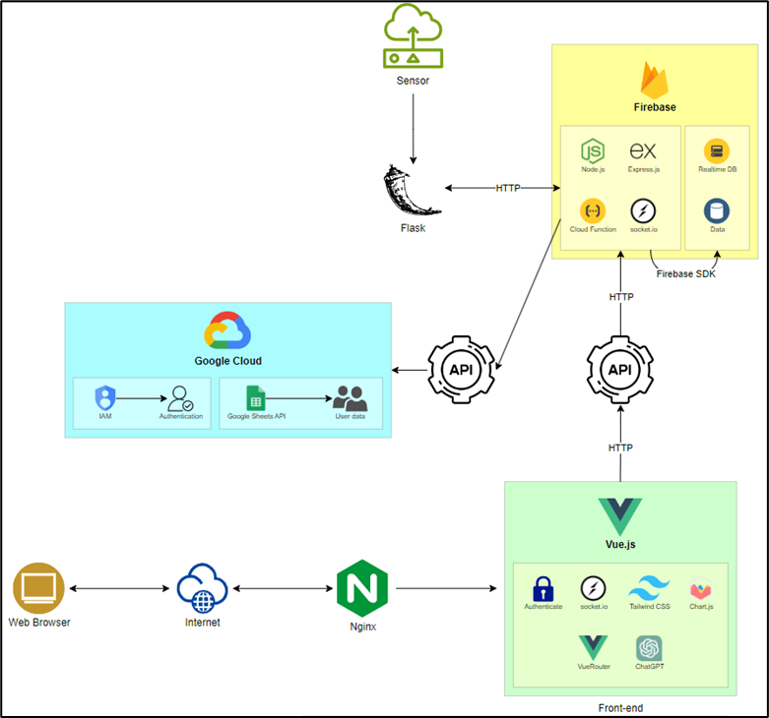

*Figure A: 3-tier Website Application Design*

**TIER 1**: **PRESENTATION**

* Cloudflare: Provides secure DNS and website optimization services.
* Vue.js: A progressive JavaScript framework for building user interfaces.
* Vue Router: For client-side routing within the Vue.js application.
* Vuex: State management library for Vue.js applications.
* Vue Auth: Authentication library for handling user authentication.
* Socket.io: Enables real-time client-server communication for notifications.
* Tailwind CSS / Bootstrap: CSS frameworks for styling user interfaces.
* Chart.js: JavaScript library for creating charts and graphs.

**TIER 2: APPLICATION**

Application 1:

* Flask: A micro web framework written in Python.
* Biometric Attendance: Module for retrieving employee attendance using biometric data.
* Flask API: Creates APIs to facilitate communication between servers.

Application 2:

* Node.js: A JavaScript runtime environment for executing server-side code.
* Express.js: A web application framework for Node.js.
* Socket.io: Enables real-time server-client communication for notifications.
* RESTful API: Provides endpoints for interacting with the application.
* Real-Time Database (RTDB): Firebase's NoSQL database for real-time data storage, suitable for IoT data.
* Google Spreadsheet: Integration with Google Sheets for data storage.
* IAM Service: Registers and manages access permissions for connecting to Google Sheets.

**TIER 3: DATABASE**

* Google Spreadsheet: Google Sheets used as a database for storing structured data.
* Real-Time Database (RTDB): Firebase's NoSQL database for real-time data storage.
  1. **UML DESIGN**

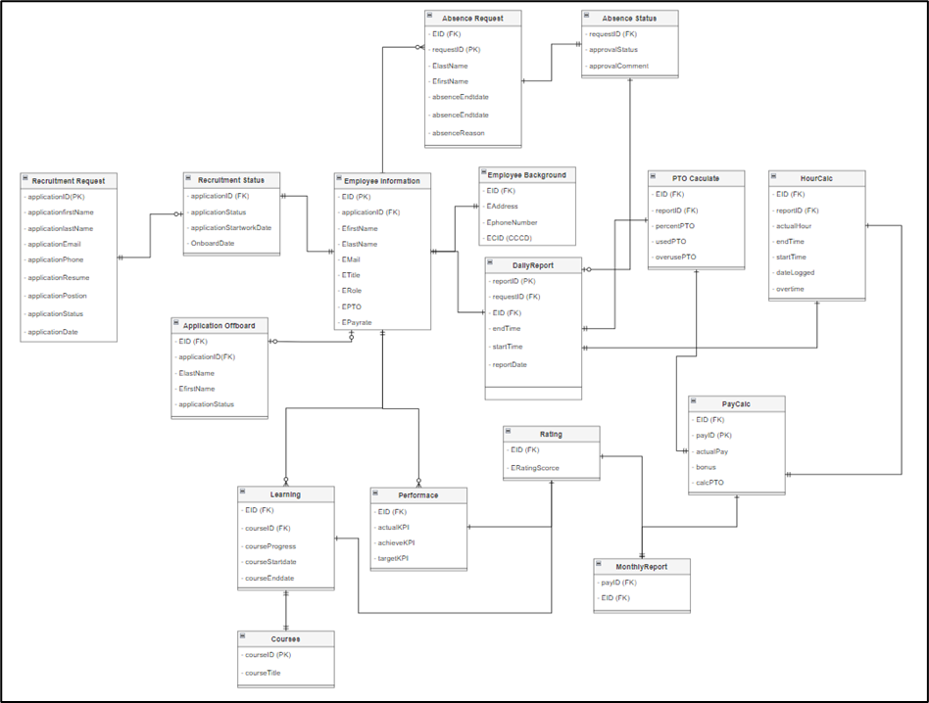

*Figure B: UML Design*

## TASK 06P: Software Quality and Definition of Done

1. **QUALITY MANAGEMENT**
   1. **What is Quality?**

Within the framework of this HR management system with a biometric attendance project, a "quality" platform is defined as the ultimate platform that satisfies all of the client’s criteria. The following is a summary of these requirements:

1. **Technical requirements**

* The system should seamlessly integrate with biometric devices (such as fingerprint scanners, iris recognition, or facial recognition cameras) to capture employee attendance data, ensure compatibility with various biometric technologies and models.
* Store and manage employee data, attendance records, and biometric templates securely in a database, implement efficient data retrieval and update mechanisms.
* Utilize TCP/IP, wireless, fiber, or copper networks for data transfer between biometric devices and the central system.
* Design the system to handle a growing number of employees and devices.

1. **Functional Requirements**

All core functionalities of the Biometric Attendance system can work efficiently and do not have any severe errors that corrupt the system. Core functionalities include:

* Biometric Attendance Tracking
* Employee information Management and Leave Management
* Payroll Integration
* Reporting and Analytics
* Security Enhancement
* Time check and attendance
* Performance and Development tracking.

1. **Non-Functional Requirements**

* Ensure data privacy and protection of biometric templates, implement encryption during data transmission and storage, prevent unauthorized access.
* Maintain high system availability (uptime) to avoid disruptions, regularly back up data and enable efficient recovery mechanisms.
* Response time for biometric authentication should be fast, handle concurrent requests efficiently and correct.
* Provide user manuals, technical guides, and change logs, document system architecture and design.
  1. **What is Quality?**

The Definition of Done (DoD) checklist can be used to assess the quality of Biometric Attendance system development. Before software development is considered complete, this checklist consists of a set of conditions that have to be met. There are several items on the DoD checklist before the release, including:

* Core functionalities development: The platform must be constructed with all of the essential features listed in the project proposal. Both automated test cases and manual tests can be used throughout the testing process.
* Usability and Scalability: Consider factors like reaction time and resource usage while assessing the software's performance under workloads. Verify that the system is capable of handling an unexpected increase in workload.
* Code Quality and Conventions: Verify that the code complies with the requirements for readability, maintainability, naming conventions, and code structure.
* Security: Verify if the platform followed the necessary data protection and authentication guidelines. Performing security testing, reviewing protocols, and reviewing IT policies and documentation are all part of this process.
* Testing and Documentation: Conduct unit testing to verify individual components, integration testing to validate interactions between modules, and user acceptance testing (UAT) involving end-users.
* UX/UI Testing: Make that the UI is responsive, easy to use, and visually consistent. It ought to satisfy every design criterion listed in the proposal.

There are several methods and metrics for assessing quality when it comes to measuring. As a result, the measuring process is standardized in many quality models. IEEE 1061, COSMIC, ISO/IEC 9126, and ISO 25010 are a few of the widely used models. Whichever quality evaluation technique is selected, the DoD Checklist's evaluation criteria must be properly formatted, comprehensible, and appropriate. The DoD can be improved by using S.M.A.R.T. concepts.

1. **CHECKLIST**

When using ISO 25010 as a framework for an HRM (Human Resource Management) project, you would tailor your project's definition and goals to address these quality characteristics in the context of HRM software or systems. For example:

* **Functional Suitability**: Ensuring that the HRM software provides all necessary functions to support HR processes such as recruitment, employee onboarding, performance management, and training.
* **Performance Efficiency**: Ensuring that the HRM software performs tasks such as data processing and report generation within acceptable time frames and with minimal resource consumption.
* **Compatibility**: Ensuring that the HRM software can integrate with existing systems such as payroll software, time-tracking systems, and enterprise resource planning (ERP) systems.
* **Usability**: Ensuring that the HRM software is user-friendly and intuitive, allowing HR professionals and employees to easily navigate and perform tasks within the system.
* **Reliability**: Ensuring that the HRM software operates reliably without frequent crashes or errors, especially during critical HR processes.
* **Security**: Ensuring that the HRM software protects sensitive HR data such as employee personal information, payroll details, and performance evaluations from unauthorized access or modification.
* **Maintainability**: Ensuring that the HRM software can be updated and modified efficiently to accommodate changes in HR policies, regulations, and business requirements without introducing bugs or issues.
* **Portability**: Ensuring that the HRM software can be deployed across different hardware and software environments, such as on-premises servers or cloud platforms, with minimal effort and modifications.

| **No.** | **(Sub) Characteristics** | **Description** | **Y/N** |
| --- | --- | --- | --- |
| **1. Functionality Suitability** | | | |
| 1.1 | Functional Appropriateness | Deploy the platform on the cloud-based hosting server |  |
| 1.2 | Functional Appropriateness | The platform allows user creation for 2 account types: Admin account and employee account |  |
| 1.3 | Functional Appropriateness | The platform allows users to switch between different languages. All content, messages, and alternative text are translated correctly |  |
| 1.4 | Functional Appropriateness | The data analytics tool can generate reports with meaningful insights from the data into visualized format on the website. |  |
| 1.5 | Functional Appropriateness | The platform's core functionalities can integrate with external systems, such as current database, existing ERP system with less than 5% of API conflicts |  |
| 1.6 | Functional Appropriateness | The data analytics tool is integrated with the feedback mechanism to analyze manager feedback to employee |  |
| 1.7 | Functional Correctness | The number of errors of each core functionality of the HRM should be less than 5% of total automated test cases |  |
| 1.8 | Functional Correctness | During the account registration process, important fields such as name, password, and email are required |  |
| 1.9 | Functional Correctness | Employee’s information updates correctly appear on the screen |  |
| 1.10 | Functional Correctness | The database searching and filtering options return the correct result |  |
| 1.11 | Functional Correctness | When calculation is made upon any one of the modules, the other with the related attribute must also update correctly. |  |
| 1.12 | Functional Correctness | Different test cases are performed to prevent XSS, exploiting URLs |  |
| 1.13 | Functional Correctness | Dashboard chart should be use properly to show a clearly details of user information |  |
| 1.14 | Functional Completeness | Manager can generate an user report of their attendance each month with a provided sample template with one click |  |
| 1.15 | Functional Completeness | Use the authenticated token to fetch the user details from the system, including user ID, role, and history information. |  |
| 1.16 | Functional Completeness | An process to verify if the authenticated token is expired or not, then alert user to login/ refresh token again |  |
| 1.17 | Functional Completeness | Use the authenticated token to fetch the order details from the system, including order ID, payment information, and shipping methods. |  |
| 1.18 | Functional Completeness | Perform a JWT authentication to obtain a valid token for the user who login the system |  |
| **2. Performance Efficiency** | | | |
| 2.1 | Time Behaviour | The following actions have a response time of less than 5 seconds:   * Display a list of employees. * Calculate and estimate the payroll. * Display dashboard for admin/ user role. * Show user information. * Generate report. * Login/Logout. |  |
| 2.2 | Time Behaviour | The loading time of pages is less than 5 seconds. |  |
| 2.3 | Resource Utilization | The CPU utilization when running the platform is below 80% and memory consumption is below 70% |  |
| 2.4 | Capacity | The application can handle a 1,000 employee test case without losing 30% of the performance. |  |
| **3. Compatibility** | | | |
| 3.1 | Co-existence | Run simultaneously with other web applications on the same operating system without conflicts |  |
| 3.2 | Interoperability | Use widely accepted and standardized data formats for communication |  |
| 3.3 | Interoperability | Design clear and well-documented APIs (Application Programming Interfaces) for your web application. |  |
| **4. Usability** | | | |
| 4.1 | Appropriate recognizability | Users complete the following tasks in less than 3 minutes:   * Register a new account * Watch their personal information * Review their KPI through chart * Generate report |  |
| 4.2 | Learnability | 90% of users (admin staff and employee) can complete basic tasks to serve their needs on the first day of the testing period |  |
| 4.3 | Operability | The average number of errors that test users encountered during a 15- minute testing session is less than 2 errors. |  |
| 4.4 | User interface aesthetics | The platform is responsive for mobile and desktop. |  |
| 4.5 | User interface aesthetics | The minimum average satisfaction score of 20 users about the UX/UI of the platform, including web page structure, text font, color palette, languages, navigation, product display, buttons, etc. is 8 out of 10. |  |
| 4.6 | User error protection | 90% of test users can understand the content of the confirmation dialog box displayed when they:   * Delete/edit their review/rating * Cancel/Confirm their orders * Change the platform settings |  |
| 4.7 | Accessibility | 80% of non-text content (video, images) have alternative text descriptions |  |
| **5. Reliability** | | | |
| 5.1 | Maturity | Mean Time Between Failures (MTBF) metrics of the platform is at least 30 days |  |
| 5.2 | Fault Tolerance | Mean Time to Recover (MTTR) takes less than 2 hours to recover platform data from errors or failures |  |
| 5.3 | Recoverability | All functionalities of the platform can be fully restored from the backup within 6s hours after the failure |  |
| 5.4 | Availability | The platform is accessible for 99.9% of operating hours. |  |
| **6. Security** | | | |
| 6.1 | Confidentiality | Block at least 95% of unauthorized access attempts and send alerts to users |  |
| 6.2 | Confidentiality | Data encryption and secure authentication protocols are integrated |  |
| 6.3 | Confidentiality | Payment card industry (PCI) compliance is applied |  |
| 6.4 | Integrity | 100% of data is stored and transmitted correctly. Data in the databases is reflected correctly on the user interface and data analytics tools |  |
| 6.5 | Integrity | The platform follows data protection regulations |  |
| 6.6 | Non-repudiation | Implement non-repudiation measures for at least 95% of user actions |  |
| 6.7 | Accountability | 100% of user interactions on the platform and the platform events are recorded in the logbook |  |
| 6.8 | Accountability | 100% of incident occur on the system is recorded and notify to admin |  |
| 6.9 | Authenticity | 95% of user authentication processes are successful |  |
| **7. Maintainability** | | | |
| 7.1 | Analyzability | Reduce time taken to diagnose and resolve reported issues to less than 1 hour 30 minutes |  |
| 7.2 | Modifiability | New change/enhancement is integrated into the platform 1 month after the change request is made |  |
| 7.3 | Testability | Maintain a code coverage of at least 80% through automated test cases |  |
| 7.4 | Modularity | The platform architecture is designed with at least 6 modules |  |
| 7.5 | Reusability | All codes have naming conventions, and comments to modify when needed without affecting other parts (Low coupling – High cohesion) |  |
| 7.6 | Reusability | A minimum of 80% code is reusable |  |
| **8. Portability** | | | |
| 8.1 | Adaptability | The time to deploy the platform on a new hosting server (on-premises or cloud server) is less than 4 days |  |
| 8.2 | Installability | The time to complete the installation and configuration of all platform components in an environment is less than 10 hours |  |
| 8.3 | Replaceability | Could we replace a component of the platform with a migration time of less than 2 weeks without impact on other components? |  |

## 

## TASK 07P: Project Proposal

1. **Background / Problem Description**

Gemadept, a leading logistics and shipping company headquartered in Ho Chi Minh City, Vietnam, is requesting a HRM software to streamline HR processes, check attendance of employees, employee management, and improve overall organizational efficiency. The primary objective of this proposal is to introduce a robust Human Resource Management (HRM) system tailored specifically for Gemadept. This proposal aims to establish the creation of a comprehensive HRM infrastructure, spanning the stages of design, development, and maintenance.

1. **Scope**
2. **Objectives**

The main goal of this solution is to build a complete HRM system that is further improved by adding a fingerprint scanner-based biometric attendance system. With the use of this technology, the HR department can precisely track when employees clock in, which makes it possible to calculate their actual work hours for a variety of purposes, including payroll and performance reviews. As a result, this is an improvement over conventional HRM systems, where regulation is lax, and attendance is frequently not formally documented.

1. **Solutions**

To achieve the objectives listed, this software will include but not limited to these key features:

* **Employee Information Management:** Centralized database for storing and managing employee data, such as personal details, employment history, and contact information.
* **Recruitment and Applicant Tracking:** Tracking of applied applications and managing the recruitment pipeline.
* **Onboarding and Offboarding:** Structured procedures for integrating new hires into the organization and managing the exit process for departing employees.
* **Payroll Management:** Adjustable automated calculation of employee salaries, deductions, and taxes.
* **Time and Attendance Tracking:** Uses a fingerprint scanner for monitoring employee attendance, tracking work hours, etc.
* **Reporting and Analytics:** Generation of customizable reports and dashboards to provide insights into employee’s information and status.
* **Performance Management:** System for setting performance goals, conducting evaluations, and providing feedback to employees.
* **Learning and Development:** Scheduling training sessions and tracking employee progress in skill development.
* **Integration with Existing Systems:** Integration with other business systems such as ERP and accounting software.

1. **Stakeholders**

| **Stakeholder** | **Interest** |
| --- | --- |
| Management | Oversee the implementation and usage of the HRM system and expect it to deliver the desired outcomes, which include smooth operation, effectiveness, and fit business functions. |
| HR Department | Primary users of the HRM software. A more efficient and effective HRM system is expected to streamline their operation and maximize their efficiency in their daily endeavor. |
| Employees | With the new HRM system, employees can focus more on working on their projects, as this application shall reduce the time it takes to manually input data on their own. |
| IT Department | Involved in the implementation and maintenance of the HRM software, ensuring the compatibility with existing infrastructures, addressing technical issues, and providing support to users. |
| Software Vendor | Assists Gemadept IT and business users with maintenance, updates, and issues of the product. They would also ensure to deliver a high-quality product that meets the requirements, standards, and expectations of Gemadept. |

1. **Deliverables and schedule**
2. **Deliverables overview:**

Our goal is to develop a comprehensive prototype that includes both the HRM application and the fingerprint scanner. The application will be accessible via a website and will have the capability to store, update, and remove employee information. To ensure scalability, we will store data from both the website and the scanner in a scalable database.

1. **Schedule:**

This project is expected to take around 12 weeks (3 months) to completed and the timeline for each stage of the project is outlined as follow:

* System Design and Prototyping: 2 weeks.
* Development and Testing: 6 weeks.
* Implementation and Training: 4 weeks.
* Post-implementation support and maintenance: On-going from go live date.

**Initial Release Schedule**

| **No.** | **Item** | **Dependencies** | **Business Value  (1 least – 10 most)** | **Release Schedule**  **(Sprint 1 | 2 | 3 | …)** |
| --- | --- | --- | --- | --- |
| F1 | Product UI/UX Design | None | 7 | Sprint 1 |
| F2 | Website for HRM | None | 9 | Sprint 1 |
| F3 | HR database schema design | F2 | 8 | Sprint 1 |
| F4 | Manager Portal | F1, F3 | 7 | Sprint 1 |
| F5 | Employee Feedback and Survey Module | F1, F3 | 6 | Sprint 2 |
| F6 | Employee information form implementation | F3 | 8 | Sprint 2 |
| F7 | Fingerprint scanner implementation/installation | F3 | 8 | Sprint 2 |
| F8 | Recruitment module development | F3 | 7 | Sprint 2 |
| F9 | Payroll calculation module development | F3 | 7 | Sprint 2 |
| F10 | On and Offboarding template implementation | F3, F6 | 6 | Sprint 3 |
| F11 | Leave request feature implementation | F3, F6 | 6 | Sprint 3 |
| F12 | Performance evaluation module development | F3, F6 | 6 | Sprint 4 |
| F13 | Implement reporting dashboard | F9 | 8 | Sprint 4 |

1. **Solution Direction**
2. **Discussion of alternative solutions**

In this section, we will explore different solution directions such as web-based applications, desktop-based applications, mobile applications or hybrid solutions(web + mobile). Considering the unique requirements of HRM and attendance management, we decided to develop a web-based application, other alternatives were discarded due to the following limitations:

| **Alternative** | **Discard reasons** |
| --- | --- |
| Desktop-based application | * Tie users to specific workstations, limiting their ability to work remotely or access HRM features from different devices. * Require manual updates on each machine where they are installed. * Attendance systems can be susceptible to time fraud, such as “buddy punching,” where employees clock in for absent colleagues. * Rely on local hardware and infrastructure, making them less flexible for distributed teams or remote work. * May lack the robust security features found in modern web or mobile apps. * Ensuring data security and privacy on individual workstations can be challenging. |
| Mobile application | * Mobile apps are vulnerable to malware, data breaches, and unauthorized access. * Mobile apps may not work on all devices (e.g., older phones, different operating systems). * Approval process and restrictions can be time-consuming. * Updates and compatibility issues across various devices. |
| Hybrid solution | * Integrating web and mobile components can be challenging. * Requires managing both web and mobile aspects. * Hybrid solutions may not perform as well as native apps. |

The Web-Based Application offers the best balance of flexibility, scalability, ease of maintenance, and security. It supports remote work, aligns with modern work practices, and has existing successful competitors. While other solutions have merits, the web-based approach provides the most comprehensive benefits for HRM and attendance management.

1. **The KoST Analysis of My Knowledge**
   1. **Knowledge *(what you know)***

Required knowledge:

* **Web-based application**: Proficiency in HTML, CSS, and JavaScript for creating user interfaces, knowledge of server-side programming languages such as Python, Java or Node.js
* **Desktop-based application**: Proficiency in C++, Java, and C#.
* **Hosting server**: Expertise in server management, networking, databases, and understanding of hosting services.
* **Biometric Integration**: Learn about integrating biometric devices (e.g., fingerprint scanners) with your application. Understand how to capture and process biometric data securely.
* **HR Management Basics**: Possess basic knowledge of HR management through engagement in volunteer operations involving personnel allocation and administration.

My team’s Knowledge:

* All of our team members had enrolled in two web development courses; hence, they can understand the basic understanding of HTML, CSS, JavaScript and PHP.
* One of our team members has enrolled in IoT programming and can develop IoT related projects.
* Two of us were enrolled in the AWS architecture designing course. Which prompts understanding of networking, DBMS and hosting services.
* One team member is in the HR sector of a club. Which helps with our domain problem.
  1. **Skills *(your experience)***

Required skills:

**Technical Skills:**

* Understanding of responsive design principles.
* Ability to develop APIs for communication between front-end and back-end.
* Familiarity with database management (e.g., MySQL, PostgreSQL, or MongoDB).
* Understanding of server inspection and deployment into production environments.
* Knowledge of how to acquire necessary infrastructure (e.g., cloud hosting, virtual servers).
* Experience in creating intuitive and user-friendly interfaces for HRM applications.

**Domain knowledge:**

* Understanding of HR functions related to attendance tracking, leave management, and payroll.
* Understanding of the benefits and challenges of using biometrics for attendance management.
* Familiarity with HRM processes specific to attendance, employee records, and time tracking.
* Knowledge of how biometric attendance fits into the overall HR ecosystem.

My team’s skills:

* All of us have created and hosted a few websites as our side and university projects.
* One of us had UX/UI designing experiences and is proficient in Adobe XD, Figma.
* Another one had created and managed databases using SQL developer by Oracle.
* The IoT proficient members had built various IoT machines that function well.
* We have had experience observing the HRM pipeline and process of a club.
  1. **Technology *(existing solution)***

Various contemporary technologies and solutions can be leveraged to develop web-based HRM systems. Key among these are:

* **Proprietary HRM Software**: Esteemed companies such as SAP (SuccessFactors), Oracle (Oracle HCM Cloud), and Workday present comprehensive HRM suites encompassing diverse HR functions. These solutions typically include modules for core HR, talent management, workforce planning, payroll, benefits administration, and analytics.
* **Cloud-based HRM Platforms**: Scalable and adaptable solutions for managing HR processes are offered by cloud-based HRM platforms like BambooHR, Namely, Zenefits, and Gusto. These platforms commonly feature employee self-service portals, tools for onboarding and offboarding, performance management, time and attendance tracking, as well as compliance management.
* **Open-source HRM Solutions**: Flexibility and customization are core benefits of open-source HRM solutions, making them ideal for constructing web-based HRM applications. Well-regarded open-source HRM frameworks and platforms include OrangeHRM, Sentrifugo, IceHrm, and Odoo HR. These solutions provide modules for managing employee information, leave management, attendance tracking, and more.
* **HRM Modules within ERP Systems**: Enterprise Resource Planning (ERP) systems like Microsoft Dynamics 365 and SAP ERP often include HRM modules alongside other business functions such as finance, supply chain, and manufacturing. These integrated solutions provide a unified platform for managing HR processes within the broader context of organizational operations.

1. **Rationale**

After a gap analysis using the KsoT framework and a comparison analysis of several solutions, the following factors suggest that creating a web application is the best course of action for this project:

* Web-based apps can be easily integrated and blended in with the existing system because they are easily accessible from a variety of devices and have an intuitive interface.
* The platform can grow to meet the needs of its users thanks to the scalability features offered by Firebase and Google cloud.
* Our team is fairly competent in producing a project this scale.

1. **Final Solution**

* The HRM application will be developed as a web-based application with a front-end built with Vue JS and a back-end utilizing a combination of Node Js and Express Js.
* The HRM Application will be developed using Nginx Web Servers, with Firebase hosting the back end. This combination will ensure the necessary scalability and reliability for this project.
* Google Spreadsheet on Google Cloud will be utilized to store user data due to its exceptional capacity to manage vast amounts of data. Additionally, Google's security and compliance measures are of the highest caliber, helping to safeguard critical user information.

1. **Architecture Design**
   1. **High Level Design**

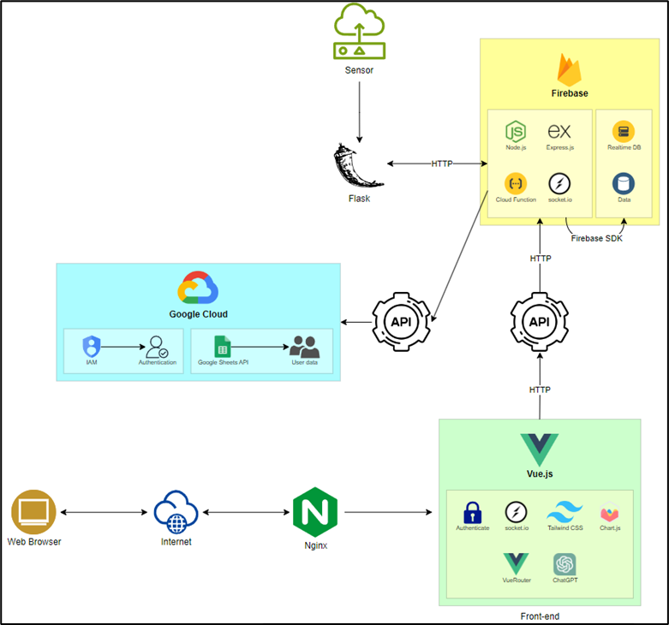

***Figure A: 3-tier Website Application Design***

**TIER 1: PRESENTATION**

* **Cloudflare:** Provides secure DNS and website optimization services.
* **Vue.js:** A progressive JavaScript framework for building user interfaces.
* **Vue Router:** For client-side routing within the Vue.js application.
* **Vuex:** State management library for Vue.js applications.
* **Vue Auth:** Authentication library for handling user authentication.
* **Socket.io:** Enables real-time client-server communication for notifications.
* **Tailwind CSS / Bootstrap:** CSS frameworks for styling user interfaces.
* **Chart.js:** JavaScript library for creating charts and graphs.

**TIER 2: APPLICATION**

**Application 1:**

* **Flask:** A micro web framework written in Python.
* **Biometric Attendance:** Module for retrieving employee attendance using biometric data.
* **Flask API:** Creates APIs to facilitate communication between servers.

**Application 2:**

* **Node.js:** A JavaScript runtime environment for executing server-side code.
* **Express.js:** A web application framework for Node.js.
* **Socket.io:** Enables real-time server-client communication for notifications.
* **RESTful API:** Provides endpoints for interacting with the application.
* **Real-Time Database (RTDB):** Firebase's NoSQL database for real-time data storage, suitable for IoT data.
* **Google Spreadsheet:** Integration with Google Sheets for data storage.
* **IAM Service:** Registers and manages access permissions for connecting to Google Sheets.

**TIER 3: DATABASE**

* **Google Spreadsheet:** Google Sheets used as a database for storing structured data.
* **Real-Time Database (RTDB):** Firebase's NoSQL database for real-time data storage.
  1. **Database UML**

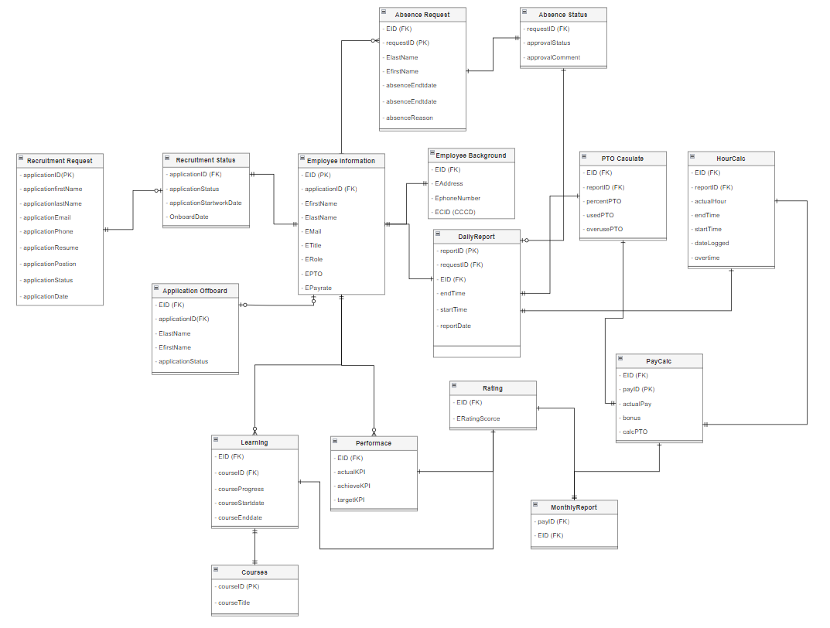

1. **Quality Management**

Using the S.M.A.R.T guidelines that indicate that goals and achievement should be Specific, Measurable, Achievable, Realistic, and Time-bound. We decided to pursue and align our quality definition on the ISO 25010 standard, which indicates the following objective to ensure the quality of a given software:

* **Functional Suitability:** Ensuring that the HRM software provides all necessary functions to support HR processes such as recruitment, employee onboarding, performance management, and training.
* **Performance Efficiency:** Ensuring that the HRM software performs tasks such as data processing and report generation within acceptable time frames and with minimal resource consumption.
* **Compatibility:** Ensuring that the HRM software can integrate with existing systems such as payroll software, time-tracking systems, and enterprise resource planning (ERP) systems.
* **Usability:** Ensuring that the HRM software is user-friendly and intuitive, allowing HR professionals and employees to easily navigate and perform tasks within the system.
* **Reliability:** Ensuring that the HRM software operates reliably without frequent crashes or errors, especially during critical HR processes.
* **Security:** Ensuring that the HRM software protects sensitive HR data such as employee personal information, payroll details, and performance evaluations from unauthorized access or modification.
* **Maintainability:** Ensuring that the HRM software can be updated and modified efficiently to accommodate changes in HR policies, regulations, and business requirements without introducing bugs or issues.
* **Portability:** Ensuring that the HRM software can be deployed across different hardware and software environments, such as on-premises servers or cloud platforms, with minimal effort and modifications

With ISO 25010 as the reference, we create the detail requirement as the definition of done for our project as follow:

* **Core functionalities development:** The platform must be constructed with all of the essential features listed in the project proposal. Both automated test cases and manual tests can be used throughout the testing process.
* **Usability and Scalability:** Consider factors like reaction time and resource usage while assessing the software's performance under workloads. Verify that the system is capable of handling an unexpected increase in workload.
* **Code Quality and Conventions:** Verify that the code complies with the requirements for readability, maintainability, naming conventions, and code structure.
* **Security:** Verify if the platform followed the necessary data protection and authentication guidelines. Performing security testing, reviewing protocols, and reviewing IT policies and documentation are all part of this process.
* **Testing and Documentation:** Conduct unit testing to verify individual components, integration testing to validate interactions between modules, and user acceptance testing (UAT) involving end-users.
* **UX/UI Testing:** Make that the UI is responsive, easy to use, and visually consistent. It ought to satisfy every design criterion listed in the proposal.

1. **Resources**

Within our team, we have four members that take on the following roles:

* **Facilitator - Minh:** Takes the lead, understands the assignment and assigns tasks to members based on their task appropriateness.
* **Initiator - Hai:** Comes up ideas, and suggests solutions, the main programer (IoT, framework, etc.) for the project. He also implemented an API to the application to make it integrate with other software.
* **Compromiser - Thy:** A good negotiator to resolve the group's conflict and mismatch in the collaboration process. She keeps the group running smoothly and efficiently.
* **Critic - Huy:** The content writer, he makes suggestions on our assignment and fine tune small details that can lead to problems. He also is the one to work on the UI design for the application.

1. **Approval Signatures**
2. **Project Team**

| **No.** | **Name of student** | **Student Id** | **Signature** |
| --- | --- | --- | --- |
| 1 | Nguyen Dinh Nhat Minh | 103802490 |  |
| 2 | Le Hoang Hai | 103542974 |  |
| 3 | Nguyen Nhat Huy | 103802911 |  |
| 4 | Nguyen Ngoc Minh Thy | 103802791 |  |

1. **Project Sponsor [Your Tutor]**

| **Tutor’s name (on behalf of the client)** | **Signature** |
| --- | --- |
| Thomas Hang |  |

## TASK 08P: Sprint Planning Meeting

**INTRODUCTION**

In any Agile development project, the process of selecting backlog items for a sprint is crucial for ensuring the successful delivery of features and meeting stakeholder expectations. During the Sprint Planning Meeting, our team engages in discussions to prioritize product backlog items based on various factors. In this project, we will discuss the factors considered by the team and formulate criteria for prioritizing the product backlog items for our hypothetical project.

**BACKLOG**

**Initial Release Schedule of the Product backlog item**

For this task, we focused on the first sprint of the full project. The items included in sprint ome are as follow:

| **No.** | **Item** | **Dependencies** | **Business Value (1 least – 10 most)** | **Release Schedule** |
| --- | --- | --- | --- | --- |
| **F1** | **Product UI/UX Design** | **None** | **7** | **Sprint 1** |
| **F2** | **Website for HRM** | **None** | **9** | **Sprint 1** |
| **F3** | **HR database schema design** | **F2** | **8** | **Sprint 1** |
| **F4** | **Manager Portal** | **F1, F3** | **7** | **Sprint 1** |
| F5 | Employee Feedback and Survey Module | F1, F3 | 6 | Sprint 2 |
| F6 | Employee information form implementation | F3 | 8 | Sprint 2 |
| F7 | Fingerprint scanner implementation/installation | F3 | 8 | Sprint 2 |
| F8 | Recruitment module development | F3 | 7 | Sprint 2 |
| F9 | Payroll calculation module development | F3 | 7 | Sprint 2 |
| F10 | On and Offboarding template implementation | F3, F6 | 6 | Sprint 3 |
| F11 | Leave request feature implementation | F3, F6 | 6 | Sprint 3 |
| F12 | Performance evaluation module development | F3, F6 | 6 | Sprint 4 |
| F13 | Implement reporting dashboard | F9 | 8 | Sprint 4 |

**SPRINT DEVELOPMENT**

1. **Important Factors**

There are several factors to consider when prioritizing a backlog item to work on for a Sprint. These factors are:

* Business Value: Business value refers to the importance of each backlog item in achieving project goals and delivering value to stakeholders.
* Development Effort: Development effort encompasses the time, resources, and complexity required to implement each backlog item.
* Feature Dependency: Feature dependency refers to the extent to which a backlog item relies on other features or components.
* Date Needed / Timeline: The urgency and timeline constraints associated with each backlog item.
* Risk Involved: Risk assessment involves identifying potential risks and uncertainties associated with each backlog item that will have a negative impact on project timelines.

After careful discussion with our team, we have finalized the following factors to be the most crucial to the success of this project:

* Business Value: Business value is an important factor to this project as it directly correlates to the project’s goals and contributes to overall success and stakeholders satisfaction.
* Development Effort: Development effort is another crucial factor to consider for proper resource and time allocation.
* Risk Involved: Understanding the risks involved with a task is vital to delivering a satisfactory product. By prioritizing items with higher risk, you can mitigate potential issues early in the development process.

The factors we discarded are:

* Feature Dependency: Feature dependency is discarded as we have decided that if we depended on it too much as a prioritization factor, we would be unable to pinpoint which task is the most important. An item of higher significance might be dependent on a less important preceding item, resulting in that more important task being locked out.
* Date Needed / Timeline: While timeline considerations are important for overall project planning and scheduling, the team has decided that timeline constraints can be addressed at a higher level during release planning and sprint planning.

1. **Criteria for Backlog Items prioritization**

We will attempt to develop our criteria by answering the following questions:

1. What if not all factors are of equal importance?
2. Why does a particular factor have a higher weight than the other?
3. What should be the proper weighing among these factors?

**Question 1.**

We need to determine the importance of each factor as it serves as the foundation for effective task management. Without categorizing and weighing factors, it becomes challenging to establish priorities, keep track of tasks, and assign them to team members.

**Question 2.**

Putting an emphasis on the weight of business value is imperative due to its direct correlation with the project's overall success. By evaluating tasks based on their business value, we align our efforts with strategic objectives, ensuring that resources are directed towards tasks that contribute most significantly to project goals.

Once the business value is determined, we delve into assessing the effort required to develop specific features or tasks. While considering development effort is essential, it takes a backseat to business value in our decision-making process. Tasks with higher business value may warrant greater effort to ensure their successful implementation.

Furthermore, we also factor in the risk associated with each task. Assigning weights to risk helps in prioritizing tasks that may pose potential challenges or setbacks to the project. By addressing high-risk tasks proactively, we mitigate potential negative impacts on project timelines and outcomes.

**Question 3.**

With these considerations, we assign weights to each factor to guide our decision-making process effectively:

* Business Value: 50%
* Development Effort: 30%
* Risk Involved: 20%

1. **Sprint Backlog Item to develop**

Based on the criteria above, our team has decided that the item *F2*, namely *“Website for HRM”* is the most important task and should be prioritized above all. It has the highest business value in Sprint 1 and is the core of the project, hosting the various functionalities later on, meaning many items are also dependent on it.

1. **Work Breakdown Structure**

We first examine the Product Backlog Items list and determine the task needed to be used in the WBS chart, after careful discussion and consideration, there are four (4) items and 20 tasks that need to be done in Sprint 1.

| **Item** | **Task ID** | **Description** | **Dependency** |
| --- | --- | --- | --- |
| Product UX/UI Design | T1 | Research the overall design  of current Gemadept’s system. | None |
|  | T2 | Sketch initial wireframes on paper or using digital tools to visualize the basic layout and flow. | T1 |
|  | T3 | Design high-fidelity mockups using design software like Sketch or Figma, incorporating branding elements and visual styles. | T1, T2 |
|  | T4 | Come up with the UI code and structure. | T3 |
|  | T5 | Conduct usability testing with a sample group of users to gather feedback on the design and iterate accordingly. | T4 |
| Base website for HRM | T6 | Develop a sitemap to organize the structure and navigation of the website. | T5 |
|  | T7 | Design and implement a responsive front-end using HTML, CSS, and JavaScript frameworks. | T6 |
|  | T8 | Fine tune the UI code to make it closely align to the UX/UI. | T4, T7 |
|  | T9 | Set up a back-end system to handle user authentication, database interactions, and business logic using technologies like Node.js or Django. | None |
|  | T10 | Conduct front and back-end testing to ensure the application meets business expectations. | T9 |
| HR database schema design | T11 | Identify and prioritize the key entities in the HR domain, such as employees, departments, and positions. | None |
|  | T12 | Create an entity-relationship diagram (ERD) to visualize the relationships between different entities. | T11 |
|  | T13 | Define the attributes and data types for each entity based on the information to be stored. | T12 |
|  | T14 | Normalize the database schema to eliminate redundancy and minimize data anomalies. | T13 |
|  | T15 | Review and optimize the schema design for performance and scalability, considering factors like indexing and query optimization. | T14, T10 |
| Manager Portal | T16 | Gather requirements from managers and stakeholders to understand their needs and expectations. | T10 |
|  | T17 | Create user stories or use cases to document the desired functionality of the portal. | T16 |
|  | T18 | Develop features such as employee performance dashboards, task management tools, and reporting capabilities. | T5, T10 |
|  | T19 | Implement role-based access control to ensure that managers only have access to relevant data and functionality. | T18 |
|  | T20 | Test the functionality to ensure the feature is up to compliance and security. | T19 |

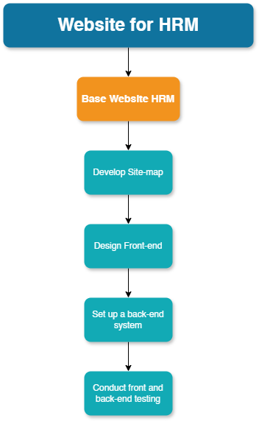

*Figure 4: WBS Chart*

## TASK 09P: Project Set Up

1. **TASK ALLOCATION**

**Initializing**

Using Trello, we create a task board completed with the different stages of task completion as follow:

* Product backlog items: Lists all the products in the current sprint.
* Sprint backlog items: Lists all the tasks associated with the backlog items.
* To do: Items not yet started
* Doing: Item currently being developed.
* Testing: Checking of items that are moving from the “doing” to “to be confirmed” state.
* To be confirmed: Item being checked for the last time before being marked done.
* Done: Item successfully developed and test

The items in the sprint and backlog are recorded on Trello as follow:

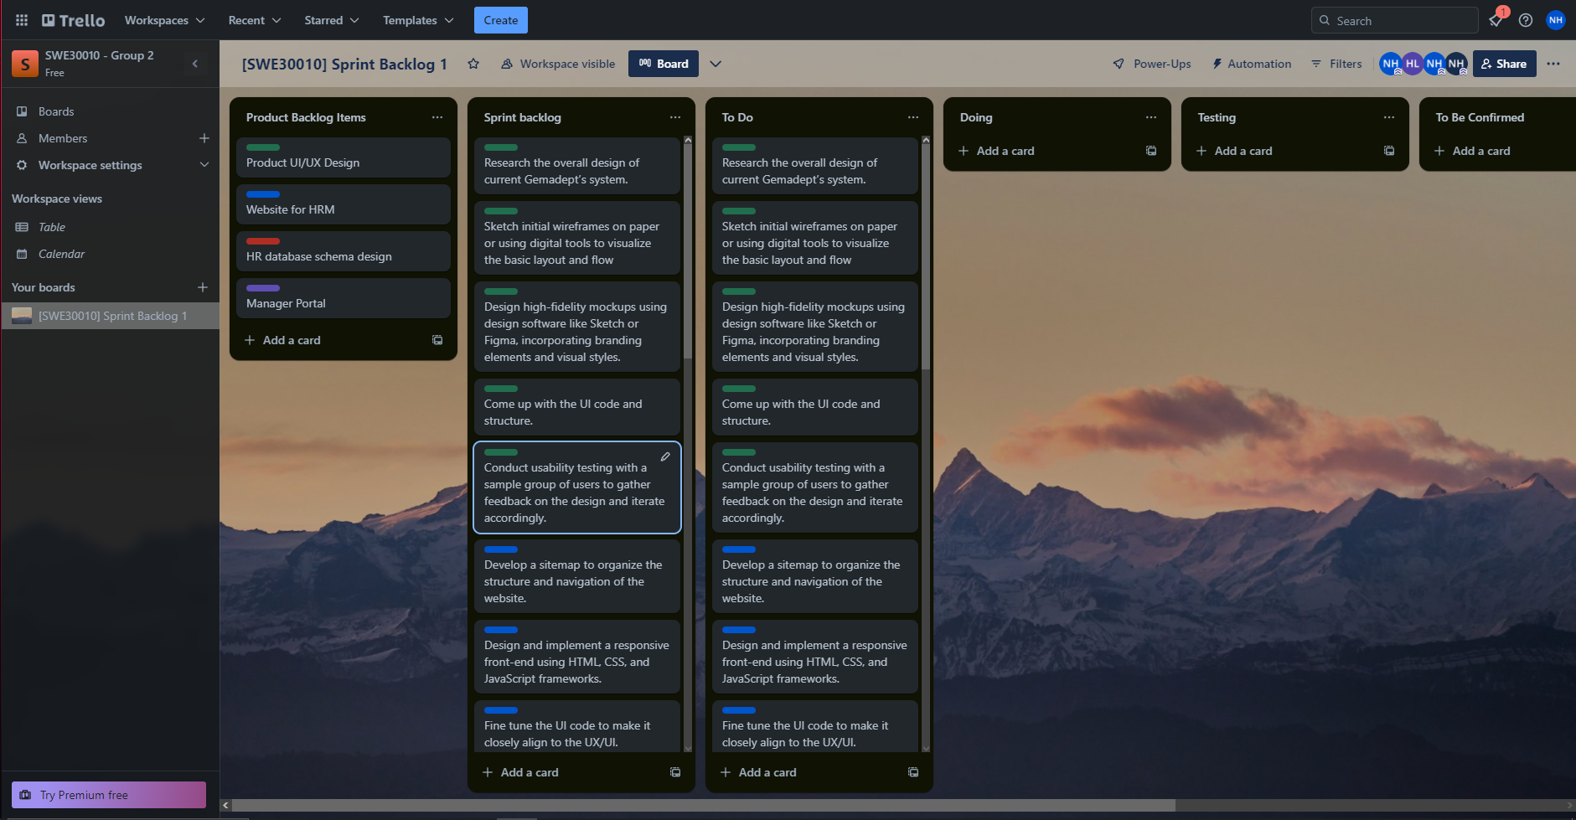

*Figure 1.1: Screenshot of Trello task board*

**Rationale**

As can be seen in the Trello screenshots, we have outlined the items based on the predefined categories above. Since this is day 0, only planning was done and no other work was done.

1. **BURN-DOWN CHART**

**Using burn-down chart**

To ensure there is a measurable method of calculating the effort being made or used in the project, we rely on burn-down data, where each task is allocated a specific completion time. We've divided all the products in the product backlog into four sprints, each lasting approximately three weeks, given our maximum project duration of 12 weeks. This enables us to compile a table detailing the total time and duration of each item.

This table serves as the basis for generating the optimal burn-down chart for our project after day 0.

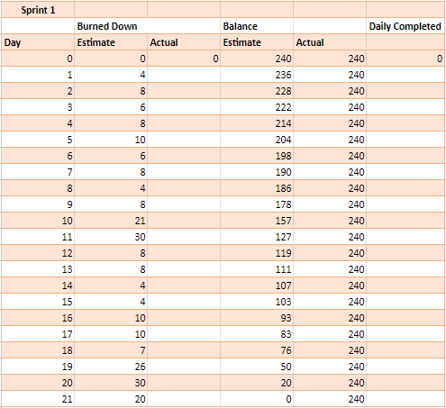

*Figure 2.1: Burn-down table*

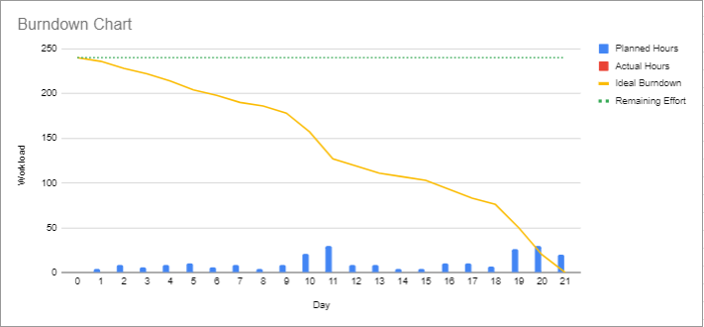

*Figure 2.2: Burn-down chart*

**Analysis**

As can be seen, some of the tasks outlined as done in the task board translate rather well in this ideal burn-down chart, and since this is day 0, we can see only the estimated time of the whole project.

1. **CODE REPOSITORY**

The front and back end code folders of the project were created in the local machine and then pushed onto the Github repository. So far, there has been little to no movement surrounding these folders, but as the project goes on, there will surely be updates being made into these repositories.

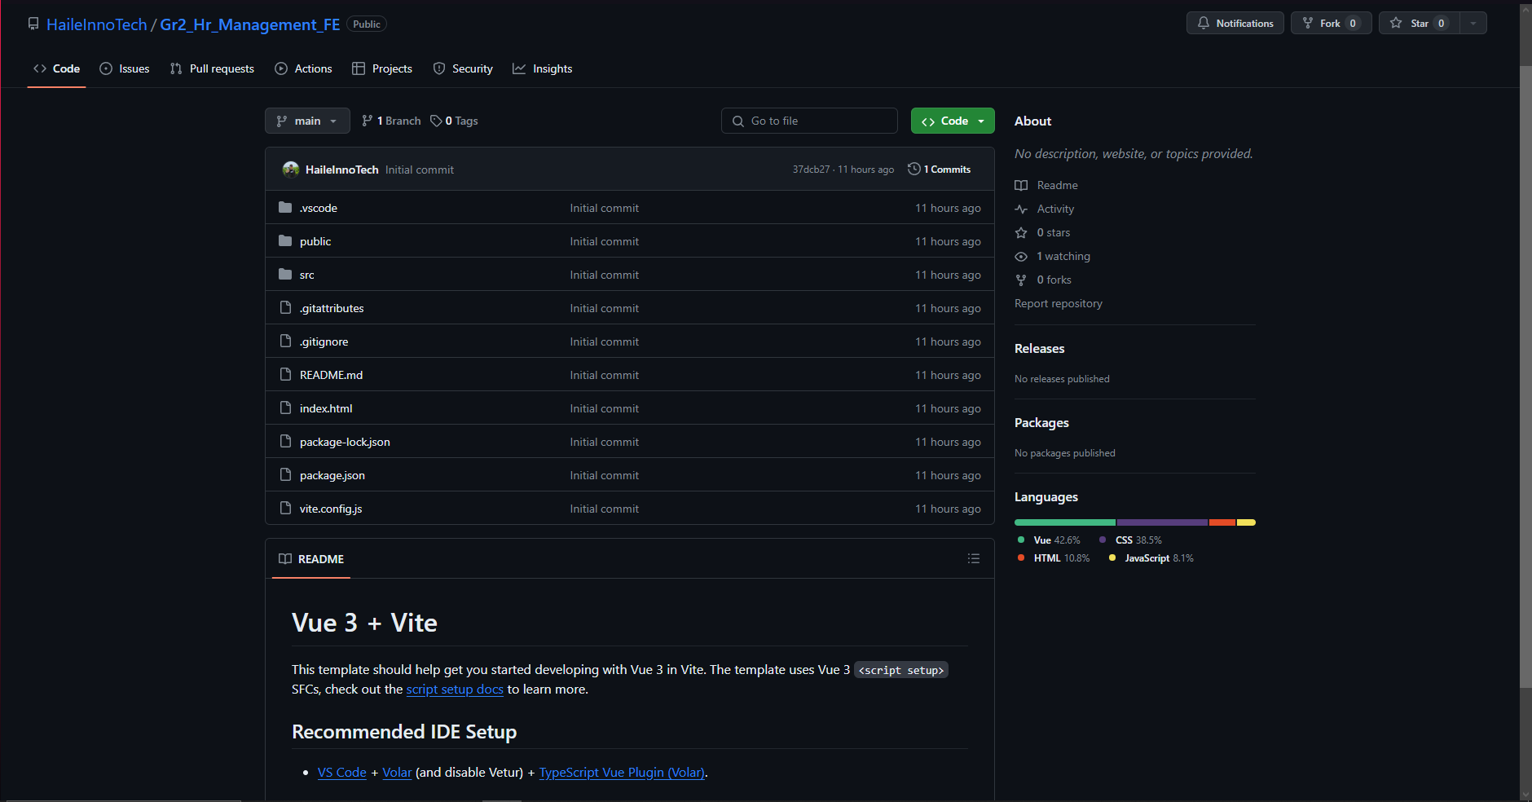

*Figure 3.2: Front-end code repo on github*

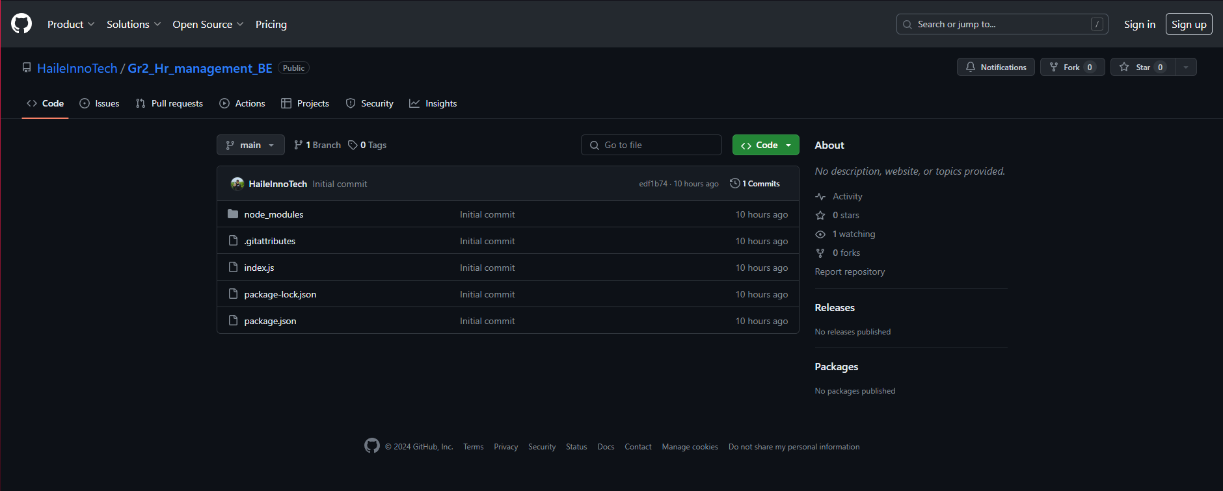

*Figure 3.2: Back-end code repo on github*

## 

## TASK 10P: Sprint 1 Mid-Point Progress Reporting

1. **Introduction**

This task is concerned with developing the HRM Application project for Gemadept.

Each day will consist of a few tasks that have been established in previous work.

Trello is used to keep track of the progress, in our Trello beside the product and sprint backlog, we also include five additional of lists as follow:

* To do: This list contains all the tasks that need to be completed during the current sprint or iteration. These tasks are prioritized based on their importance and dependencies.
* Doing: Tasks that are currently being worked on by team members are moved to this list. It helps in visualizing the ongoing work and ensures that team members are not duplicating efforts.
* Testing: We would define this list as an extension to the Doing list, as should any problem occur during this phase, it should be put back into the doing phase to be further developed.
* To be confirmed: We will check the items the team completed for the day before sending it to the done list (testing for actual work, and to see if the task met requirement). A member cannot check their item as done to avoid bias, hence, checking must be done by another person that did not participate in doing the items.
* Done: Tasks that have been successfully completed and confirmed are moved to this list. It serves as a record of achievements and completed work items throughout the project lifecycle.

This structure helps us efficiently manage our workflow and ensure transparency and accountability within the team.

1. **Sprint Progress:**

Below are all the items which we have mustered up in the process of doing this sprint.

1. **Day One**

**Task sign-up at the start of the day:**

| **Item** | **Description** | **Member** |
| --- | --- | --- |
| 1. Research Gemadept Design | The designer must conduct research on Gemadept Design to gather insights and inspiration for the project. | Nhat Huy |
| 2. Sketch wireframe | Initial wireframes needed to be sketched out to visualize the layout and structure of the project. | Nhat Huy |
| 3. Design Front-end mockup | Preliminary designs for the front-end interface must be created to outline the visual appearance and user interaction flow. | Nhat Huy |
| 4. Develop sitemap | Designer and Leader develop a sitemap to organize the navigation and structure of the website or application. | Nhat Huy  Nhat Minh |
| 5. Develop Front-end code (1st edition, not final) | Initial coding efforts that focused on developing the front-end of the project, with a version aimed at providing basic layout. | Hoang Hai  Minh Thy |

**Trello task board at the end of the day:**

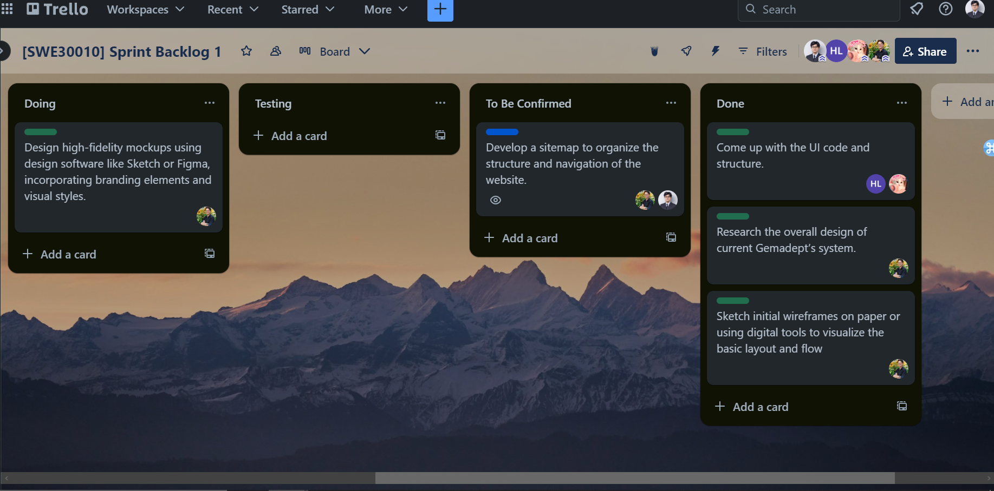

**Code repository on Github:**

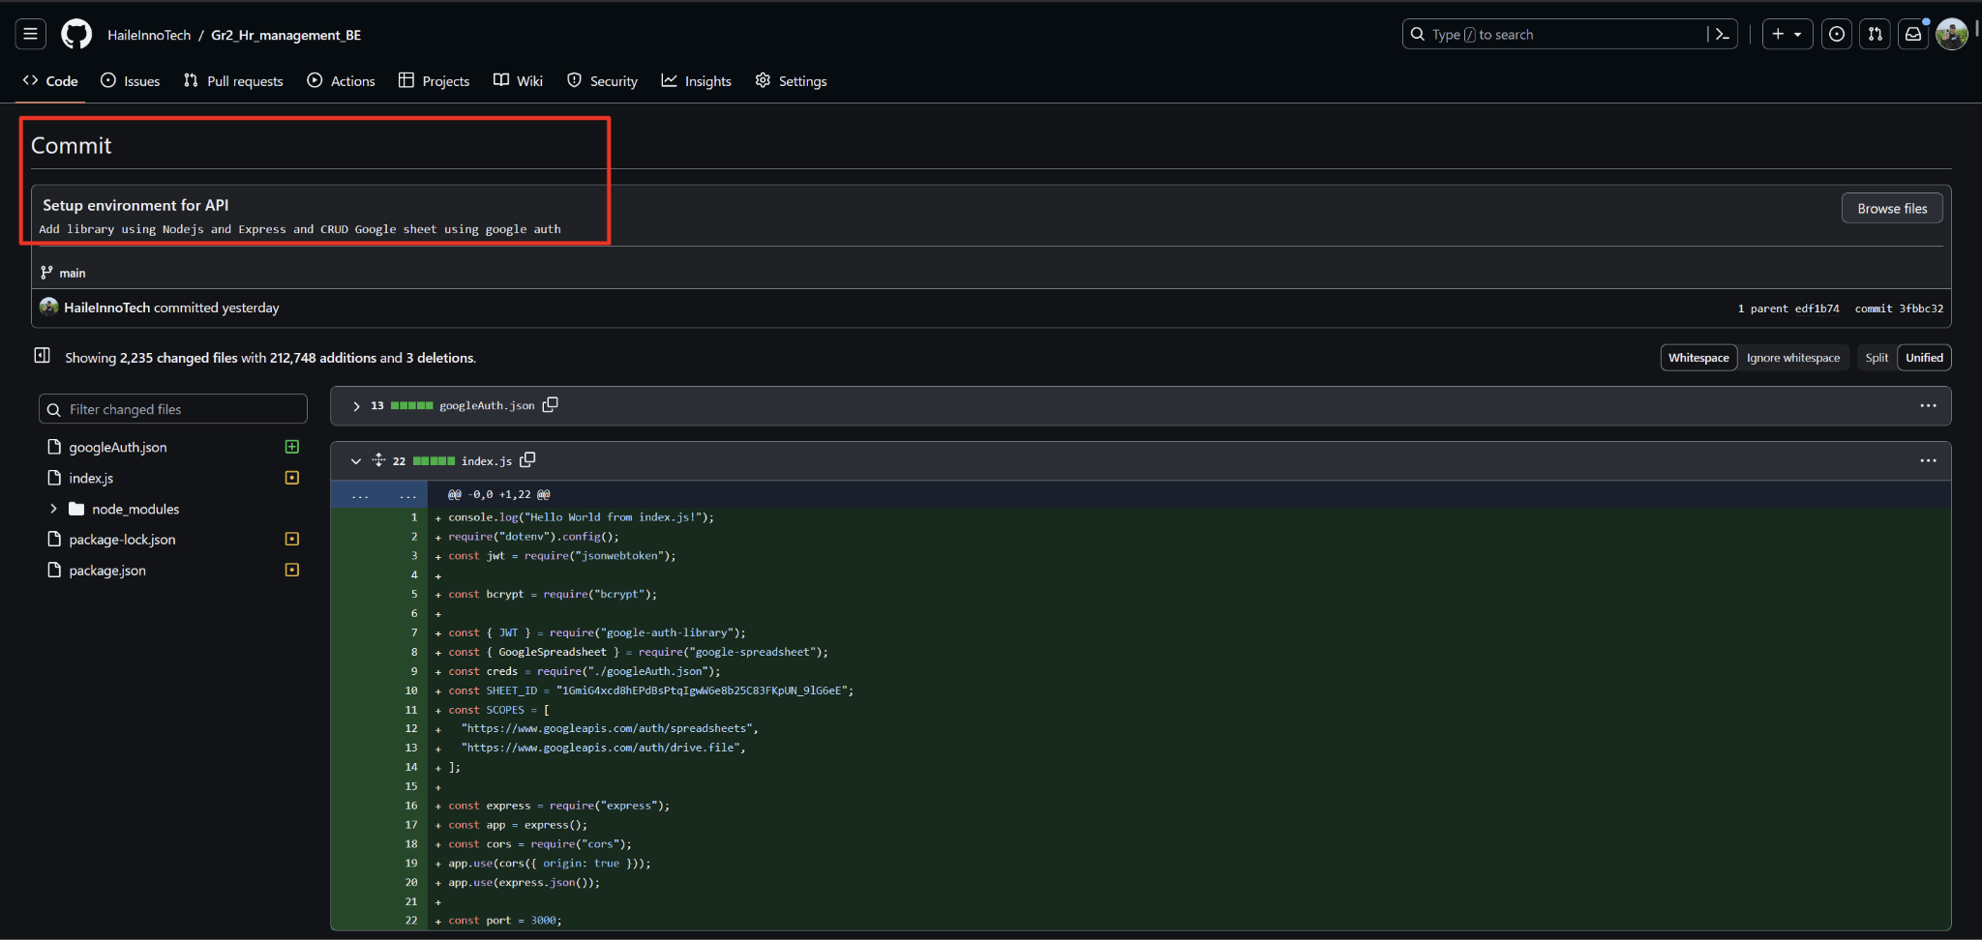

*Back end code development*

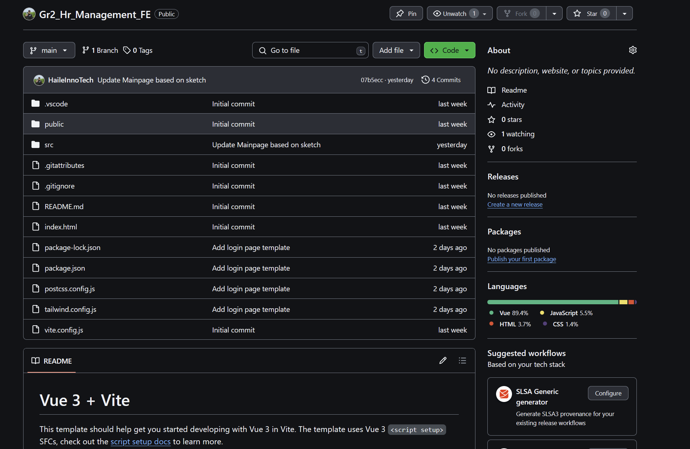

*Back end code development*

**Burndown chart:**

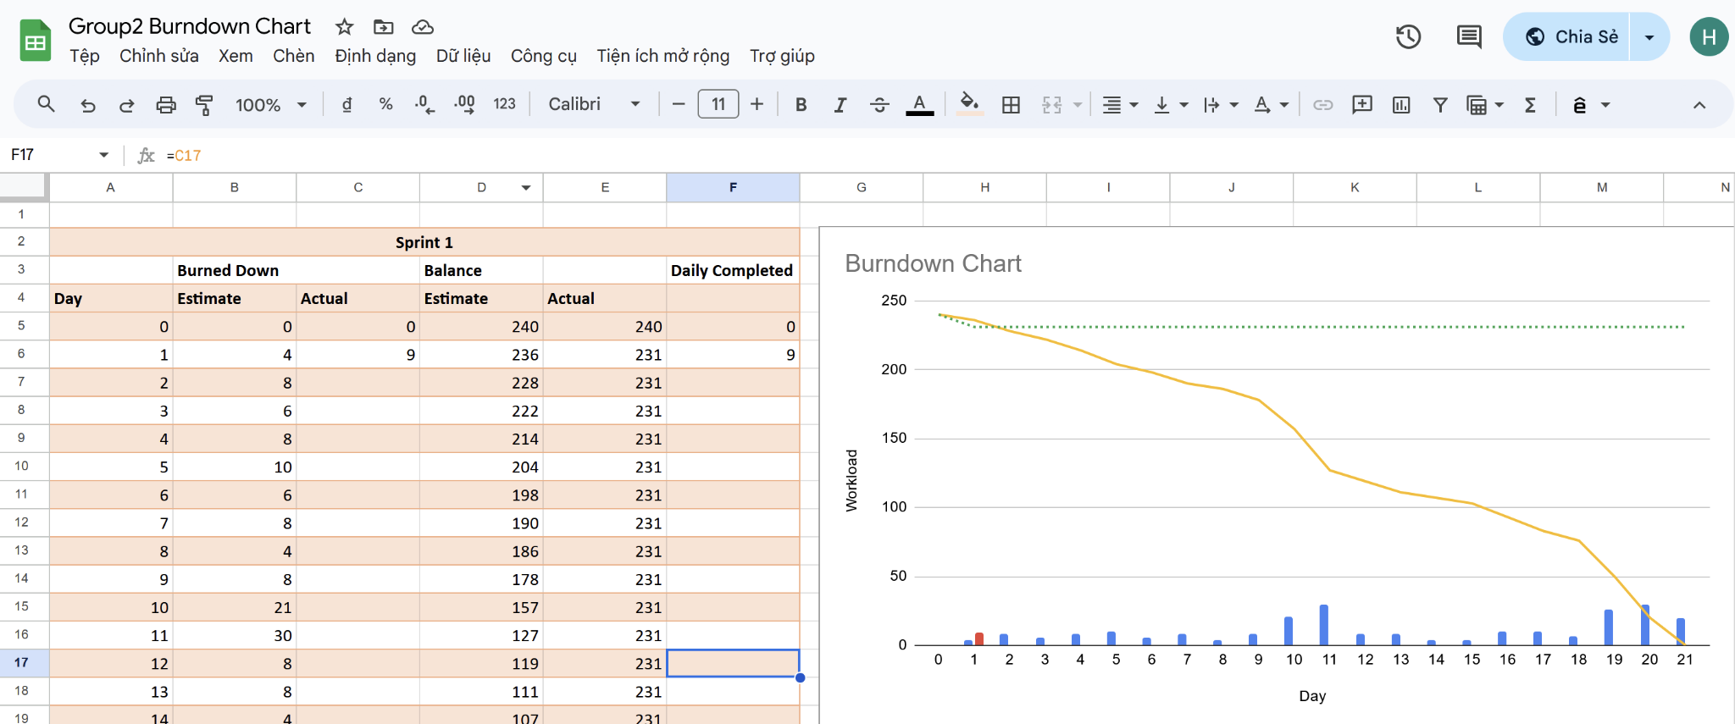

**Daily meeting minute:**

| **Status** | **Description** | **Count** |
| --- | --- | --- |
| Item Done | Come up with the UI code and structure., Research the overall design of current Gemadept’s system., Sketch initial wireframes on paper or use digital tools to visualize the basic layout and flow. | 3/5 |
| Item Testing | N/A | 0/5 |
| Item Confirming | Develop a sitemap to organize the structure and navigation of the website | 1/5 |
| Item Not Done | Design high-fidelity mockups using design software like Sketch or Figma, incorporating branding elements and visual styles. | 1/5 |
| Next step | Continue working on the mockup, then move onto doing day 2’s tasks |  |

1. **Day Two**

**Task sign-up at the start of the day:**

| **Item** | **Description** | **Member** |
| --- | --- | --- |
| 1. Finish website Mockup | Complete the creation of the website mockup, which includes designing the visual layout, user interface elements, and overall aesthetic presentation of the website. | Nhat Huy |
| 2. Setting up back-end functionality | Implement the necessary functionality on the server-side of the website, including database integration, server logic, and API development to support the website's features and interactions. | Hoang Hai  Minh Thy |
| 3. Implement responsive and user friendly features to the initial UI code | Add functions of CSS, JS and HTML to the code function to give the website somewhat of a crude usability. | Nhat Huy  Hoang Hai  Minh Thy |
| 4. Checking of completed items | We will check the items the team completed for the day before sending it to the done list. A member cannot check their item as done to avoid bias, hence, checking must be done by another person that did not participate in doing the items. | Nhat Minh |

**Trello task board at the end of the day:**

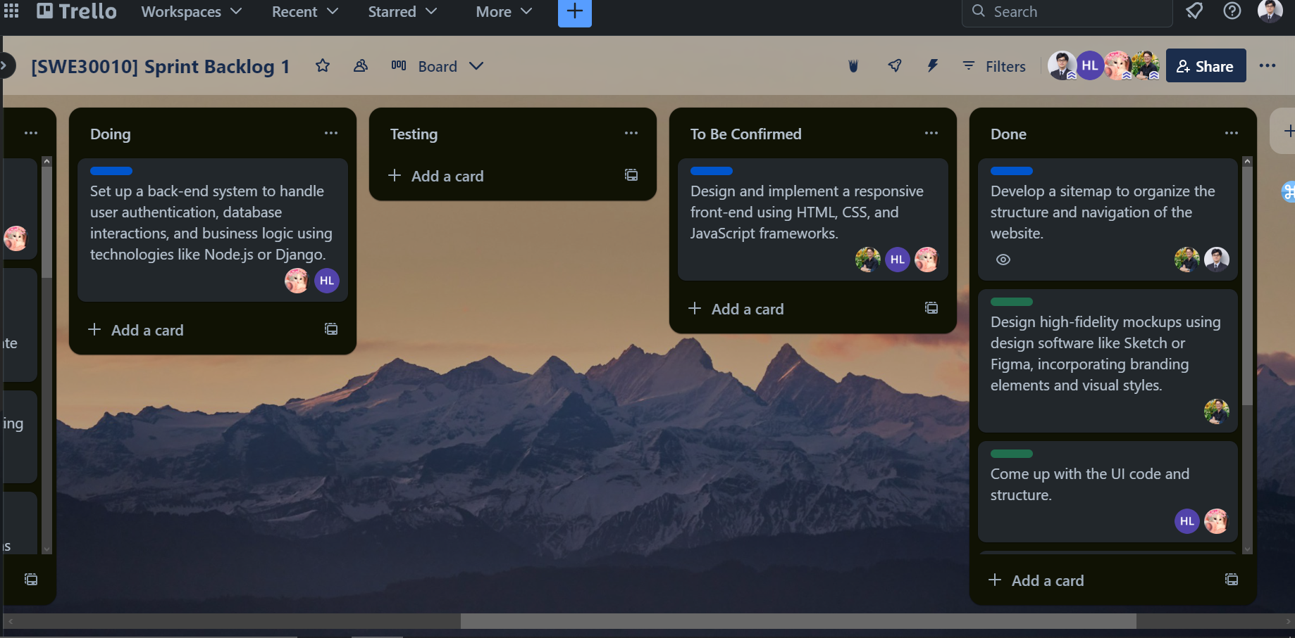

**Code repository on Github:**

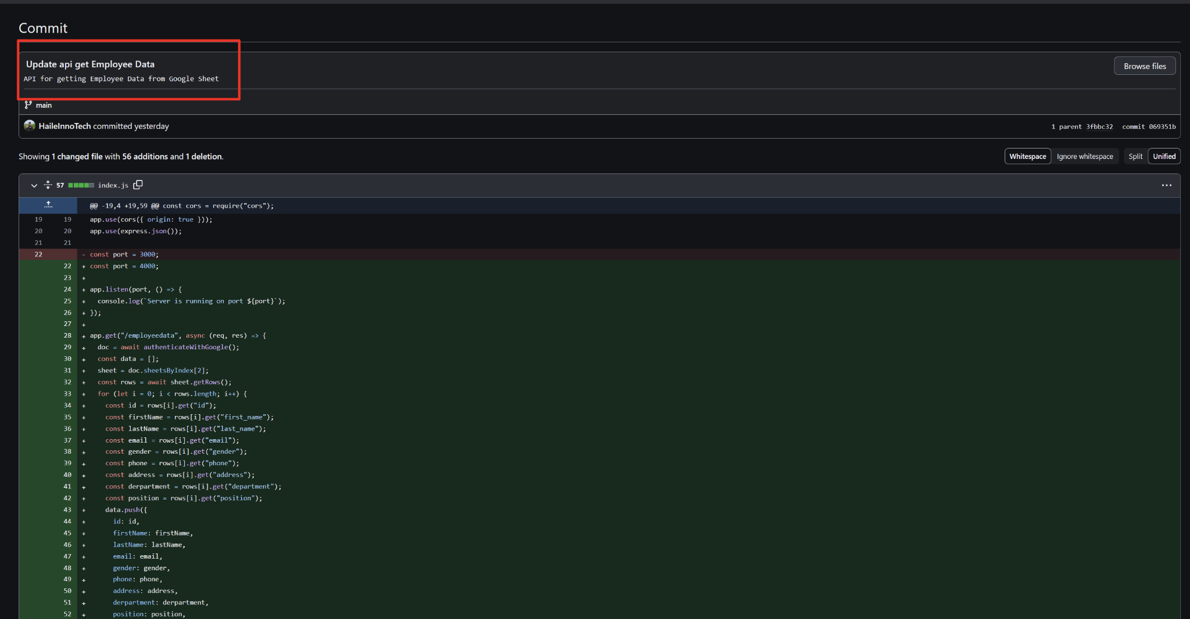

*Back-end commits on github*

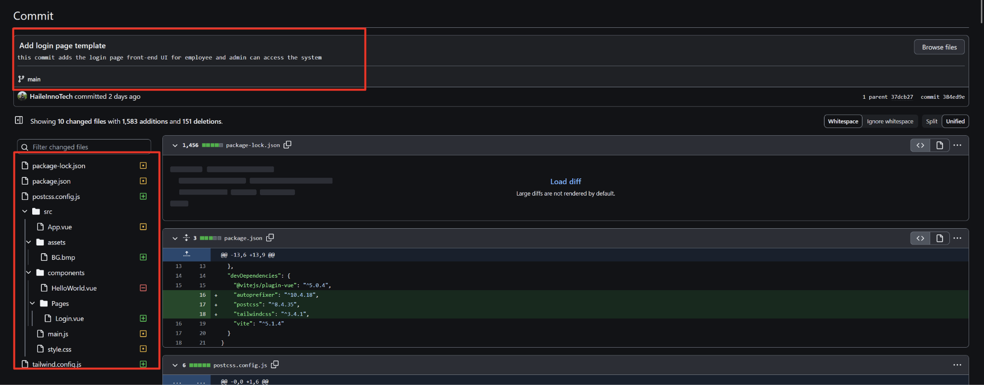

*Front-end commits on github*

**Burndown chart:**

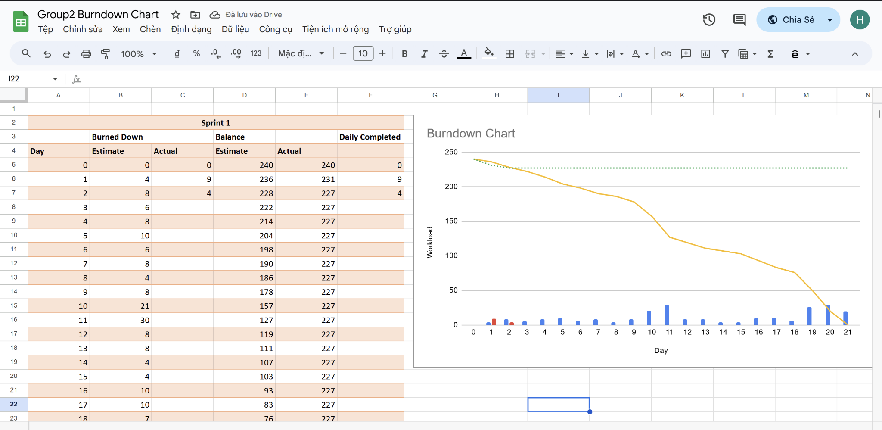

**Daily meeting minute:**

| **Status** | **Description** | **Count** |
| --- | --- | --- |
| Item Done | Front-end mock up | 1/4 |
| Item Testing | N/A | 0/4 |
| Item Confirming | Improved front-end design and usability | 1/4 |
| Item Not Done | N/A | 0/4 |
| Next step | Continue working on the back-end system, check fine tune appropriateness, and move onto next day |  |

1. **Day Three**

**Task sign-up at the start of the day:**

| **Item** | **Description** | **Member** |
| --- | --- | --- |
| 1. Continue back-end functionality | Proceed with the development of back-end functionalities, including database integration, server logic implementation, and API development. Ensure that the back-end system is robust, efficient, and capable of supporting the required functionality of the application. | Hoang Hai  Minh Thy |
| 2. Testing the UI code | Perform thorough testing of the front-end codebase to identify and address any bugs, errors, or inconsistencies in the user interface. Test for compatibility across different browsers, devices, and screen sizes to ensure a seamless user experience. | Hoang Hai |
| 3. Conduct testing of front end | Conduct comprehensive testing of the front-end components and features to validate their functionality, usability, and performance. Utilize testing techniques such as unit testing, integration testing, and user acceptance testing to identify and resolve any issues or discrepancies. | Nhat Minh  Nhat Huy |
| 4. Checking of completed items | We will check the items the team completed for the day before sending it to the done list. A member cannot check their item as done to avoid bias, hence, checking must be done by another person that did not participate in doing the items. | Nhat Minh  Hoang Hai |

**Trello task board at the end of the day:**

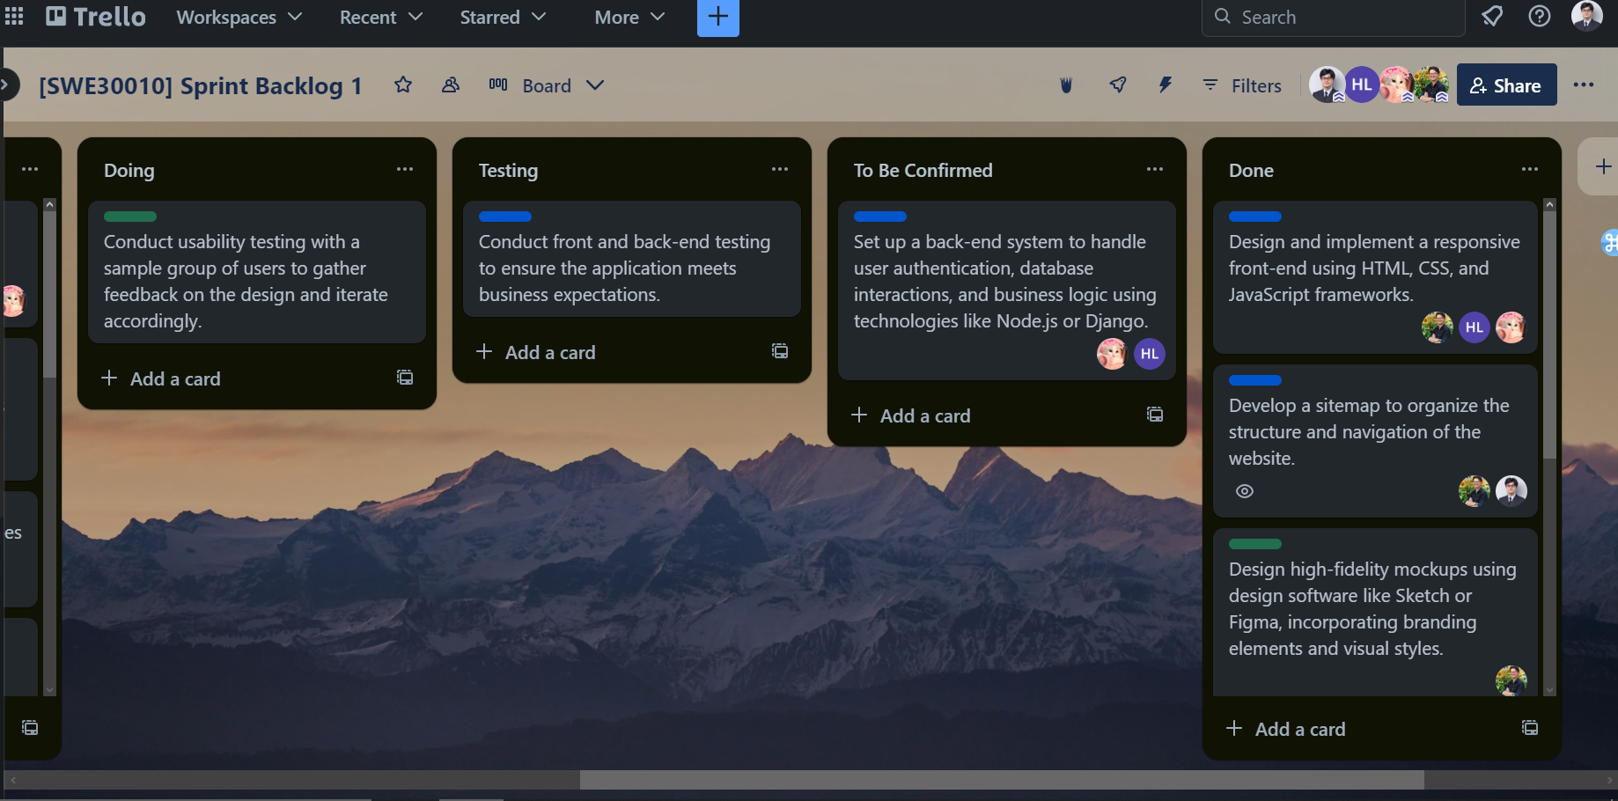

**Code repository on Github:**

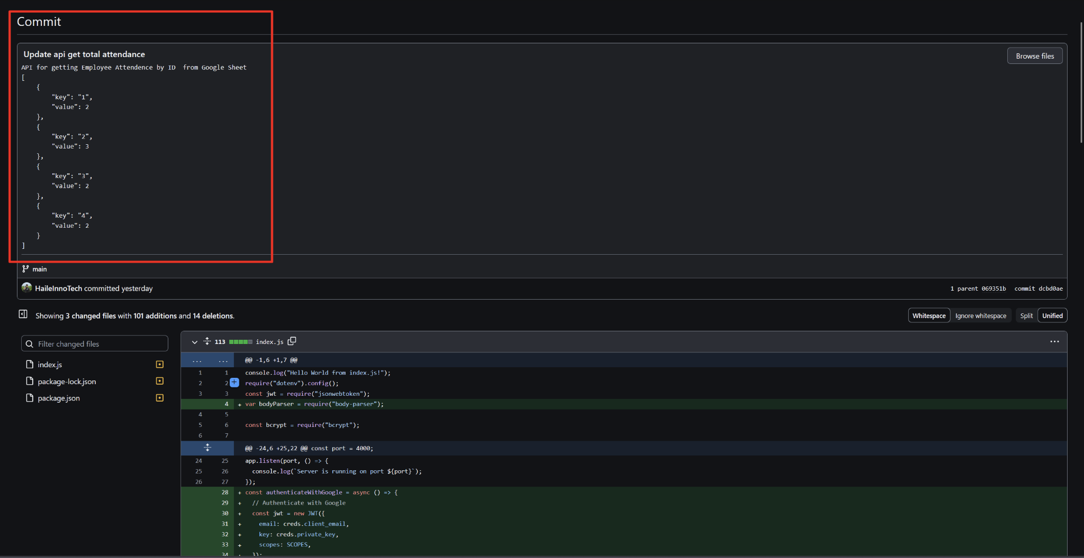

*Back-end development*

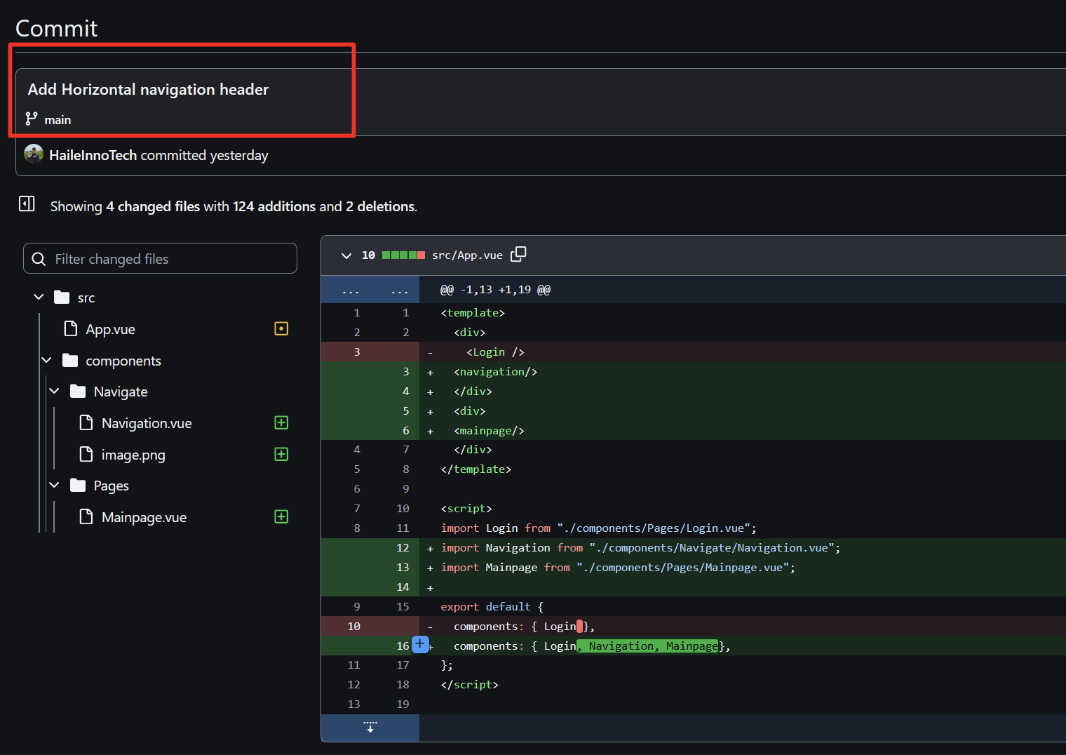

*Front-end development*

**Burndown chart**

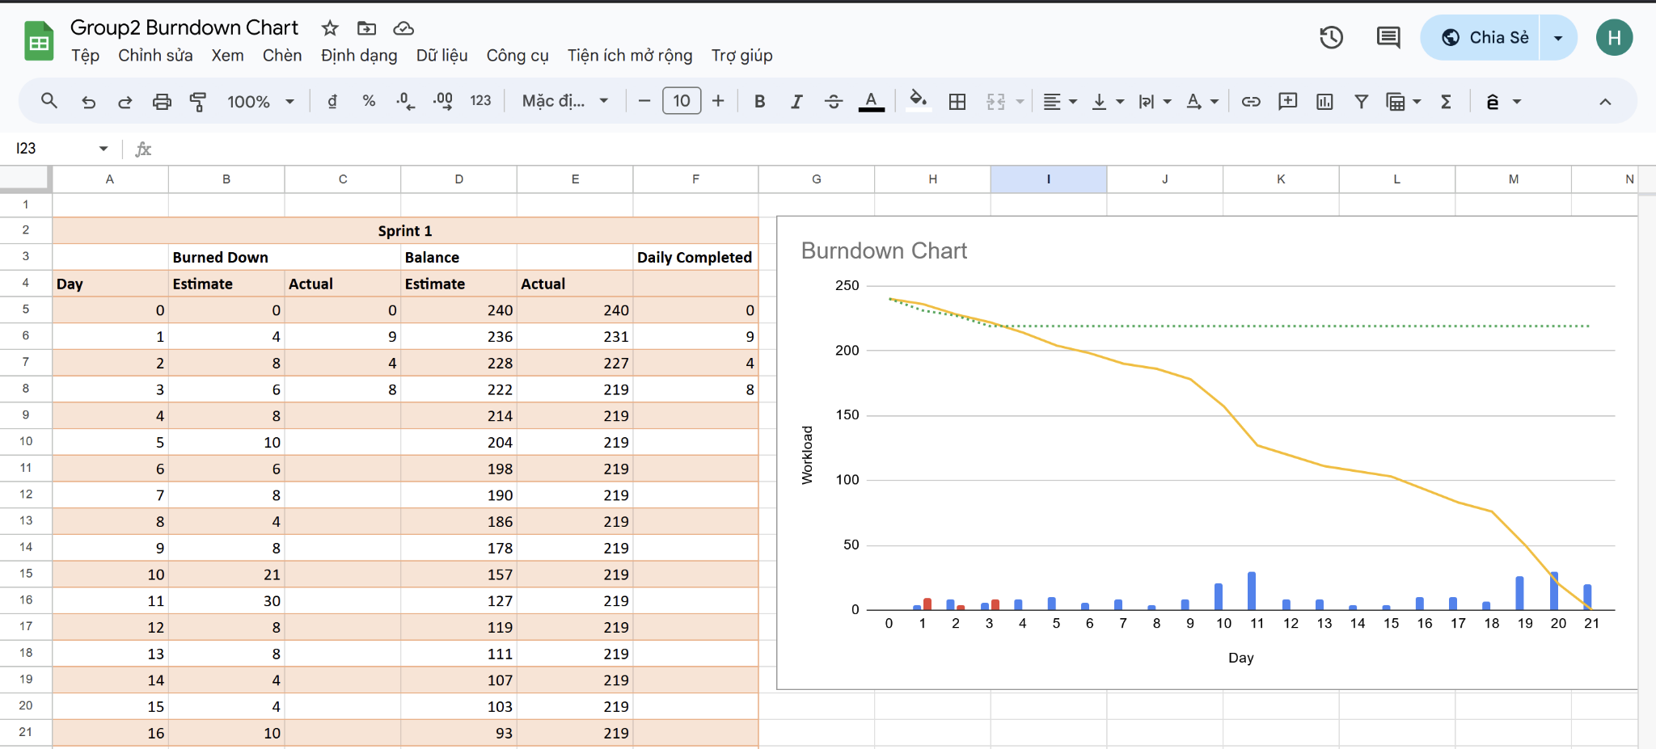

**Daily meeting minute:**

| **Status** | **Description** | **Count** |
| --- | --- | --- |
| Item Done | Back-end functionality | 1/4 |
| Item Testing | Back-end testing (internal testing to ensure correctness) | 1/4 |
| Item Confirming | Back-end function | 1/4 |
| Item Not Done | Front-end testing (due to time constraint in meeting up with sample users to conduct interview and testing) | 1/4 |
| Next step | Reserve more time to meet up with users for testing, and continue with next items. |  |

1. **Day Four**

**Task sign-up at the start of the day:**

| **Item** | **Description** | **Member** |
| --- | --- | --- |
| 1. Review of front-end testing | Front-end review to make sure the task is actually completed and all components are met. | Nhat Minh |
| 2. Reviewing of back-end function | Due to the size of the back-end, it can take a lot of time to review each function. Moreover, this task is also tied to the completeness of the testing phase. | Nhat Minh |
| 3. Testing of back-end function | Back-end testing required a lot of time to make sure each function ran correctly. Should any function fail or need improvement, it is also transferred to the doing stage. | Hoang Hai  Nhat Minh |
| 4. Fine tune UI code | After meddling with the back-end, to ensure the visual is met, this website must encompass adjustments to CSS styles, HTML structure, and JavaScript functionality to optimize performance, responsiveness, and accessibility across different devices and screens. | Minh Thy |

**Trello task board at the end of the day:**

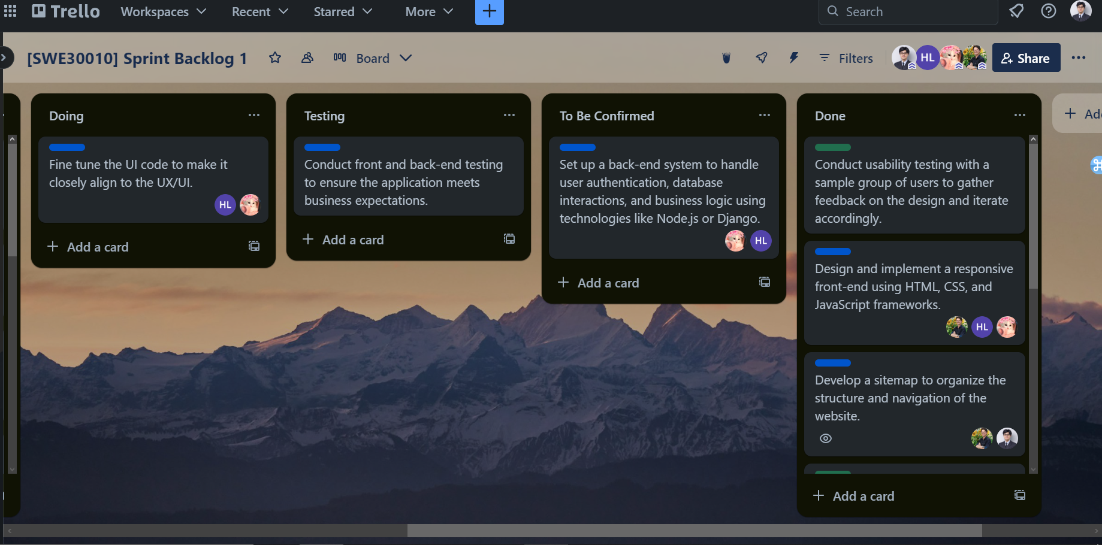

**Code repository on Github:**

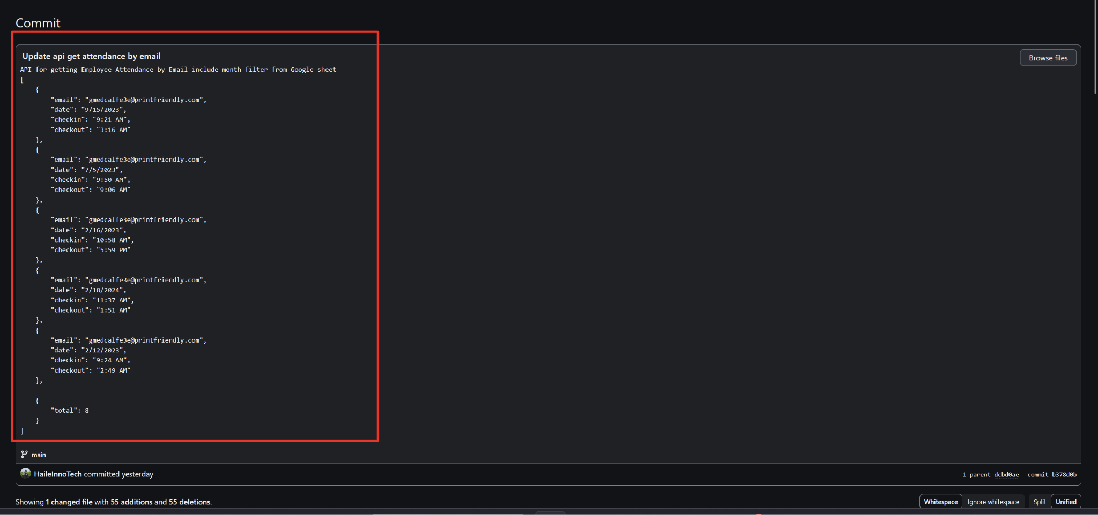

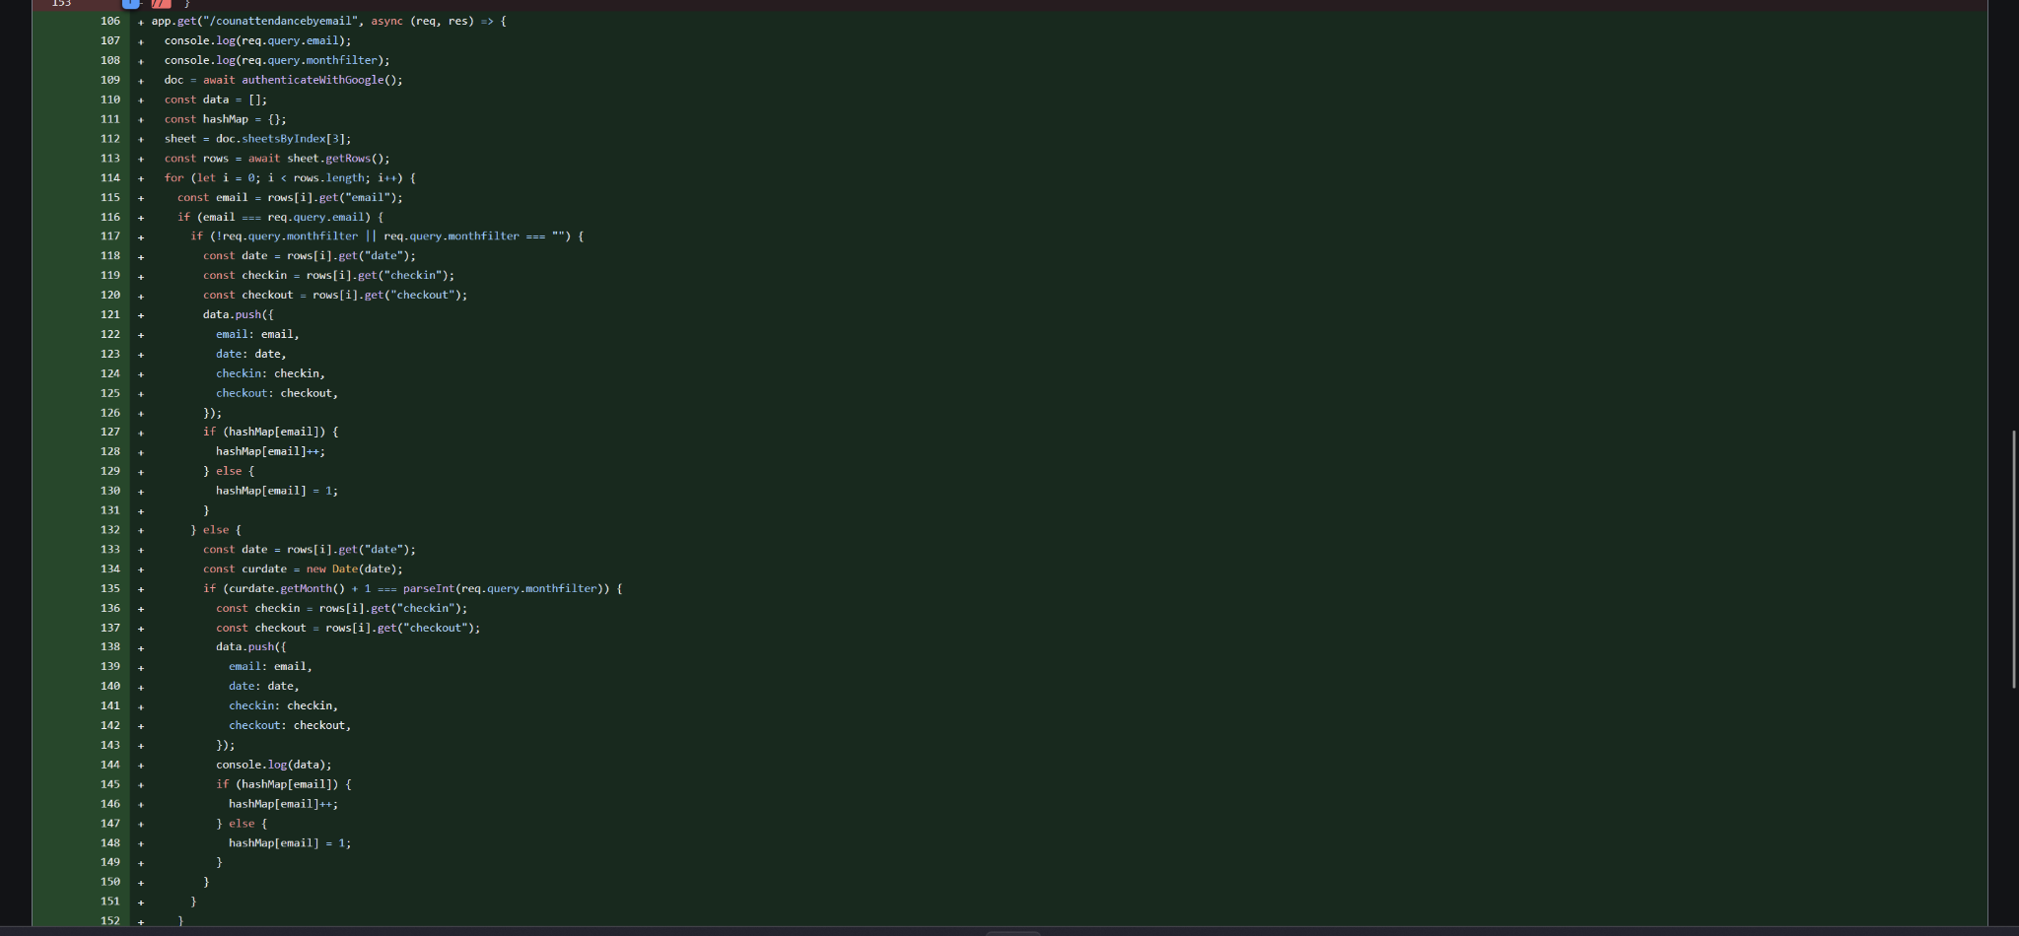

*Back-end development*

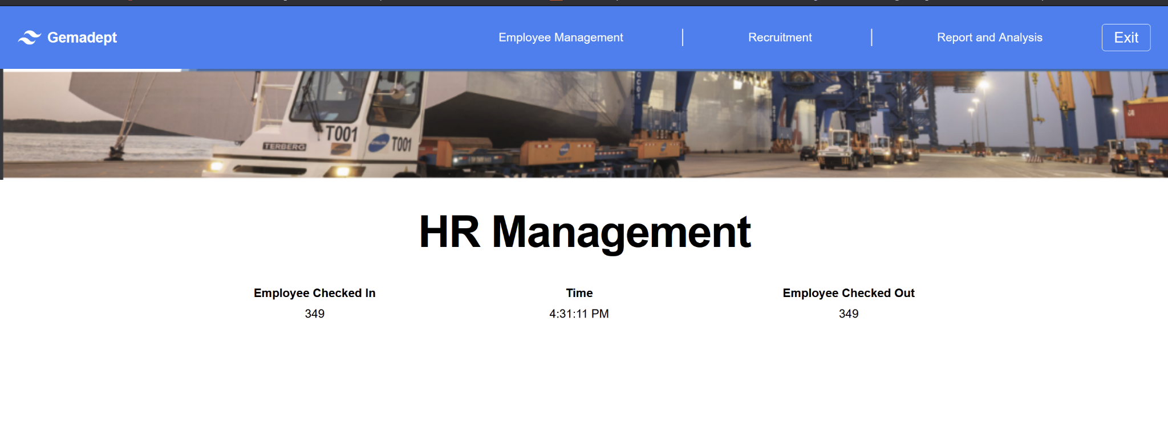

*Front-end code refine*

**Burndown chart**

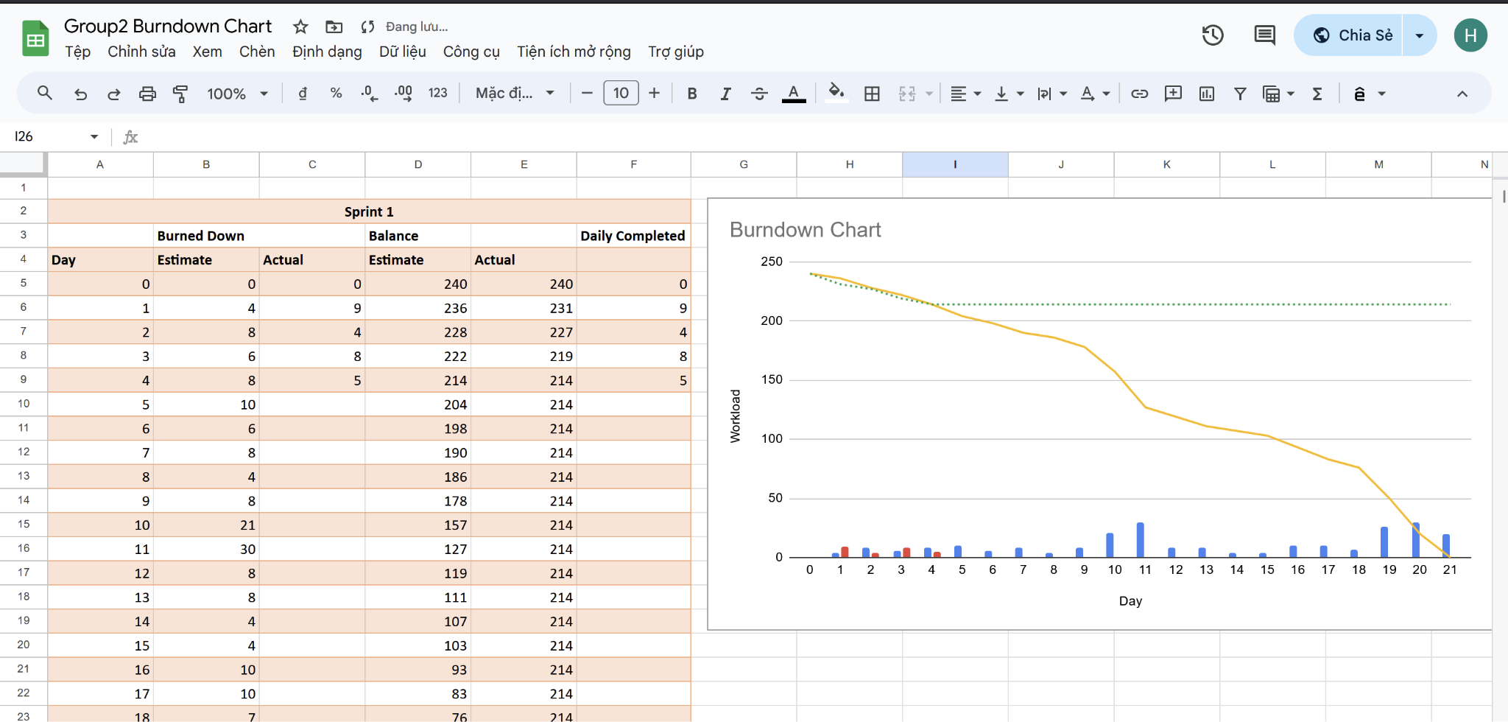

**Daily meeting minute:**

| **Status** | **Description** | **Count** |
| --- | --- | --- |
| Item Done | N/A | 0/4 |
| Item Testing | Back-end testing | 1/4 |
| Item Not Done | Fine tune UI code (only partially carried out due to size of back-end) | 1/4 |
| Next step | Finish all review and testing |  |

1. **Day Two**

**Task sign-up at the start of the day:**

| **Item** | **Description** | **Member** |
| --- | --- | --- |
| 1. Finish review of previous task | All task not previously done must be done | Nhat Minh |
| 2. Finish UI code | Fine tune UI code to closely align with the mock up | Hoang Hai  Minh Thy |

**Trello task board at the end of the day:**

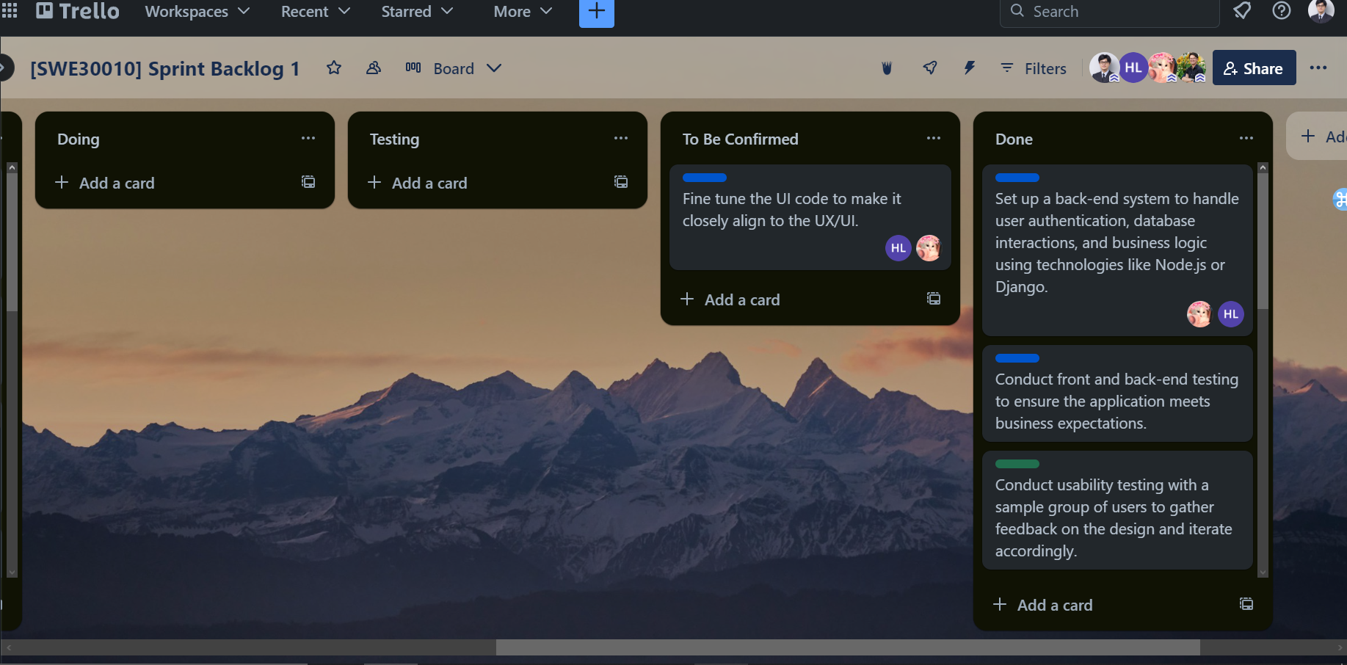

**Code repository on Github:**

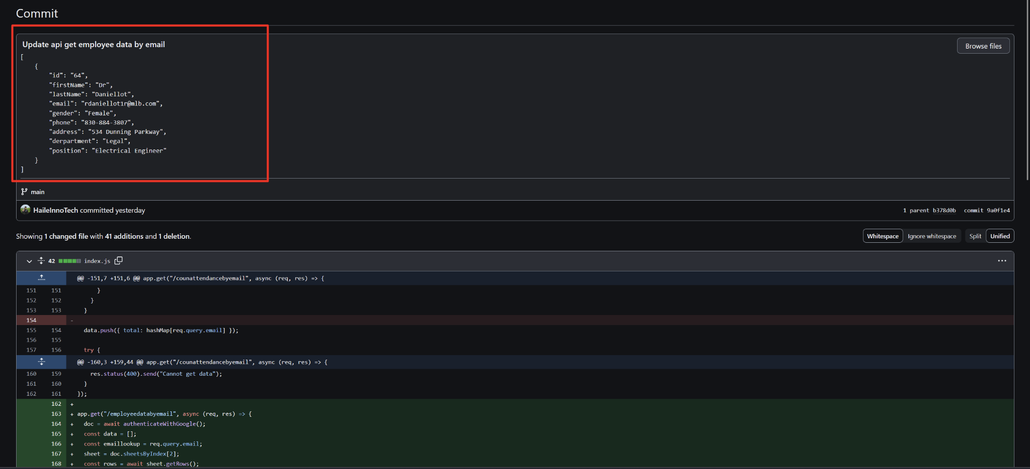

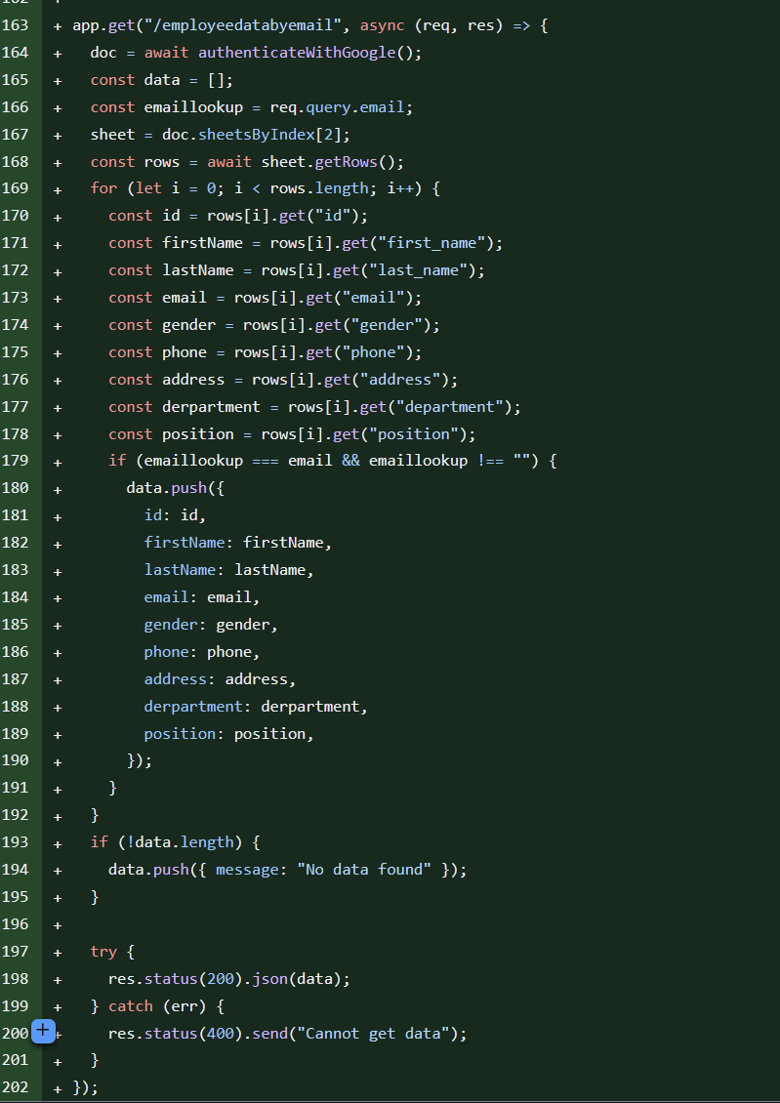

*Back-end development*

**Burndown chart**

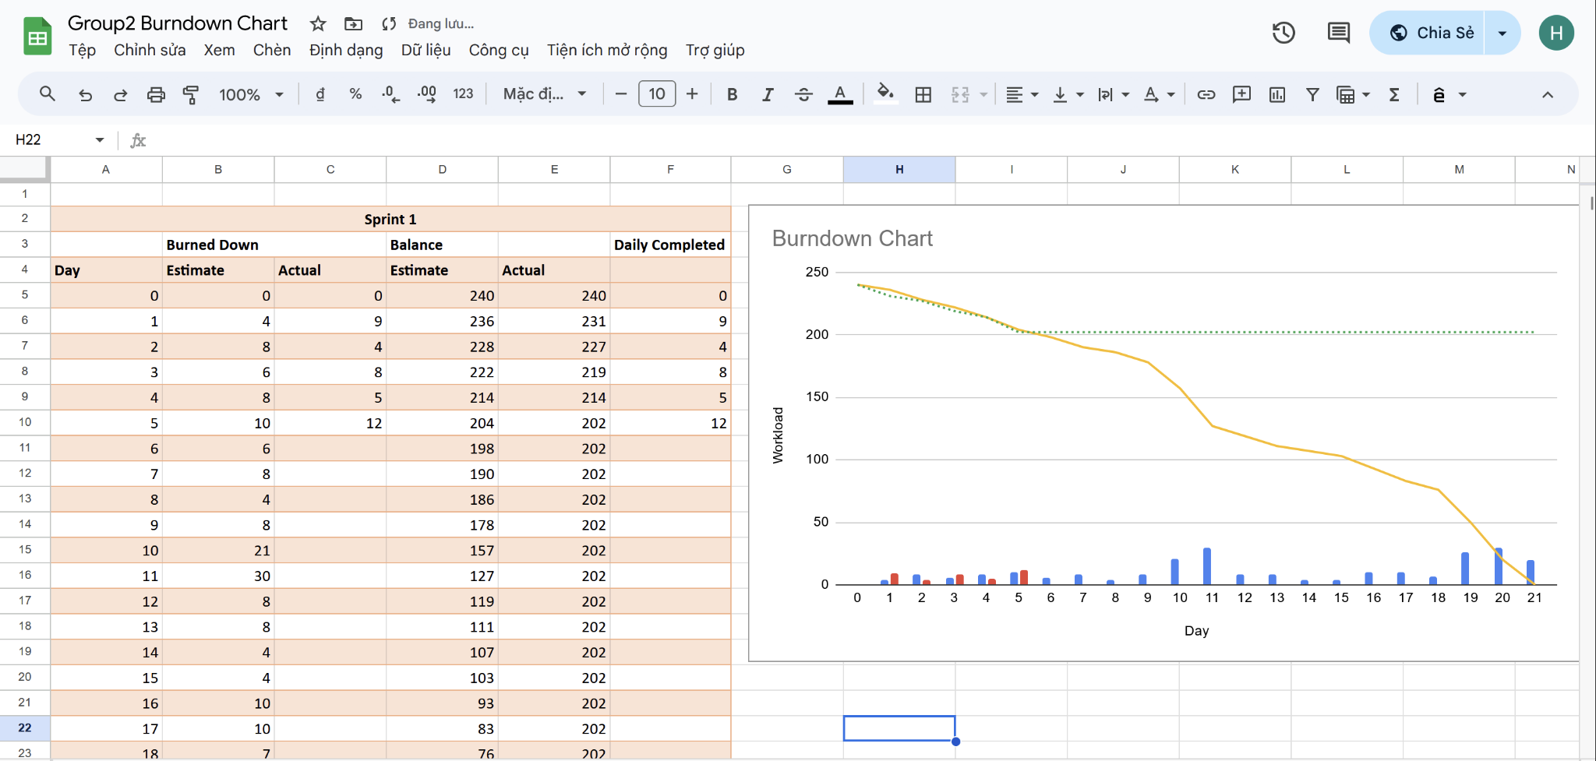

**Daily meeting minute:**

| **Status** | **Description** | **Count** |
| --- | --- | --- |
| Item Done | Review of function | 1/2 |
| Item Testing | N/A | 0/2 |
| Item Confirming | FIne tune UI code | 1/2 |
| Item Not Done | N/A | 0/2 |
| Next step | Moving to Database Design and Manager Portal |  |

**Appendix of Mockup**

**Wireframe:**

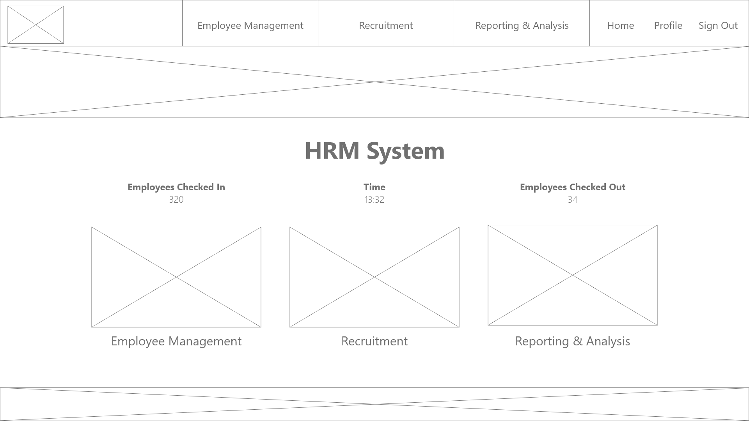

**Main page mockup:**

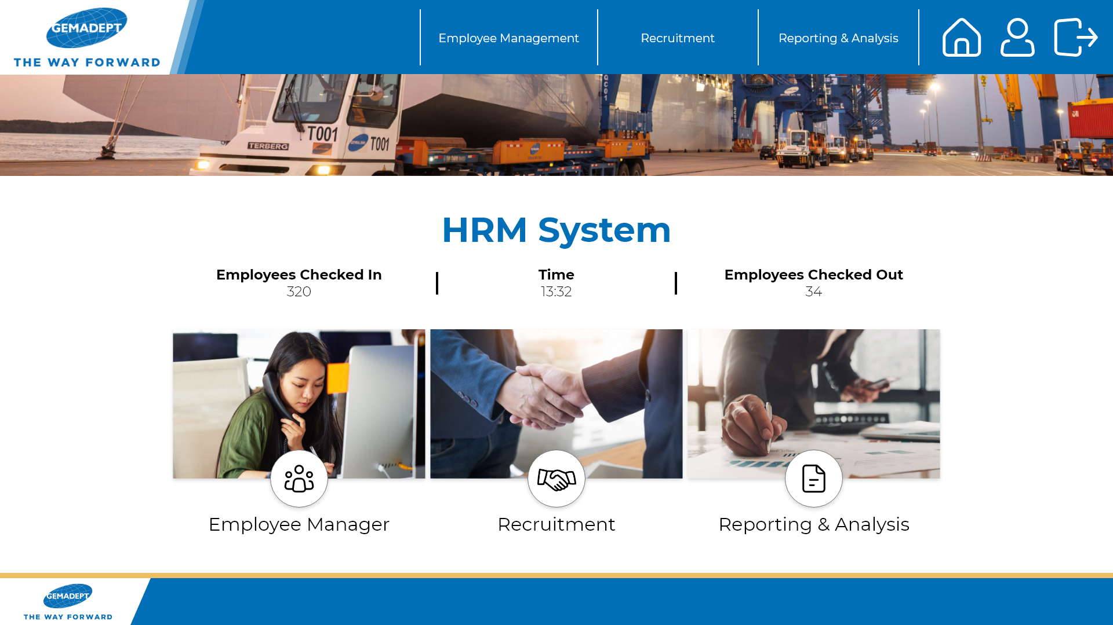

**Employee Manager mockup:**

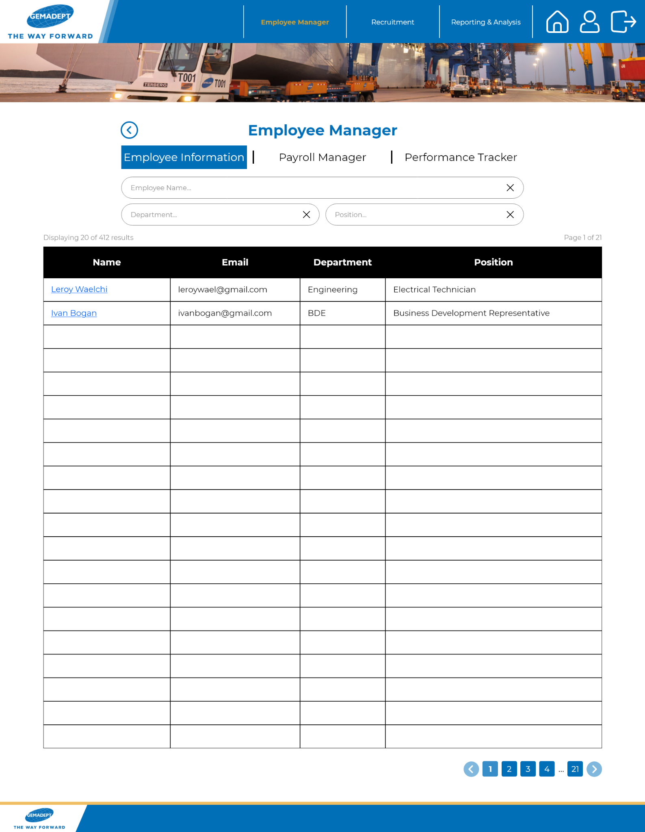

**Recruitment & Applicants mockup:**

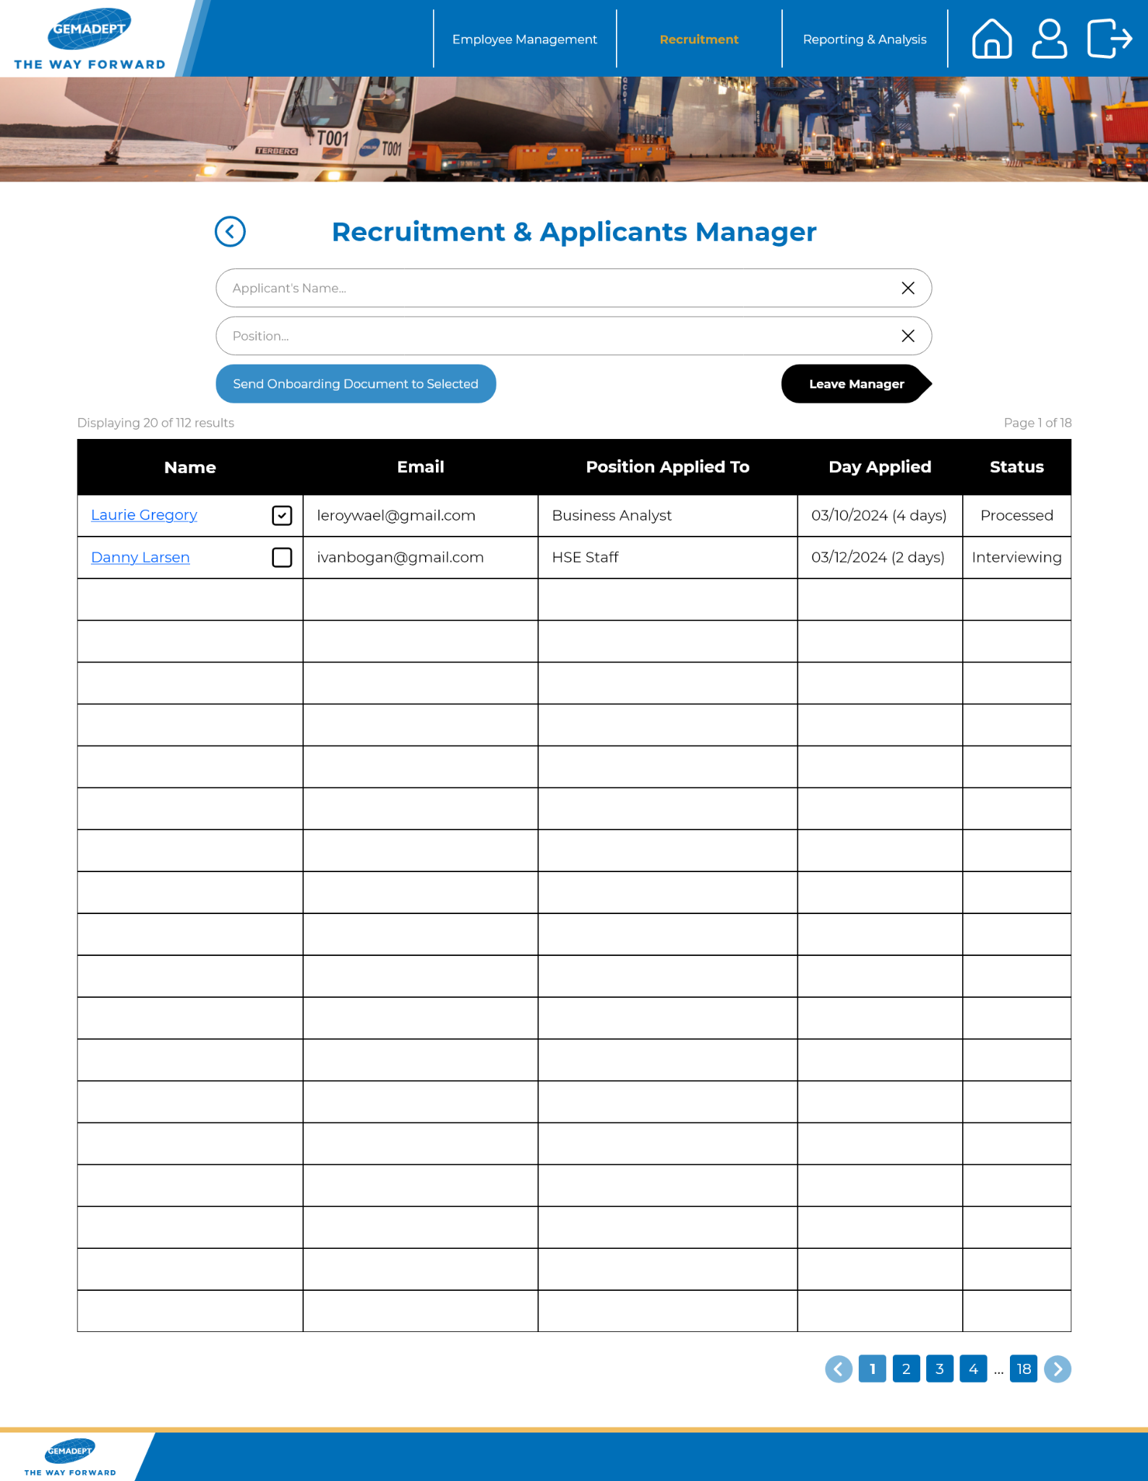

## TASK 11P: Sprint 1 End-of-Sprint Progress Reporting

**SPRINT TASK**

1. **Introduction**

This task is concerned with developing the HRM Application project for Gemadept. This task specifically is going to be a continuation from the previous task of keeping track of day 1 to 5’s progress as it is about the progress of day 6 to 10.

For the main content, we will attempt to deliver the manager’s portal and then database design and management. These items are not previously done in the last task due to time constraints, however they will be developed here.

1. **Task progress**
2. **Day 6**

**Tasks Sign Up**

| **Item** | **Description** | **Member** |
| --- | --- | --- |
| Identify and prioritise the key entities in the HR domain. | These entities include employee’s name, departments, positions, and additional entities like salaries, and performance reviews. By prioritising these entities, we can ensure that we stay focused on the most critical aspects of HR management that directly impact organisational operations and goals. | Hoang Hai  Nhat Minh |
| Define the attributes and data types for each entity based on the information to be stored. | We will carefully analyse the information to be stored for each entity and determine the appropriate data types, such as string, integer, date, decimal, etc., to accurately capture and represent the data. | Hoang Hai  Nhat Minh |
| Create an ERD to visualise the relationships between different entities. | By creating an ERD, we should have a better understanding of the structure and interactions between HR entities, which will help form effective database design and system development. | Hoang Hai  Nhat Minh  Nhat Huy |

**Trello task board update**

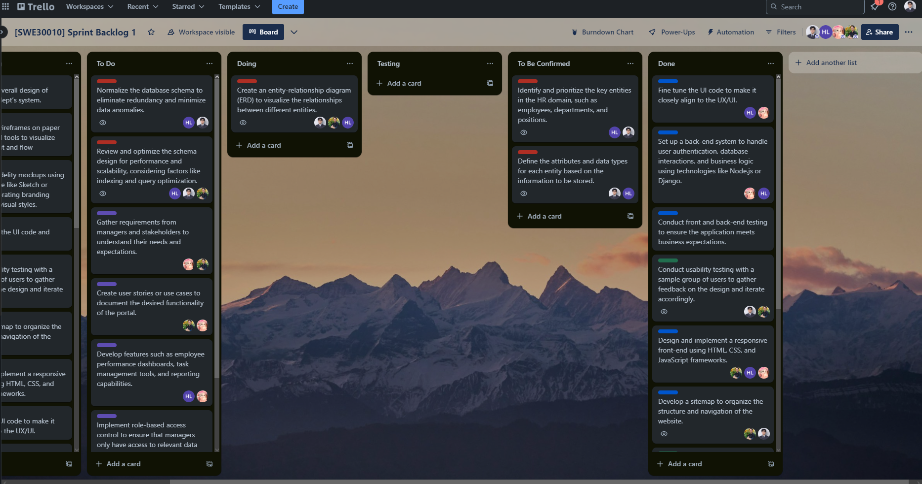

**Github repository**

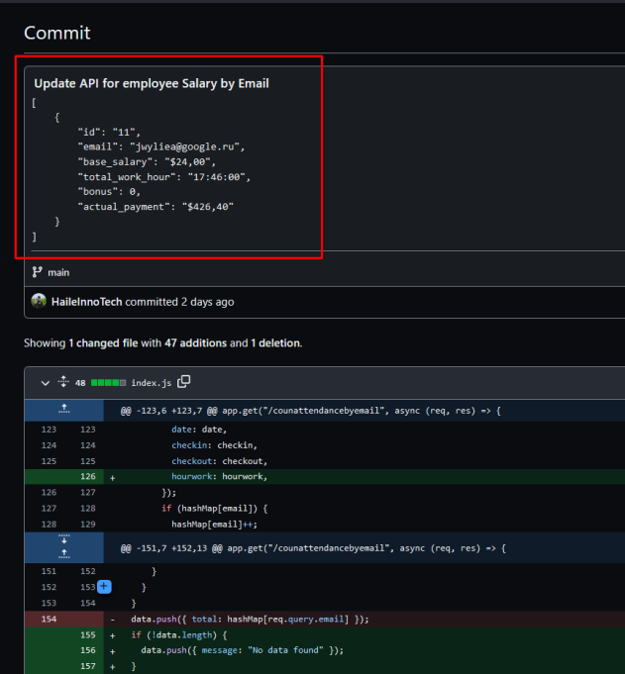

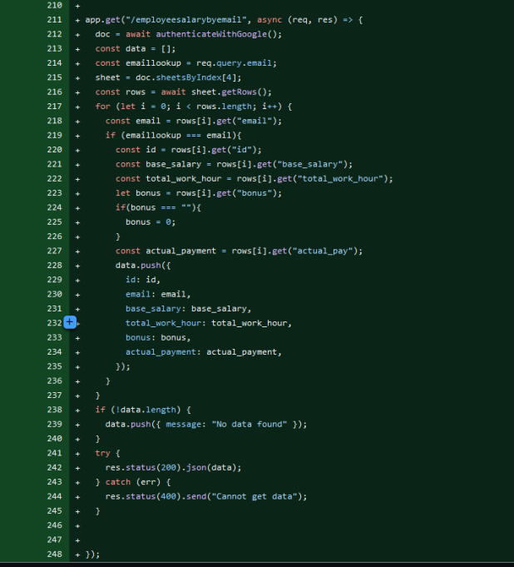

**Burndown chart**

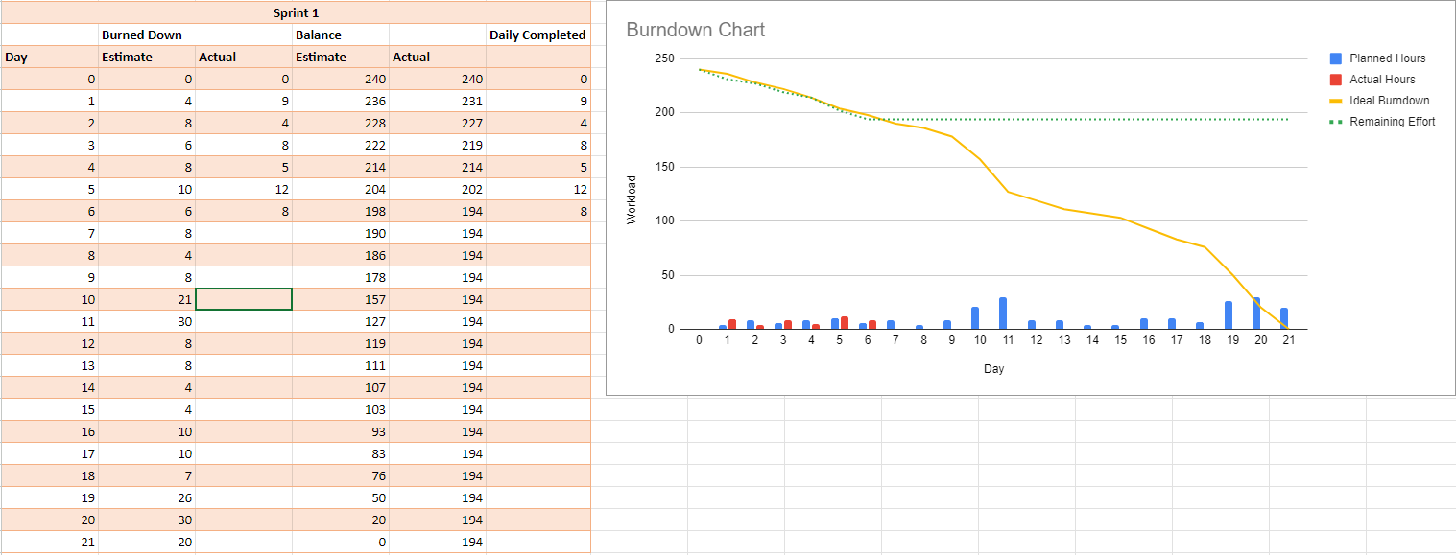

**Daily meeting minute**

| **Status** | **Description** | **Count** |
| --- | --- | --- |
| Item Done | N/A | 0/3 |
| Item Testing | N/A | 0/3 |
| Item Confirming | Identify and define the attributes and data types for each HRM entity based on the information to be stored. | 2/3 |
| Item Not Done | ERD Creation, this task takes a long time as ERD designers need to take a lot of consideration into account to create a good model. | 1/3 |
| Next step | Review the initial version of the ERD, import some employee data and perform normalisation on it |  |

1. **Day 7**

**Tasks Sign Up**

| **Item** | **Description** | **Member** |
| --- | --- | --- |
| Review of ERD. | Make sure the first database design is adequate, this step can take some time as the reviewer must ensure correct association between entities. | Nhat Minh  Nhat Huy  Hoang Hai |
| Normalize the database schema. | We identify entities, define attributes, establish primary keys, and apply normalization rules to ensure data integrity and optimize performance to organise a database schema to eliminate redundancy and minimize data anomalies. | Hoang Hai  Nhat Minh |
| Review and optimize the schema design. | Our team optimises the query statements and or the apis code to make sure the website can function as optimised as possible, i.e., faster and more reliable. | Nhat Minh  Nhat Huy  Hoang Hai |

**Trello task board update**

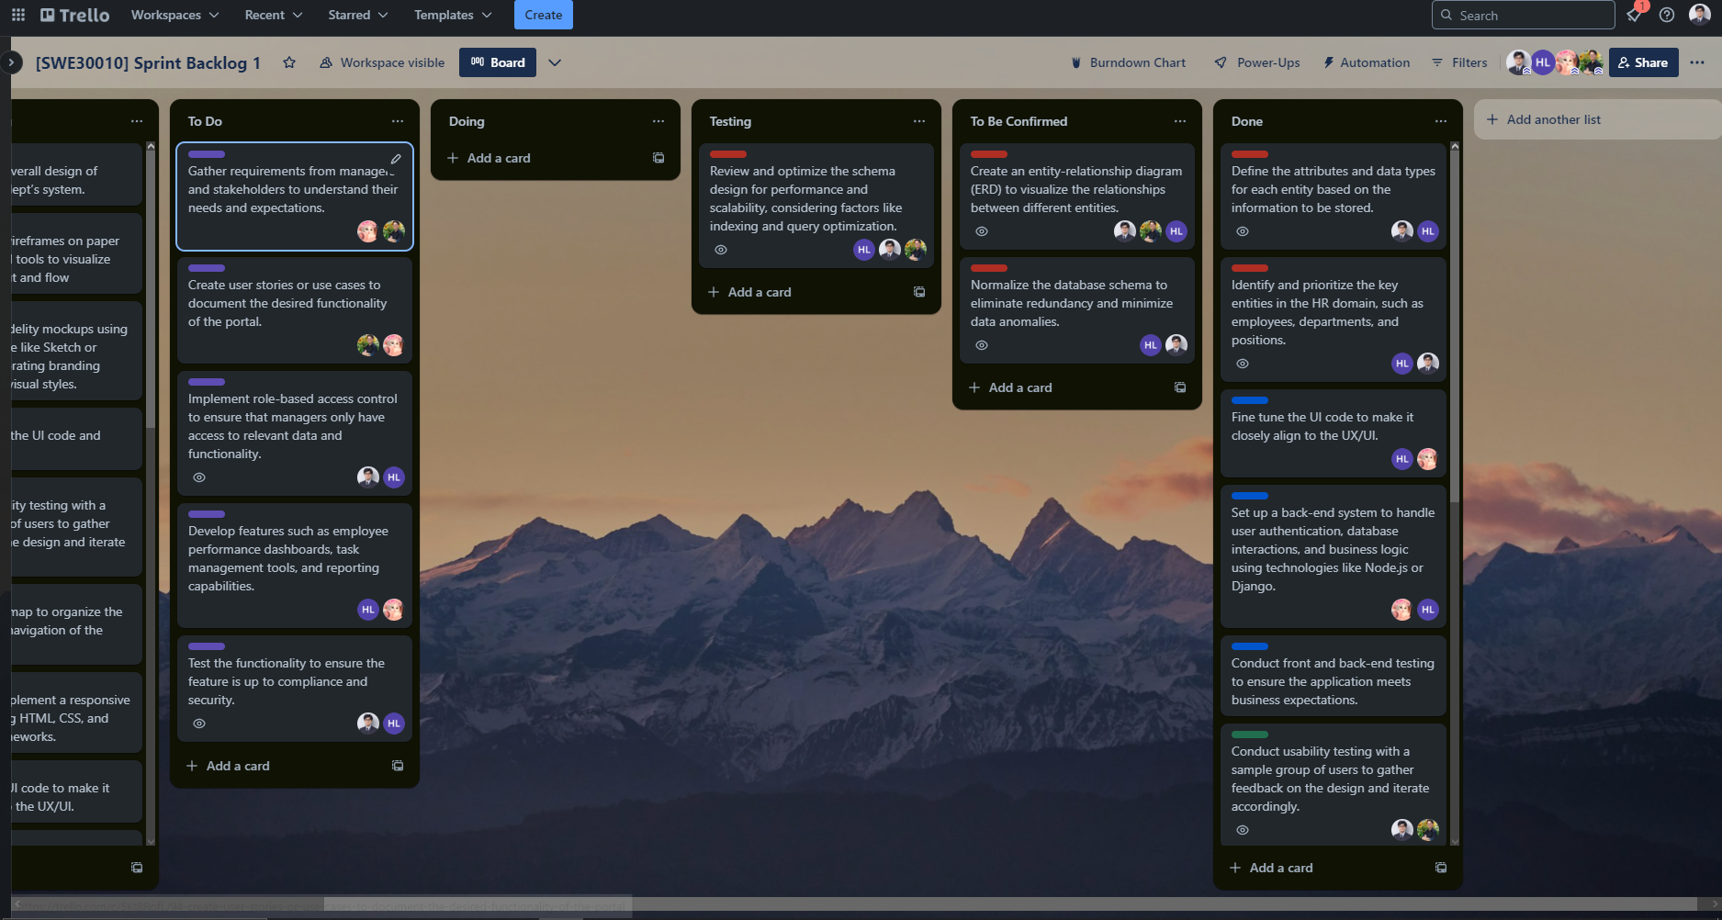

**Github repository**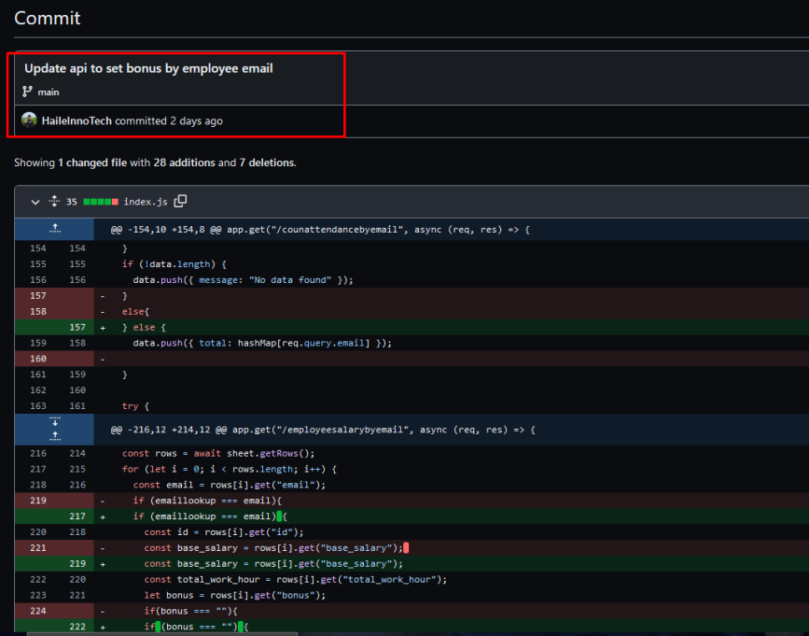

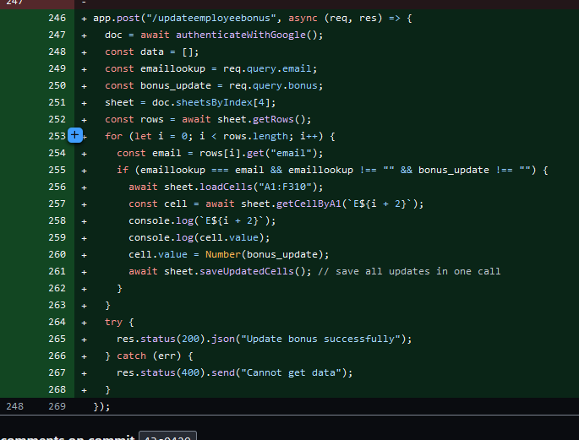

**Burndown chart**

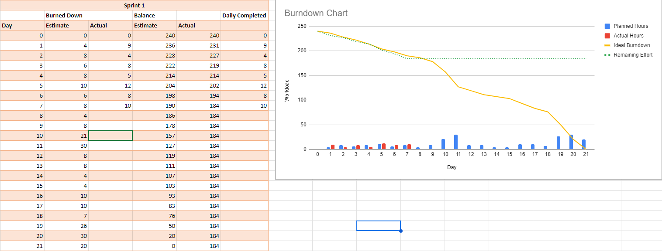

**Daily meeting minute**

| **Status** | **Description** | **Count** |
| --- | --- | --- |
| Item Done | Identify and define HRM attributes to use in the database design | 2/5 |
| Item Testing | Review and optimize the schema design. | 1/5 |
| Item Confirming | Create an entity-relationship diagram (ERD).  Normalize the database schema. | 2/5 |
| Item Not Done | N/A | 0/5 |
| Next step | Finish nomarlizing and optimizing the database as well as its relevant code. Start collecting insight to build the Manager Portal. |  |

1. **Day 8**

**Tasks Sign Up**

| **Item** | **Description** | **Member** |
| --- | --- | --- |
| Finish the ERD schema | Continue working on the ERD to finalise it | Nhat Minh  Nhat Huy  Hoang Hai |
| Normalize the data in the database | Continue with cleaning and normalizing the data within the database for better consistency between functions | Nhat Minh  Hoang Hai |
| Review and optimize the schema design. | We review the task at the end to make sure it functions well (those who did not do the coding well review the code, while the one to code will review the schema design). | Nhat Minh  Nhat Huy  Hoang Hai |
| Gather requirements from managers and stakeholders. | Our team will engage with managers and stakeholders to gather comprehensive requirements for the portal. As we need to ensure that the portal meets their specific requirements and delivers value to the users. | Nhat Huy  Minh Thy |
| Create user stories or use cases to document the desired functionality of the portal. | We will review the requirements from managers and stakeholders then document the desired functionality of the portal through user stories or use cases. This will help us capture the requirements in a clear and structured manner, allowing for better communication and alignment between the development team and stakeholders. | Nhat Huy  Minh Thy |

**Trello task board update**

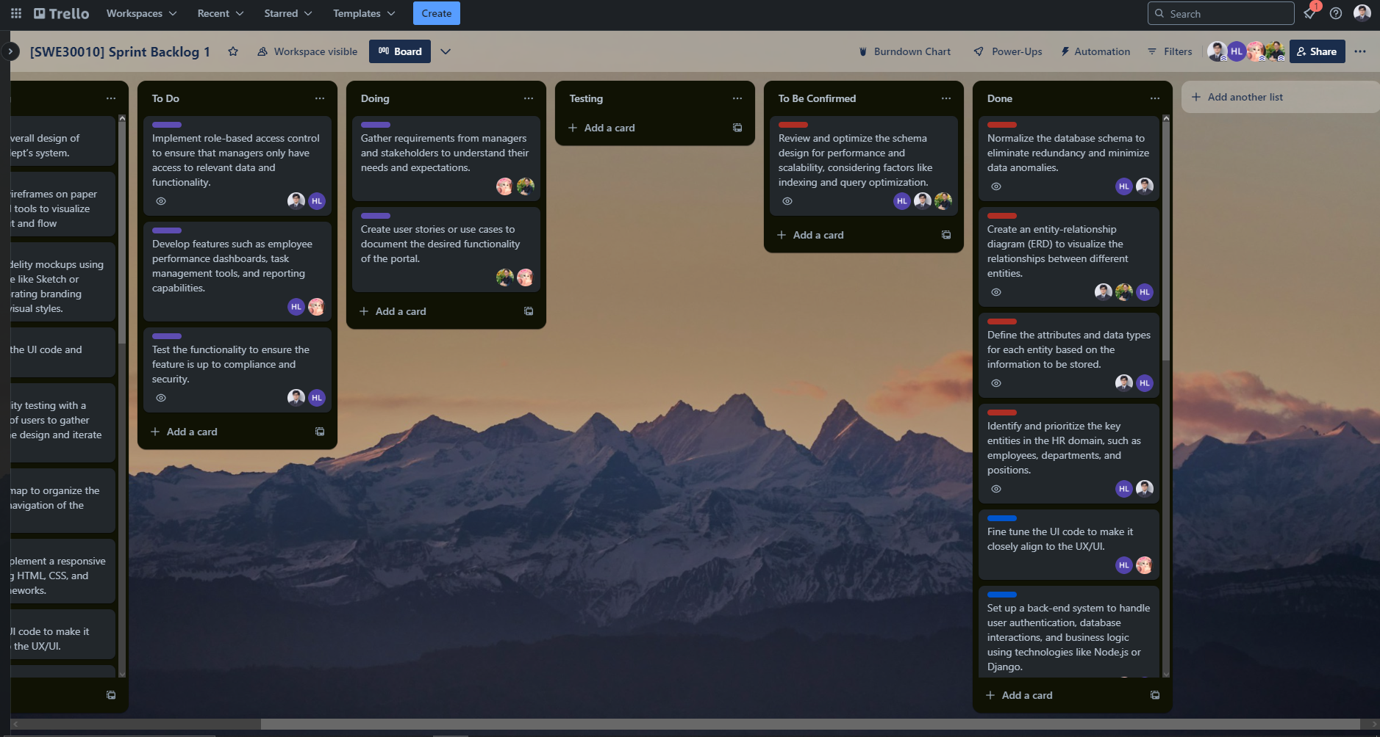

**Github repository**

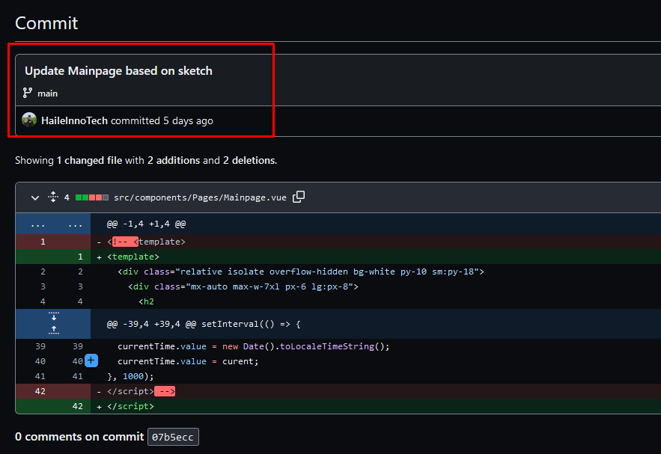

**Burndown chart**

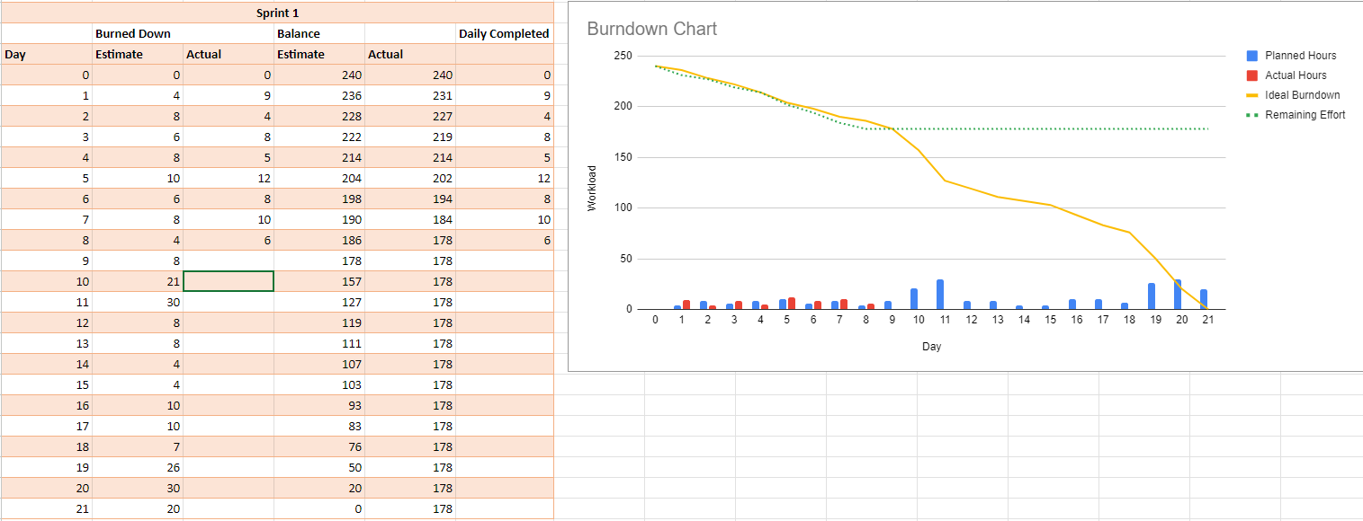

**Daily meeting minute**

| **Status** | **Description** | **Count** |
| --- | --- | --- |
| Item Done | Create and normalize the schema as well as the database. | 2/5 |
| Item Testing | N/A | 0/5 |
| Item Confirming | Review and optimize the schema design, basically fine tuning schema for better performance | 1/5 |
| Item Not Done | Gather requirements from managers and stakeholders.  Create user stories or use cases to document the desired functionality of the portal. | 2/5 |
| Next step | As gathering requirements and creating user stories goes together, these tasks need to be done with one another, hence we need to finish them together next time. |  |

1. **Day 9**

**Tasks Sign Up**

| **Item** | **Description** | **Member** |
| --- | --- | --- |
| Finish documenting and getting user’s requirement | In order to develop the functions, we need this task to be done first. | Minh Thy  Nhat Huy |
| Develop features such as employee performance dashboards, task management tools, and reporting capabilities. | These features will allow users to track performance metrics, manage their attendance, and generate insightful reports to support decision-making processes. We aim to enhance productivity and enable data-driven decision-making within the organization with the development of these functionalities. | Hoang Hai  Minh Thy |
| Implement role-based access control to ensure that managers only have access to relevant data and functionality. | We perform this task as to ensure that only authorized managers have access to relevant information based on their roles and responsibilities, thereby enhancing data security and confidentiality. | Nhat Minh  Hoang Hai |
| Test the functionality to ensure the feature is up to compliance and security. | Our team will test the functionality of the system to ensure it complies with regulatory requirements and adheres to security standards. | Nhat Minh  Hoang Hai |

**Trello task board update**

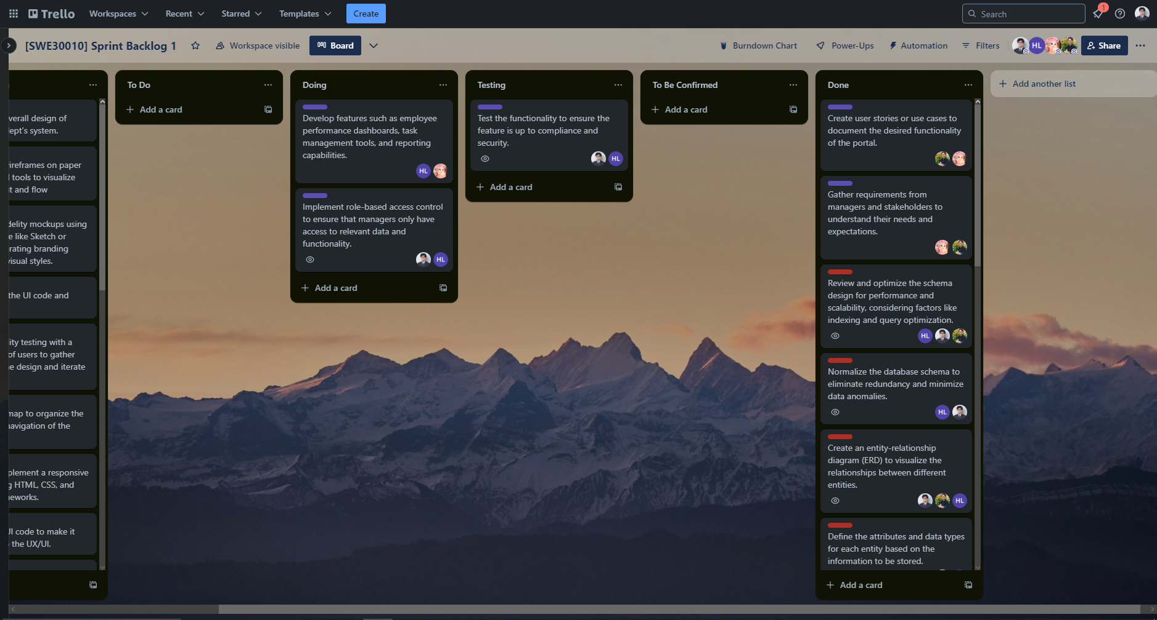

**Github repository**

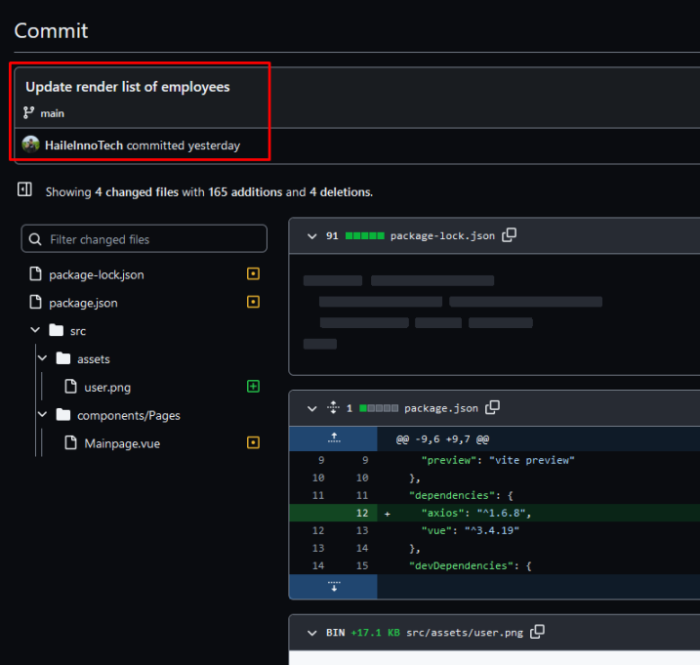

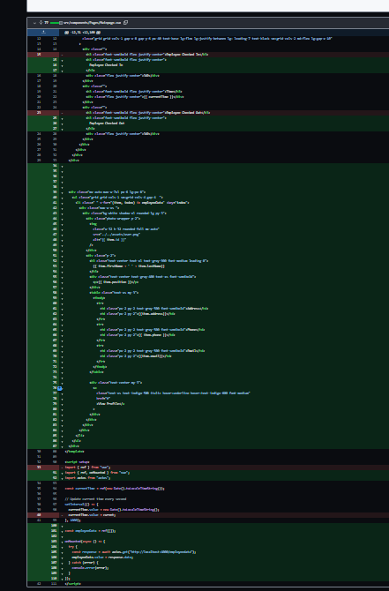

**Burndown chart**

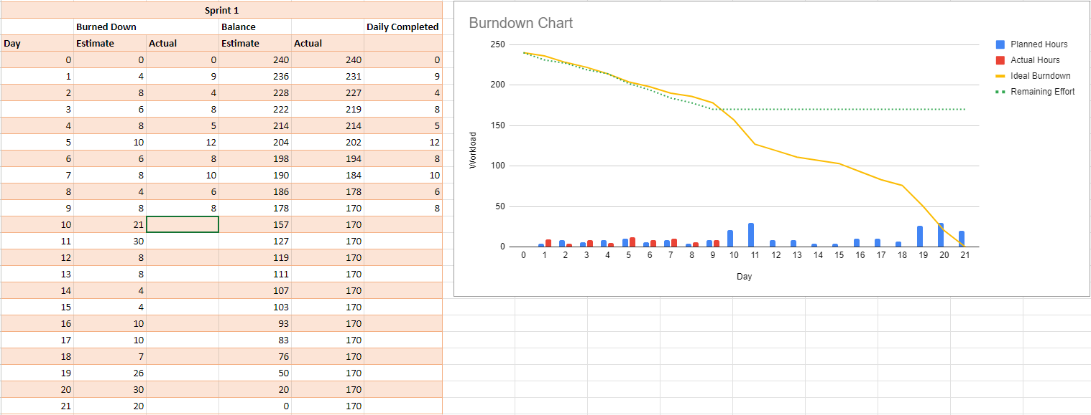

**Daily meeting minute**

| **Status** | **Description** | **Count** |
| --- | --- | --- |
| Item Done | Documenting users requirements | 1/4 |
| Item Testing | Test the functionality to ensure the feature is up to compliance and security. | 1/4 |
| Item Confirming | N/A | 0/4 |
| Item Not Done | Implement role-based access control to ensure that managers only have access to relevant data and functionality.  Develop features such as employee performance dashboards, task management tools, and reporting capabilities. | 2/4 |
| Next step | Finish the website’s functions, review testing result and website’s security |  |

1. **Day 10**

**Tasks Sign Up**

| **Item** | **Description** | **Member** |
| --- | --- | --- |
| Finish development of manager’s functions | We need to ensure the functional aspect of the website to be developed before delivering it to the stakeholders, hence we need to make sure functions are completed | Hoang Hai  Minh Thy |
| Test the functionality to ensure the feature is up to compliance and security. | Testing must be done to ensure functional correctness of the product. | Nhat Minh  Hoang Hai |
| Implement role-based access control to ensure that managers only have access to relevant data and functionality. | Only Managers should have access to the Manager’s portal and other unauthorised access should be limited to ensure data security and privacy. | Nhat Minh  Hoang Hai |

**Trello task board update**

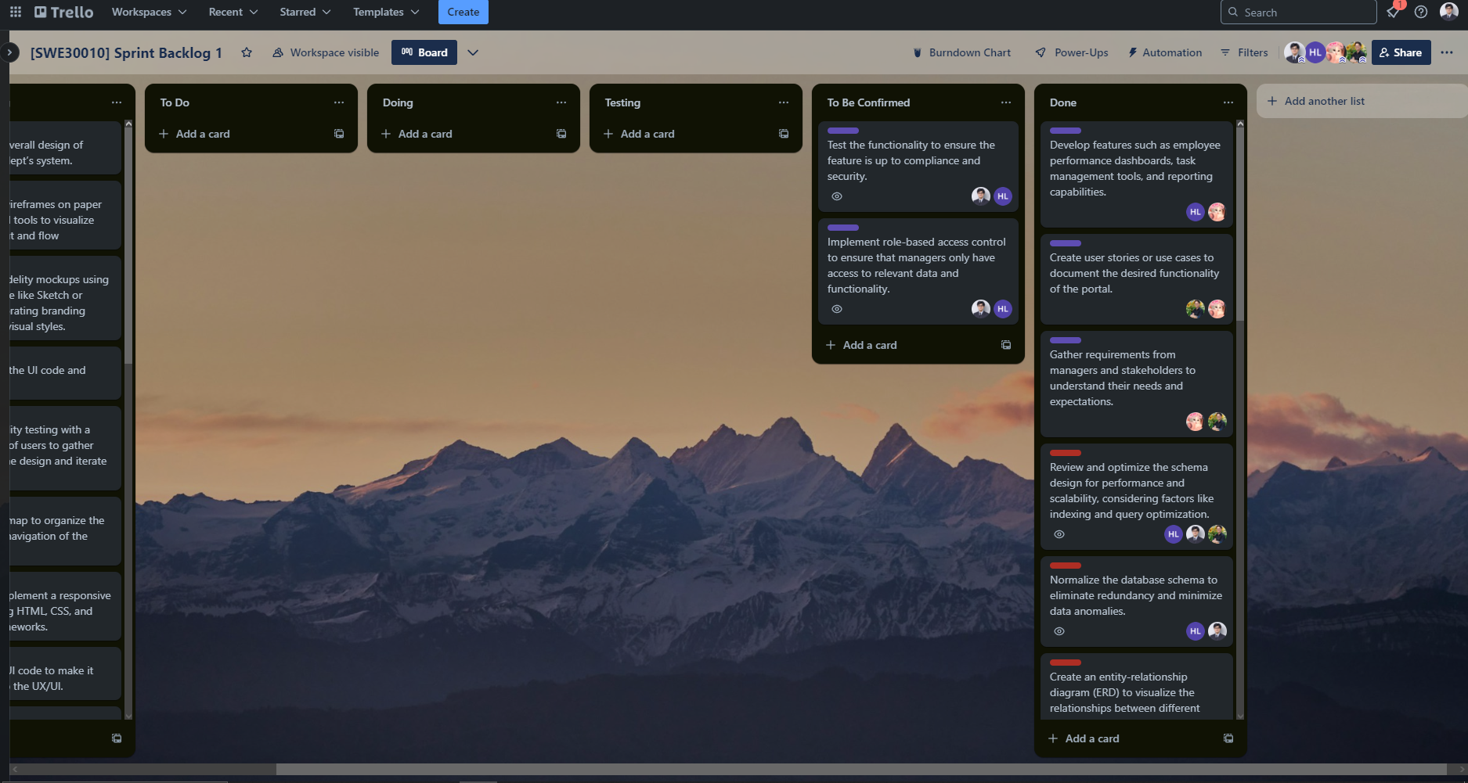

**Github repository**

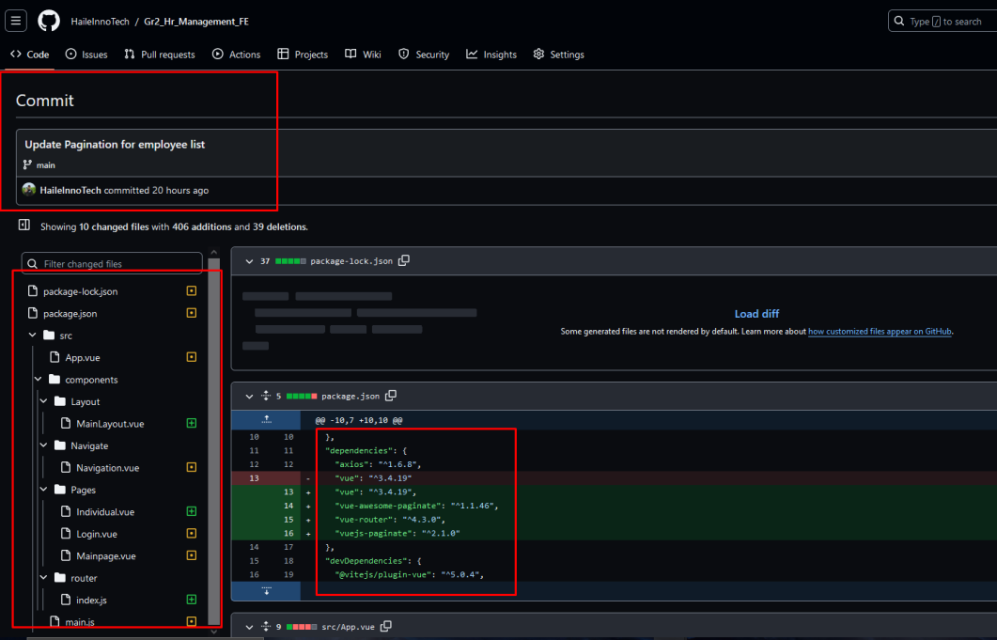

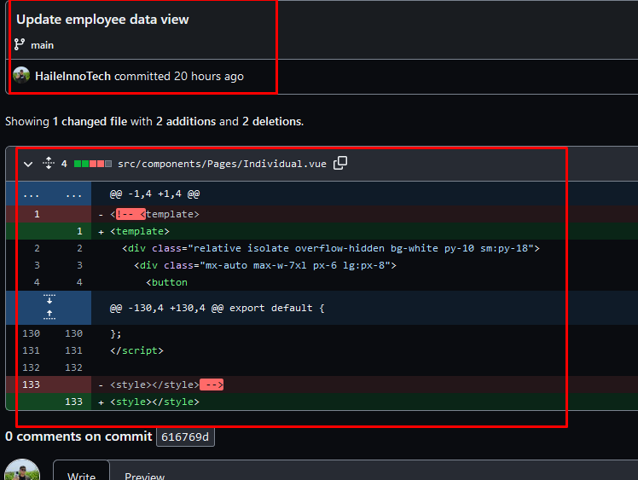

**Burndown chart**

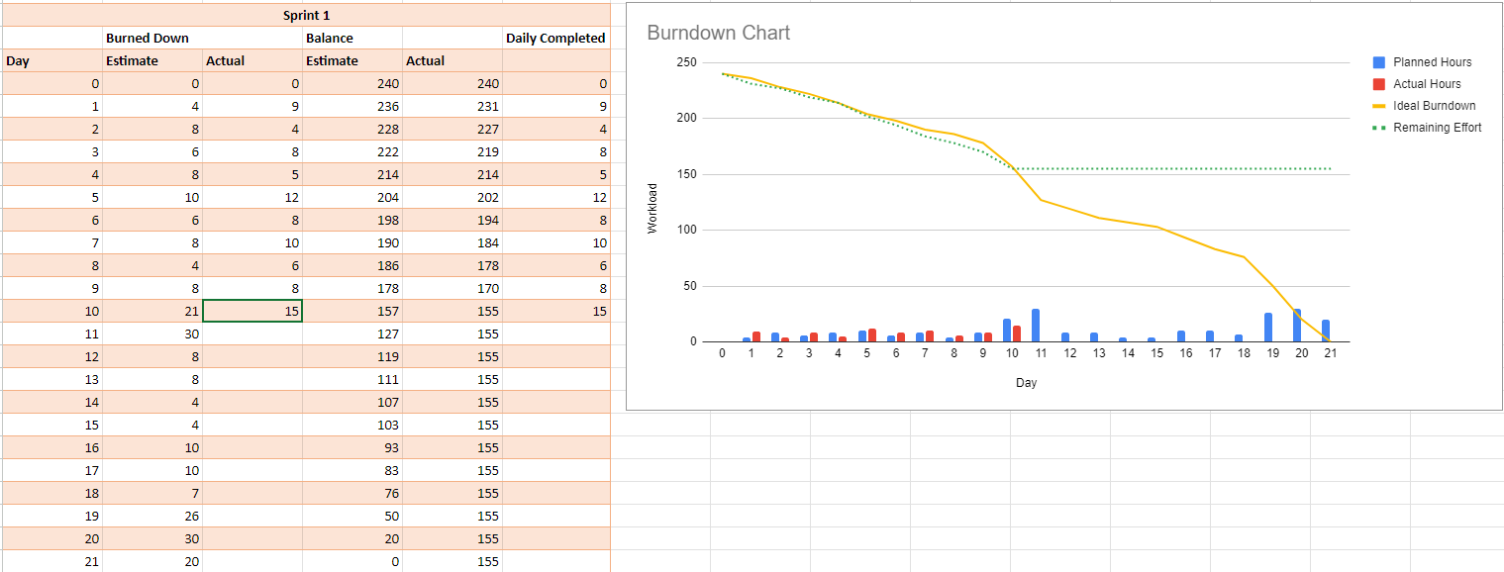

**Daily meeting minute**

| **Status** | **Description** | **Count** |
| --- | --- | --- |
| Item Done | Develop features such as employee performance dashboards, task management tools, and reporting capabilities | 1/3 |
| Item Testing | N/A | 0/3 |
| Item Confirming | Test the functionality to ensure the feature is up to compliance and security.  Implement role-based access control to ensure that managers only have access to relevant data and functionality. | 2/3 |
| Item Not Done | N/A |  |
| Next step |  |  |

**APPENDIX**

**HRM website’s ERD**

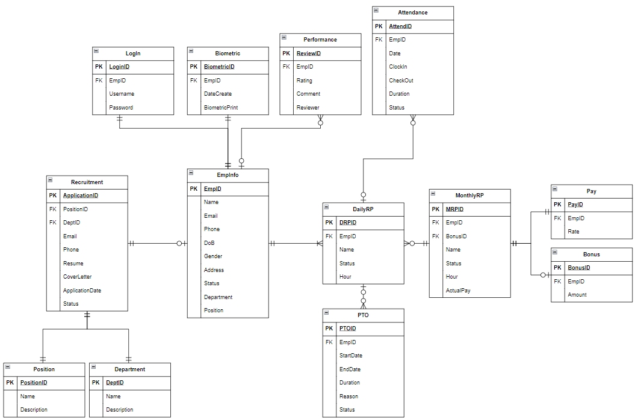

*Desired Database Design for HRM system*

**Manager Portal’s View**

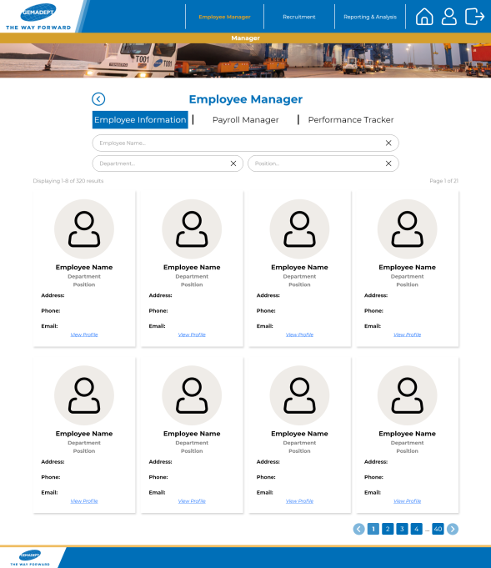

*Employee Management Window (Manager View)*

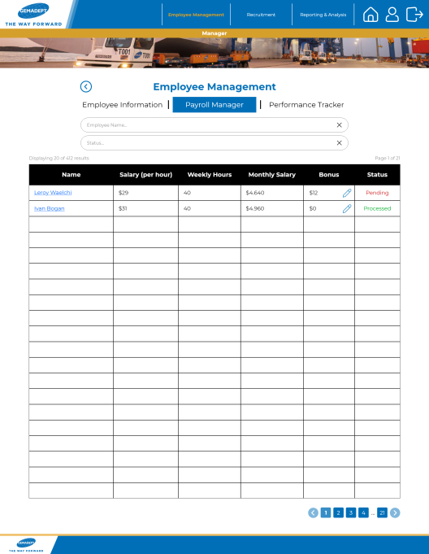

*Payroll Management Window (Manager View)*

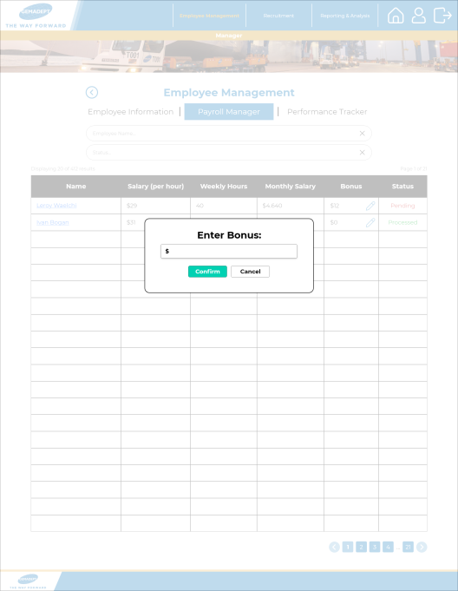

*Bonus Editing Window (Manager View)*

## 

## 

## TASK 12P: Sprint Review

**SPRINT REVIEW**

When we were defining the tasks for this sprint, we defined 20 general tasks, five for each of our sprint products. Initially, we thought that these tasks were sufficient, however as we developed our product, the scope of it expanded and we inevitably lost track of the tasks at hand and had to resort to creating smaller subtasks in order to keep track of our progress on the website.

These subtasks aren't listed in the WBS. However, our team has noted down the tasks they've gathered from their work independently (and they will be combined in the subsequent section). Therefore, we'll assess the completeness of our product based on both the items outlined in the WBS and those that aren't formally documented.

1. **Completed Items**
2. Research the overall design of current Gemadept’s system.
3. Create sitemap and navigation paths of the website.
4. Wireframe of the main page of the HRM website.
5. Design mockup of main page, employee manager, payroll manager, manager, reporting dashboard.
6. Design and implement a front-end using HTML, CSS, and JavaScript frameworks.
7. Set up a back-end system to handle user authentication, database. interactions, and business logic.
8. Implemented Authentication and Authorization on the website.
9. Added middleware for API security, crypto hashing and salting for authentication.
10. Conduct usability testing.
11. Conduct front and back-end testing.
12. Identify and prioritise the key entities in the HR domain.
13. Define the attributes and data types for each entity based on the information to be stored.
14. Create an entity-relationship diagram (ERD).
15. Gather requirements from managers and stakeholders.
16. Create user stories or use cases to document the desired functionality of the portal.
17. Payroll module is completed ahead of schedule (scheduled for Sprint 2 but finished in Sprint 1)
18. **Incomplete Items**

Even though we were able to complete most of the website’s function:

1. **UI/UX**
2. Responsive design.
3. The reporting dashboard is generally incomplete.
4. Fine tune the UI code to make it closely align to the design mockup.
5. **System functionality**
6. Generate reports.
7. Align the database design to ERD.
8. Deep testing.
9. Mass email sending.
10. Register new accounts.
11. User role page access.
12. Real-time Notification, chatbox support.
13. Biometric system for attendance check.
14. Monthly mockup data for charts.
15. Normalise the database data, review and optimise the schema design.
16. **Rationale**

There are several reasons why we were unable to complete some of the items on time. One of them was the fact that we underestimated the sheer complexity of some of the tasks. For instance, the objective of Sprint 1 was to implement a base HRM website with some basic HRM operations. However, we severely underestimated the complexity of developing a website as there are many subtasks involved. This meant more time was needed to complete the task, delaying the completion of other tasks significantly. Another problem was that the task descriptions were too vague in the beginning. We learnt the hard way that we should have divided our tasks into smaller, more manageable portions to get better results.

In order to improve this, we would need to research the tasks at hand more thoroughly to be able to understand what needs to be done. With a clearly defined task, we can much more easily determine their complexity, the subtasks involved and have a more accurate time estimation. Furthermore, we should discuss our product and process with the tutor or other experienced personnel to gain insight into how feasible a task is.

1. **Suggestions for Improvement**

After the sprint review, our stakeholders requested for some adjustments to be made with the current project, including:

1. **User access management:** Users should only be able to access what is available to them, depending on their role.
2. **System improvements:** Improvements to design, control management, implementation of Captcha.
3. **DB improvements:** Transfer current database system (Google Sheets) to a proper one such as MariaDB or MongoDB.
4. **Appendix**

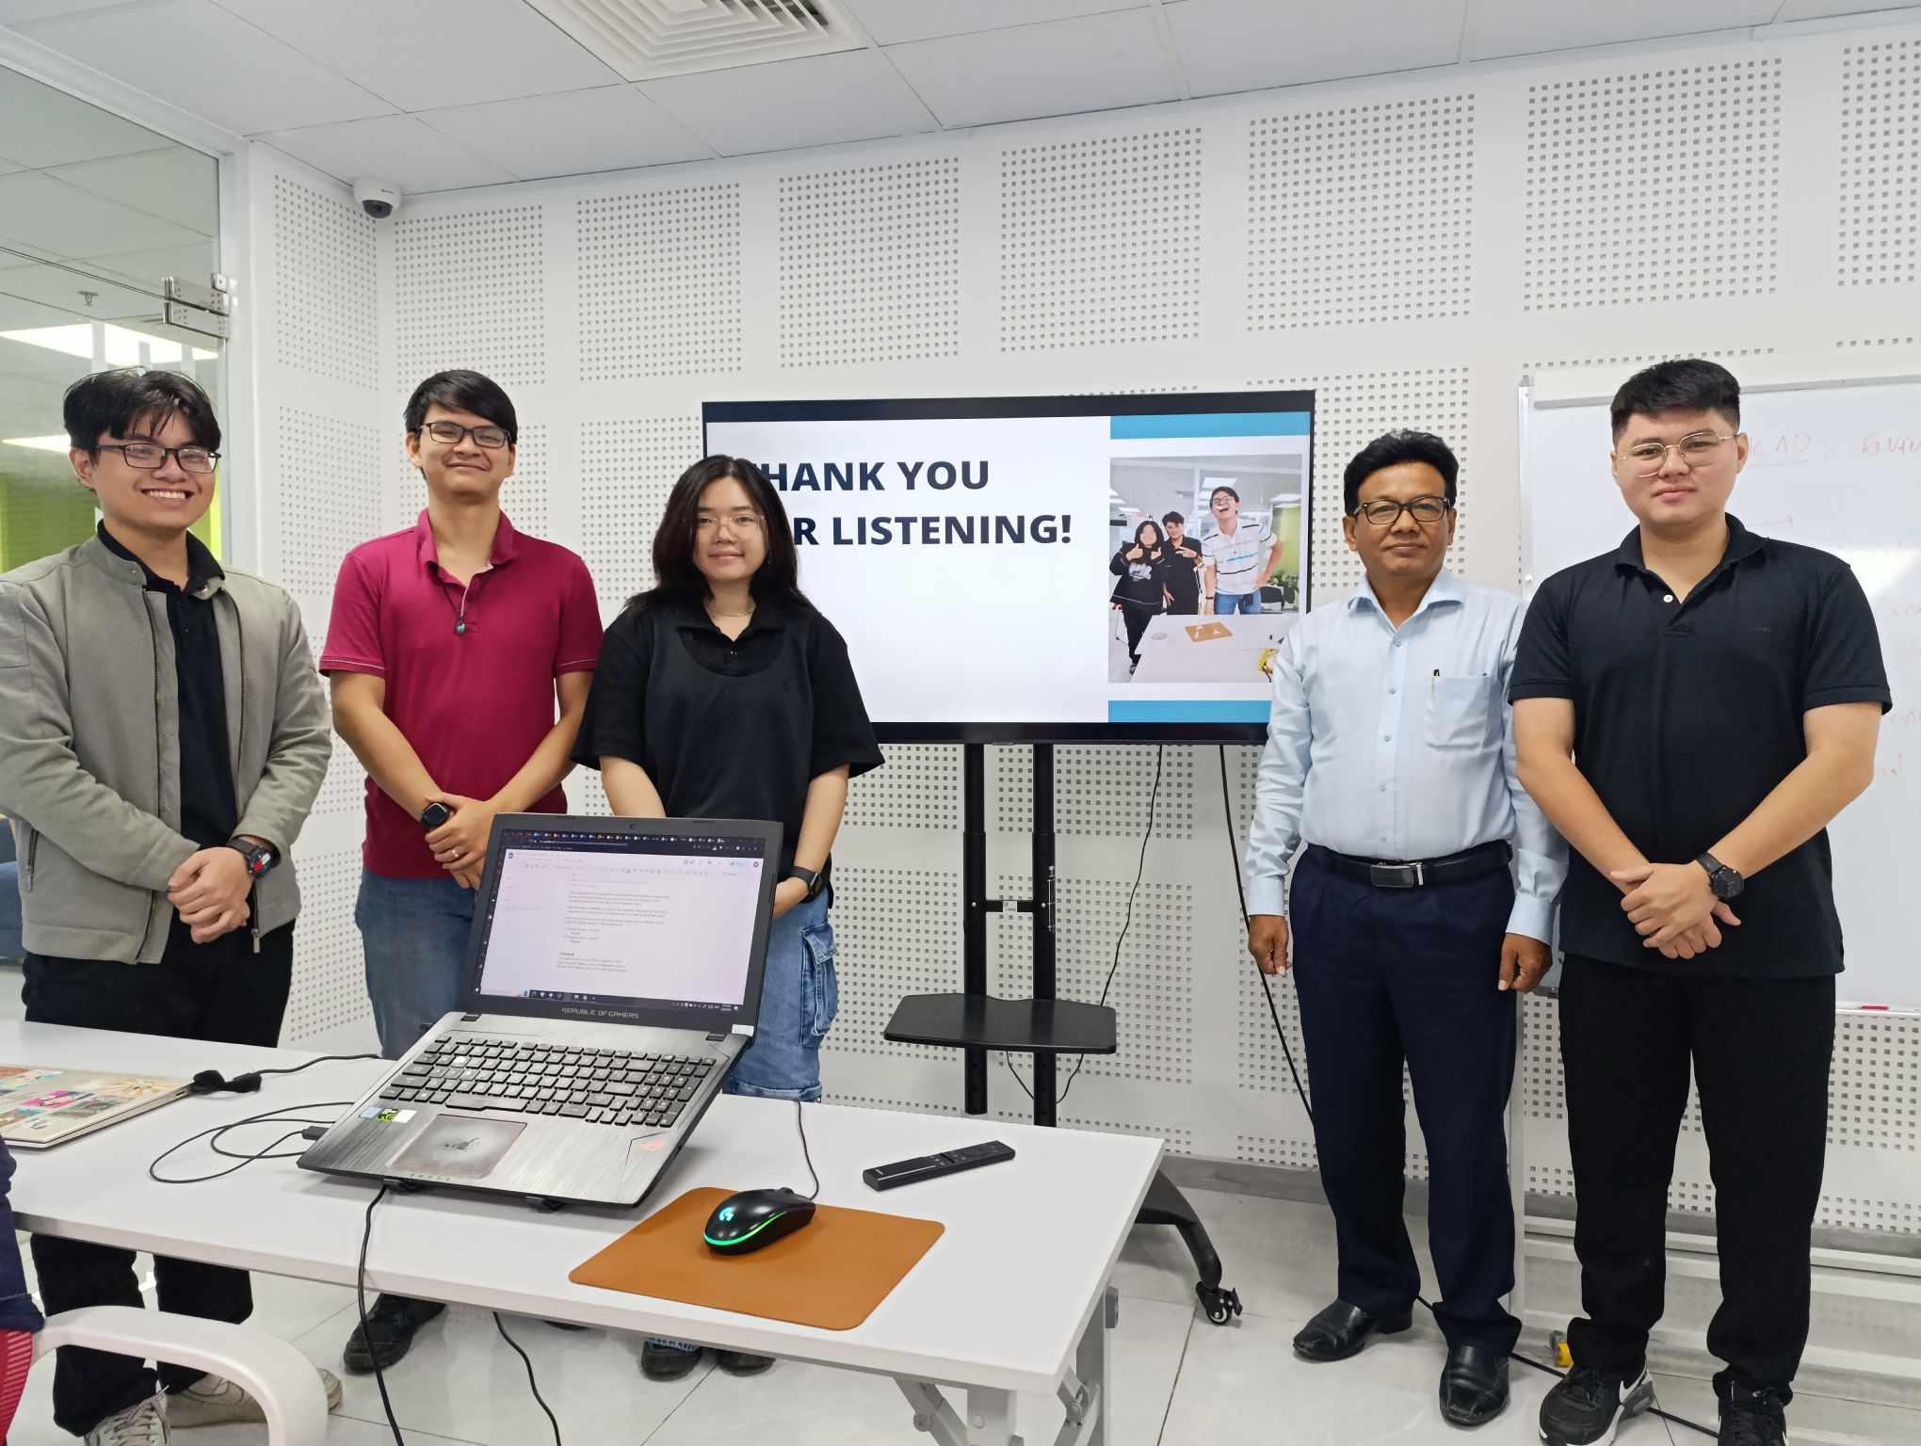

*Figure E.1: Our team’s sprint review presentation*

## 

## TASK 13P: Sprint Retrospective

**Introduction**

After our first sprint is completed, we feel the need to revisit the process of completing our sprint to get a better understanding of what we have done that is capable and what we could have done better. To assist this task, we will attempt to answer some retrospective questions as well as document further ideas that our team has about this sprint.

1. **Sprint Retrospective**
2. **Team’s velocity**

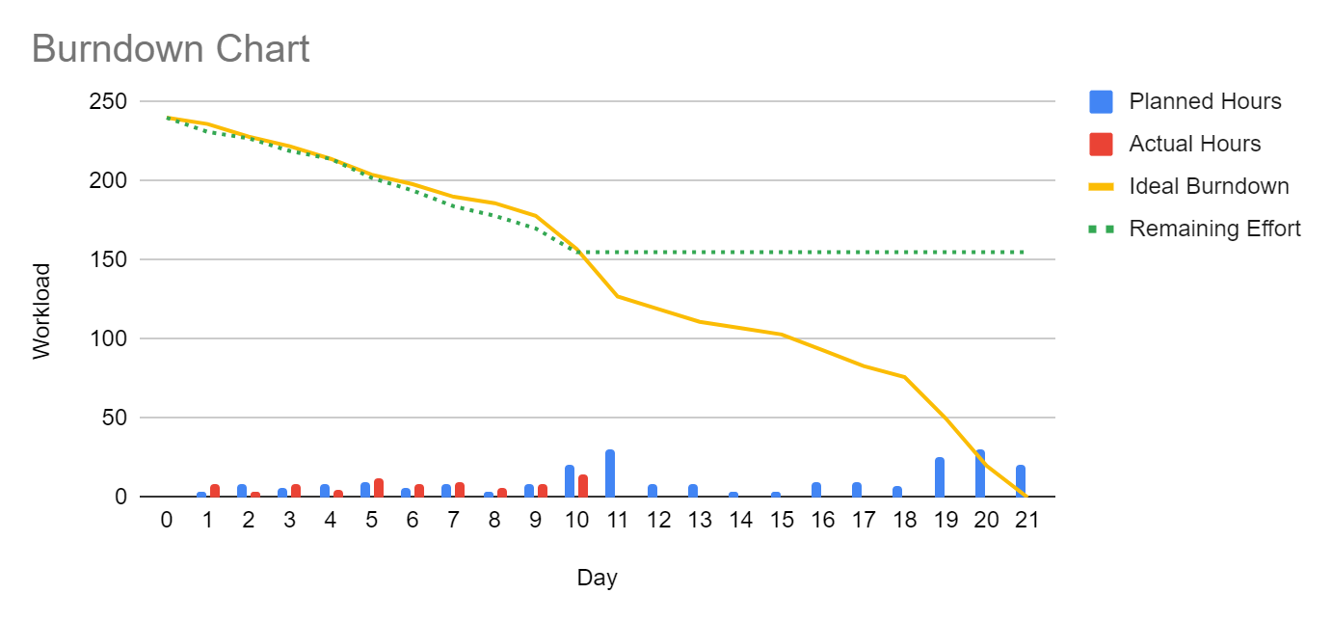

*Figure 1.1: Burndown Chart*

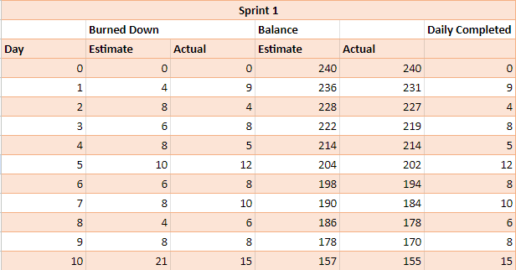

*Figure 1.2: Burndown Table*

* Did your team overestimate your ability? Or Did you under-estimate the effort required to complete the tasks?
* Analysing our team's burndown chart for the initial ten days of the sprint, it appears we may have slightly underestimated the effort required to finish each product within the sprint. However, this discrepancy isn't major, as we're managing to wrap up some work that has been planned later ahead of time. It still highlights the need for us to meticulously reconsider and tweak our approach to subsequent sprint products, which involves breaking down heavier tasks and allocating them to days with fewer hours required, thereby balancing out the days that demand more effort.
* What can you do in order to get a better understanding of the "complexity" of the tasks required? Or What can you do in order to get better time estimates next time?
* We need to perform regular review with our tutor to refine our plan and adjust our effort accordingly. We would also benefit from observing the plan of other professionals, whose template can be found from the internet.
* We also need to break down tasks into more detailed descriptions or create additional subtasks for our product's main tasks. This is necessary because we sometimes struggle to keep track of all the tasks we need to do. Moreover, as the project nears completion, the scope of our product expands, and we lack a formal method of recording all the new tasks that arise.

1. **Team’s process**

* What is working? Why?
* Our team's communication is quite effective. We use various channels like Messenger, Discord, and Trello to exchange information about tasks, deadlines, and other notes. This advantage enables us to swiftly pass on new information as soon as it's available.
* Task allocation is also well done in my opinion. Each team member gets to showcase their strengths. For example, designers handle mockups and writing, developers create and run websites, and the leader handles review and quality control. Overall, I believe our team dynamics are solid.
* What is not working? Why not? Any suggestions to improve the situation if this occurs in the future?
* Our time management and handling of heavy tasks could be improved. We often make tasks too large and fail to break them down into sufficient detail. As a result, allocating time to these large tasks becomes inaccurate upon closer examination, leading to tight deadlines and lower-quality outcomes.
* Suggestions for improvement are listed on the former parts, however, our team agrees that in order for our processes and dynamics to be more fluid, we should plan a few weeks further for tasks that have been defined. Moreover, regular meetings to review tasks done by every member would be beneficial.

## TASK 14P: Software Design

1. **Sprint 1 Software Design**

With the completion of sprint one, we are able to create an activity UML diagram that captures our website’s functionality as well as its design.

Since we have two different kinds of users, employees and managers, their activities differ dramatically. While employees can only view their own attendance, and personal information, managers can do that while also add more employees as well as updating their pay (via the payroll manager) as well.

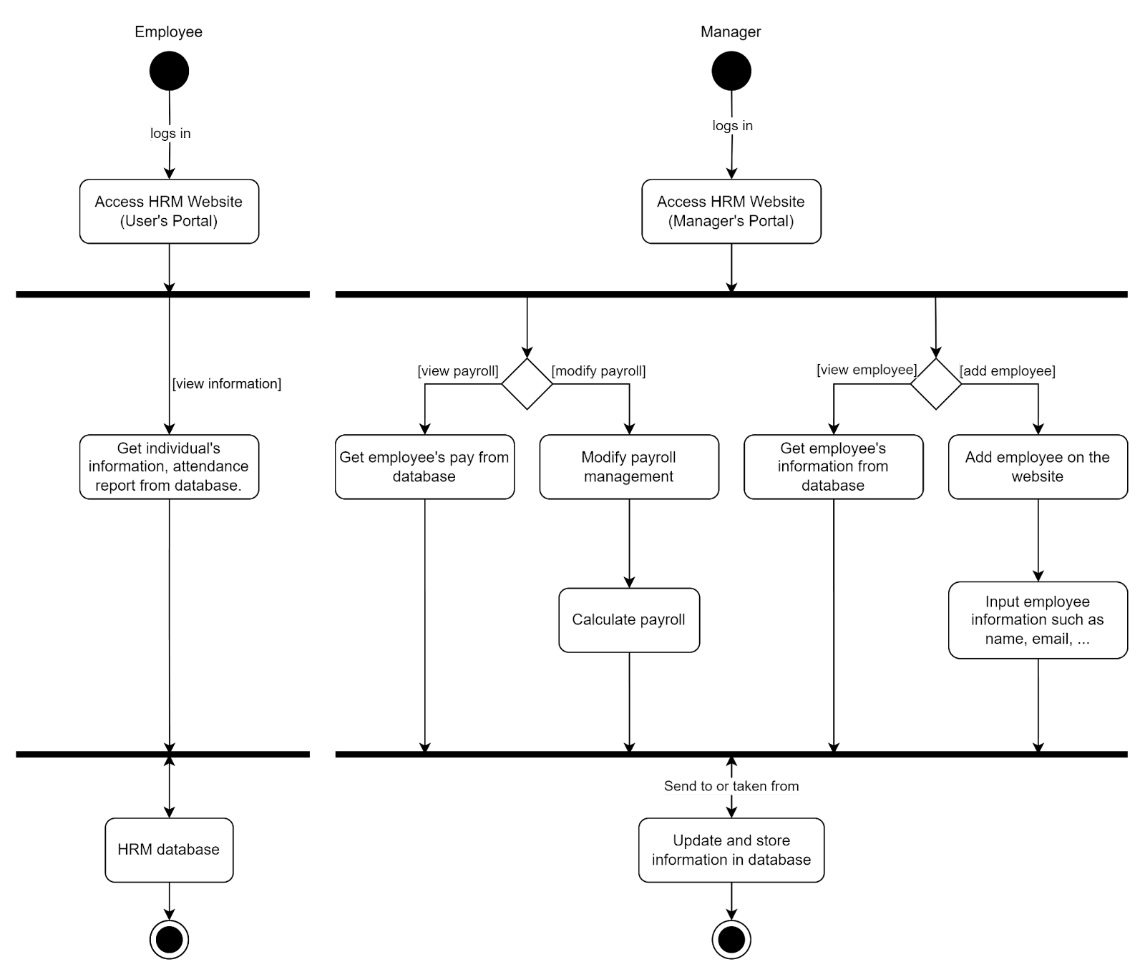

*Figure A: Software design after Sprint 1*

1. **Justification**
2. **MVC**

We followed the Model-View-Controller (MVC) design pattern when creating the post-sprint 1 activity UML design. In this design, the controller (website’s backend) coordinates interactions between the model and view, the view (website’s frontend) manages the display layer, and the model (website’s backend and database) represents the data and business logic. By adhering to the MVC pattern, we can ensure that modifications made to one component don't unduly impact the others, encouraging maintainability and simplifying future development.

1. **Security**

We have implemented various API security measures to protect user data and prevent unauthorized access. Our methods include:

**Salting**: Each password is salted with a random value before hashing.

**Cryptographic Hashing:** Salted passwords are hashed using the bcrypt algorithm, making them resistant to brute-force attacks.

**Limited Database Access:** Access to data in the database is restricted to authorised personnel only (developer and overseer), reducing the risk of data breaches.

**Role-Based Access Control:** Our system incorporates a role-based access control mechanism with two roles: "admin" and "user." This ensures that different users have appropriate levels of access privileges and view features appropriate to their role.

**JSON Web Tokens (JWT):** JWTs are utilised for token generation and management. Upon successful authentication, a unique token is generated and issued to the user. These tokens expire after a set period, mitigating the risk associated with stolen or intercepted tokens.

**Middleware Validation:** The backend API employs middleware to verify the authenticity of incoming requests. Only authenticated users with valid tokens are permitted to make requests, enhancing overall system security.

In this first sprint, our concerns are only about the website’s basic functionalities, hence, advanced security has yet to be developed; still, this critical layer of security safeguards our platform against unauthorised access and potential security breaches, reinforcing user trust and confidence in our commitment to protecting their data and privacy.